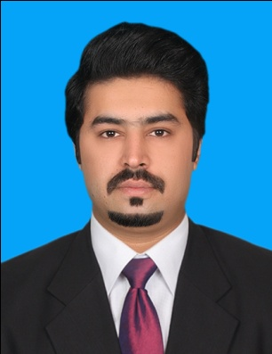**Waseem Javaid**

**Email:** waseemjavaidkps@gmail.com

**Mobile:** +923007486606

**Whatsapp:** +923007486606

**Address:** 466 R1 Johor Town Lahore

**Objective:**

|  |
| --- |
|  |
| **TO explore my expertise and to be in a good and professional department. I am experienced professional . I promise for my loyalty, consistency and I will prove myself as the most important part of the organization. I will not make this institute feel sorry for hiring me.** |

**Key Skills and Activities:**

|  |
| --- |
|  |
| * Leadership Skills (Always group leader of Labs work, Project tasks and Proctor Board). * Managerial skills like planning, organization and time management. * Excellent communicational skills, Goal- oriented and self motivated. * Able to do documentation and analysis. * Hardworking and able to work under pressure also. * President of The ULRICH HR Forum (UCP Students Society) * Served in the main body of The ULRICH HR Forum. |

**Certificate and Awards:**

|  |  |
| --- | --- |
|  | |
| **Name** | **Duration** |
| * Excellence Award (University of Central Punjab ) * Excellence Award (University of Central Punjab ) * Mobilink Market session * Youth Entrepreneurial Summit * Professional Development and Corporate Trainig workshop * TEDx X=Independently Organized TED event * CV Building Trainig Session * Ulrich,HR Forum | * 2012 * 2013 * 2010 * 2012 * 2013 * 2012 * 2012 * 2014 |

**Qualification:**

|  |  |  |
| --- | --- | --- |
|  | | |
| **2009 to 2013** | **Masters of Business Administration**  University of Central Punjab Lahore | **3.15 (CGPA) (Out of 4.0)** |
| **2007 to 2009** | **Bachelors of Arts**  Bahauddin Zakariya University Multan | **2nd Division** |
| **2005 to 2007** | **F.sc in Pre-Engineering**  Rashid Minhas Higher Secondary School Ali pur | **1st Division** |
| **2003 to 2005** | **Matric in Science**  Rashid Minhas Higher Secondary School Ali pur | **1st Division** |

**Computer Skills**

* + - * + MS Office
        + MS Excel
        + Power Point

**Personal Information**

|  |  |
| --- | --- |
| Name | **Waseem Javaid** |
| Father’s Name | **Jam Javaid Saleem** |
| Date of Birth | 07-03-1990 |
| NIC # | 32302-1975057-9 |
| Passport # | AQ8690572 |
| Religion | Islam |
| Marital Status | Married |
| Gender | Male |
| Nationality | Pakistani |

**Languages**

English , Urdu

**Reference**

Reference will furnish on demand.