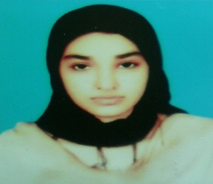

**MALIHA SIDDIQUI**

**Date of birth** 09_12_1993

**City** Lahore (Sadar Cantt)

**Contact** 03314962648

**E-mail** mmalihasiddiqui9@gmail.com

**OBJECTIVE**

To get more exposure, accept challenges, utilize skills and prove worth. Attain self-satisfaction by working in a stable, challenging environment where I can optimally utilize my skills and abilities while continuing to grow professionally

**EDUCATION**

2019 **MSc** Applied Psychology (Virtual University of Pakistan)

2015 **M.A** English Language & Literature (University of Punjab)

2013 **B.A** Applied Psychology Computer Science (University of Punjab)

2011 **FSC** Pre Medical (BISE Lahore)

2009 **Metric** Science (BISE Lahore)

**Experience**

Internship in CMH Lahore ( 2 month)

Teaching (private school) .

Worked as a content writer (private sector) (Feb2017-July2017)