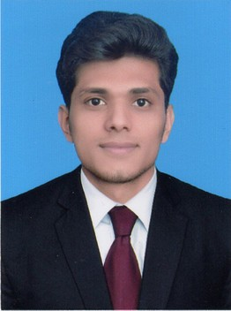 **Muhammad Abdul Rehman Shah**

Email**:abdulrehmansyedc5000@gmail.com** Phone**: +92 308454435**

**Address: House no.22, St No.02, Gulshan Farooq Park**

**Near Gulshan Park, Fateh Garh Road Lahore.**

**PERSONAL INFORMATION**

Father Name: Ilyas Hussain Shah

CNIC: 35200-9400294-5

Religion: Islam

Marital Status: Single

Languages: Urdu, Punjabi, English

**Career Objective**

I am an energetic and hardworking person aspiring to work in a challenging and dynamic environment. I want to transform my knowledge into valuable work experience to progress as a professional and contribute to the growth of the company.

**EDUCATION**

* 2018 B.E(Four year Bachelor of Electrical Engineering) H.U Complete

(Specialization in Electronics)

**(Pakistan Engineering Council Registration No. 80798)**

* 2014 DAE(Three Year Diploma of Electrical) I.E.T Complete
* 2011 Matric S.G.S Complete

**WORK EXPERIENCE**

* **IET Institute of Engineering and Technology**
* **Work as Electrical Instructor (One year 01-11-2015 to 01-11-2016)**
* **Umer & Company (Specialist In Panels)**
* **Work Experience (Three Year 28-11-2016 to 07-12-2019)**

**TECHNICAL COURSES / PROJECTS**

* Programmable Logic controller PLC(KICS,UET LAHORE)
* Auto Cad (6 month duration)

**INTERNSHIP**

* **PCSIR Laboratories Complex Lahore**

Center for the development of laboratory equipment (12 weeks duration)

**SKILLS**

* Electrical Drawings,Wiring
* Motor connection star delta and reverse forward
* Computer Skills: Basic
* Microsoft: Word, Excel, PowerPoint
* All Operating Systems (XP, Vista, 7), Internet and email usage

**STRENGTHS**

* Good in planning and execution of creative ideas
* Adaptive and quick learner
* Teamwork and leadership skills

**HOBBIES / INTERESTS**

* Playing Cricket, Learning computer skills, Reading Books

**REFRENCES**

* + Amir Munir
  + Editor in chief Jung News(+92 322-8046160)