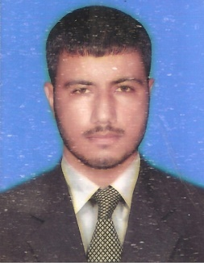

**Zain Ul Abideen Khan**

**ADDRESS: Mohalla Samal Khel City Daud Khel**

**Tehsil & Distt. Mianwali**

**Mob:🖁 +92- 301-3650509**

**Personal Information**

**Father Name : Safdar Khan**

**Date of Birth : 18-07-1991**

**N.I.C No. : 38302-4114317-5**

**Religion : Islam**

**Nationality : Pakistani**

**Domicile : Punjab**

**Marital Status : Single**

**Academic Programs**

|  |  |  |  |  |  |  |  |  |  |  |  |  |  |  |  |  |  |  |  |  |  |
| --- | --- | --- | --- | --- | --- | --- | --- | --- | --- | --- | --- | --- | --- | --- | --- | --- | --- | --- | --- | --- | --- |
| |  |  |  |  |  | | --- | --- | --- | --- | --- | | Degree | Session | Marks | Per/Div | Board/University | | Matric | **2008** | **670/850** | **1st div** | **BISE Sargodha** | | F.Sc | **2010** | **636/1100** | **2nd div** | **BISE Rawalpindi** | | B.Sc  (math,phy)  B.Ed | **2015**  **2017** | **366/800**  **536/900** | **2nd div**  **1st div** | **PunjabUniversity**  **AIO University** | |  |

|  |
| --- |
| **Msc Math is continue from Virtual University** |