**SHAKEEL SIDDIQUE**

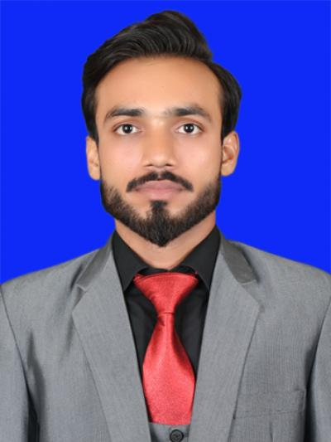

[ShakeelSiddiue2@Gmail.com](mailto:ShakeelSiddiue2@Gmail.com)

**Attari sarroba post office ismailnager**, +92-300-4949262

Lahore – Pakistan.

D.O.B: November 25,1992

Nationality: Pakistani

**Career Objectives:** I would dedicate myself towards the achievement of institute objective while being a part of it and would carry out my duties responsibility, while maintain excellent interpersonal relationships with my colligue.

**Academic Qualification:**

* M.PHIL in microelectronics engineering and semiconductor physics

University of the Punjab Lahore,Pakistan.

* B.S.C. (Hons) in Electronics  
  GC University Lahore, Pakistan.
* D.A.E. (Electronic)  
  Punjab Board of Technical Education Lahore, Pakistan.
* Matric

Lahore Board, Pakistan.

**Experience:**

**PAK Elektron Limited . June 06, 2016 – to July 18, 2016.**

Energy Meter Plant.

**Language Skills**

* I have good command on English.
* I can comfortably understand and communicate in Urdu & Punjabi.

**Computer Skills**

* Microsoft Office.
* Email.
* Operating Systems including Microsoft Windows.
* Can use different internet browsers including Internet Explorer,Mozilla Firefox.
* Familiar with Computer Hardware, Windows and Software installation.
* Internet Surfing
* Proteous
* Matlab
* Keil C51
* Electronic work bench
* C++