**URRICULUM**

**ITAE**

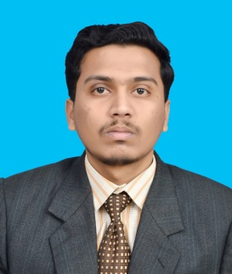

***OBJECTIVE***

Seeking a challenging position in a progressive organization with an aim to contribute positively towards the objectives of the organization to the best of my capabilities and to develop my professional skills with

constant learning.

***PERSONAL DETAILS***

Name : Muhammad Najam Butt

Father’s Name : Muhammad Shafi Butt

CNIC No. : 4110354287657

Date of Birth : 07-11-1995

Marital Status : Single

Nationality : Pakistani

Gender : Male

Religion : Islam

Address : House No.126/2, PAF Iqbal Camp, Lahore Cantt.

Email Address : Najambutt0567@gmail.com

Contact number : 03404110373 - 03004997633

***ACADEMIC QUALIFICATION***

BS Physics (2018) GPA:3.83 Lahore Garrison University

F.Sc (2014) 850/1100 Fazaia Inter College Lahore

Matric (2012) 921/1050 Fazaia Inter College Lahore

## ***EXTRA QUALIFICATION***

## REFERENCE

## REFERENCE

* Will Be Furnished Upon Request.
* Certification in Computer Foundation from Brain College Lahore.
* Certification in Spoken English from Brain College Lahore.

## ***SKILLS AND EXPERIENCE***

## REFERENCE

## REFERENCE

* Will Be Furnished Upon Request.

* Teaching experience of Home Tuition.
* Certificate for Participating in NUST INTERNATIONAL MODEL UNITED NATIONS 2016.
* Certificate of Achievement for Discipline Committee Member in LGU in 2017.
* Certificate for Member of Organizing Committee in 1st IPC in 2018.

## ***REFERENCE***

## REFERENCE

## REFERENCE

* Will Be Furnished Upon Request.
* Will be furnished upon request.