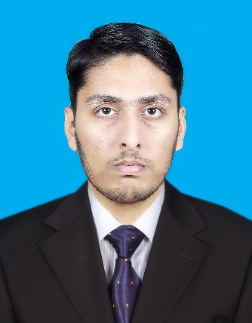

Fakhar Yasin

**Address:** **Ali town, RS boys hostel, in front of university of Lahore.**

**Mobile**: **0307-4107118**

**E-Mail:fakharyasin786@gmail.com**

**Objective:**

To continue to learn and develop my organizational skill within an organization that provide challenge at a respective level and opportunities to progress through hard work and convert my theoretical knowledge into practical.

**Personal Details:**

|  |  |
| --- | --- |
| CNIC # | **31101-5638592-1** |
| Date of Birth | **04-06-2000** |
| Father’s Name | **Muhammad Yasin** |
| Domicile: | **Bahawal Nagar (Punjab)** |
| Marital Status | **Single** |
| Nationality | **Pakistani** |
| Religion | **Islam** |

**Educational Qualification:**

|  |  |  |  |  |
| --- | --- | --- | --- | --- |
| **Degrees** | **Passing Year** | **Marks** | **Division** | **Name of Board/University** |
| **Matric** | **2014** | **836/1050** | **1st** | **FBISE Islamabad** |
| **F.Sc Medical** | **2016** | **748/1100** | **1st** | **BISE Bahawalpur** |
| **BSc** | **2018** | **501/800** | **1st** | **IUB Bahawalpur** |
| **Msc** | **continue** | **Cgpa(3.75)** | **2nd psoistion** | **University of Lahore** |

**Managerial Skills:**

|  |  |
| --- | --- |
|  | * **Good interpersonal skills, Good commutation skills** * **Ability to handle multiple tasks, Reading Books** |

**Languages:**

|  |  |
| --- | --- |
|  | **English, Urdu, Punjabi** |

**Experience ne:**

|  |  |
| --- | --- |
|  | **02 Year Teaching Experience in Faizan Science Academy(BWN)** |

|  |  |
| --- | --- |
|  | **02 Year home-tution experience in BahwalNagar** |