Maira Israr

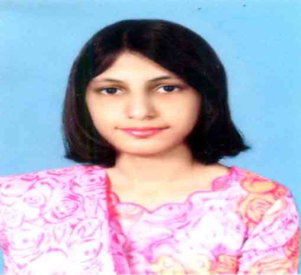

Email ID:[mairaisrar50@gmail.com](mailto:mairaisrar50@gmail.com)

Mobile no: 0302-8447704

N.I.C: 35202- 7778139-6

Address: 650-L- Johar Town, Lahore

## ---------------------------------------------------------------------------------------------------

Objective**:**

To obtain job to enhance my skills in the field of community services.

Qualification Summary:

* Masters in public administration from University of Management and Technology (2013-17)
* BS (Hons) in political science from Lahore College from Women University (2009-13)
* Intermediate in Arts from Lahore College from Women University
* (2007-09)
* Matriculation in Arts from The Educators (2005-07)

Skills:

* Computer Skills (Microsoft word and PowerPoint)
* Communication skills

Abilities:

* Ability to work independently or as part of a team
* Proven leadership skills and ability to motivate

Pre- Professional Experience:

* **Internship at Care foundation (NGO)**

Work in Library Department

* **Internship at Children Hospital**

Work in their administrative Department

# Professional Experience:

1.3 years teaching experience at American Lyceum International School

Certification:

* Character Certificates
* Internship Certificates
* Two Certificates of Course Completion in Global Health. USAID
* Certificate on Workshop CV writing

Reference:

Will be provided upon request