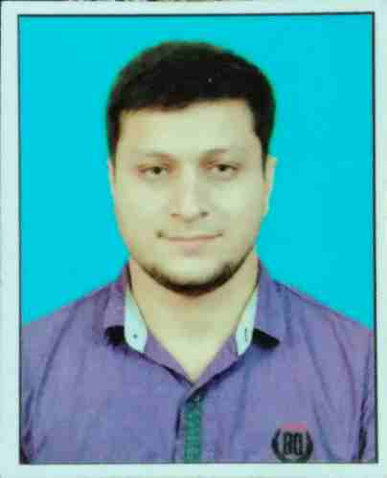SHAMOON BASHIR

HOUSE NO:33-A BLOCK, KEMC HOUSING SOCIETY

Defence Road Lahore

Cell No: 0304-0420556

Email: [Shamoon521@yahoo.com](mailto:Shamoon521@yahoo.com)

**Applying for the post of Admission Officer**

**Education:**

* GC University, Lahore
* Completed B.A (Hons) in Philosophy for the session 2009-13.
* Major – Philosophy CGPA 2.78/4.00
* Subsidiaries – Political Science and History

**B.A(Hons) Thesis:**

**Title: Hegel’s Theory of State**

* Board of Secondary Education, Lahore
* HSE Examination, `B` Grade, August 2009
* F.A(Arts) Group – Statistics, Economics, Civics
* GC University, Lahore
* Board of Secondary Education, Lahore
* SC Examination, `A` Grade, 2007
* Humanities Group – General Science, Islamiat Elective, Punjabi
* Private Candidate
* **Other Qualification**
* 4 Month basic HSK level-1 Chinese language course
* 2 Month Certificate in **‘‘**IMPORT EXPORT PROCEDURE & DOCUMENTATION**’’**
* 6 Month Certificate in Computer Course

MS OFFICE

EXCEL

POWERPOINT

* **Experience**

Fresh Candidate

* **Interests:**
* Politics
* Current Affairs
* Sports

FINISH