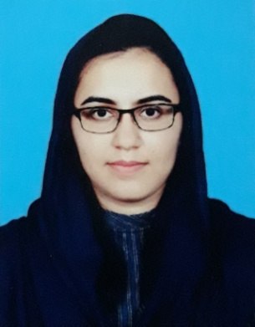

CONTACT

PROFILE

IQRA MUJAHID

Highly motivated, as being a quick and productive learner, to work in Accounts & Finance department of competitive business organization.

 0332-4130649

 [iqra.mujahid13@gmail.com](mailto:iqra.mujahid13@gmail.com)

 House Number 292, block 4, sector A2, Township, Lahore.

* University of the Punjab (2016)

**Master’s degree Commerce**

* University of the Punjab (2012)

**Bachelors of Commerce**

* Kinnaird College for women (2010)

**Intermediate General Science**

* The Punjab School (2008)

**Matriculation Science**

* CTTS, Johar Town, Lahore (2019)

**Professional cooking diploma**

* 2019

Maribelle Restaurant, Lahore

Commis chef 2 (Three months internship)

* 2017

Coral Enterprises Ltd.

Sr. Sales Coordinator

* 2016

PakTurk International schools and colleges

Substitution teacher

* 2014 – 2016

EPIC School of Contemporary and Islamic Studies

Mathematics teacher middle Section

* 2012-2014

Al_Aꞌlā International Islamic School

Mathematics teacher middle section

* Learning more about my interests
* Socializing
* Free education for deserving students
* Badminton
* Name : Iqra Mujahid
* Father Name : Mujahid Ali
* Nationality : Pakistani
* Domicile: Punjab
* Date of Birth: 06.06.1992
* Language : English / Urdu

I am an honest, focused and vigilant individual who works with effective dedication and strong commitment to bring fruitful outcomes of the set targets.

BELIEVE – WORK – CHANGE

* MS office

( Word, Excel, PowerPoint, Outlook)

* InPage
* Interactive white boards and tablets
* Internet Surfing
* ERP Accounting

QuickBooks, Excel

* Spoken English (2008)
* Qasr e Behbood Institute for women
* Pakistani cuisine (2008)

Qasr e Behbood Institute for women

* Computer Information & Technology (IT Basic)

From Citizen College of Computer Sciences (2010)

* Effective Classroom Management & Teaching Strategies (2013)

By paramount publishing Enterprises

* Effective Teaching Strategies

By Ali Institute (2013)

AIE



Technical Knowledge

ABOUT ME

Workshops & Trainings

CoralSweetCoralSweet

Professional Work History







HOBBIES

EDUCATION