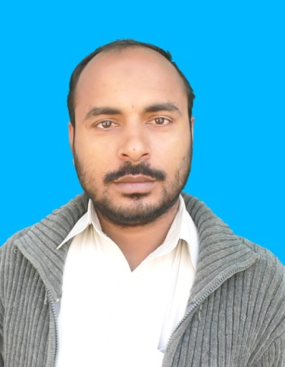

**PERSONAL STATEMENT:**

***I*** *am confident and enthusiastic person with the ability to learn and adopt quickly new challenges and to handle difficult situation under pressure. I have an organised approach with good communication skills, which enables me to work effectively either on my own or as a part of the team.*

**ACADEMIC PROFILE:**

|  |  |  |  |
| --- | --- | --- | --- |
| Exam | Year | **Marks Obtained** | **University / Board** |
| **SSC** | **2013** | **792/1050** | **BISE BANNU** |
| **FSc** | **2015** | **763/1100** | **BISE BANNU** |
| **BSc** | **2017** | **388/550** | **UST BANNU** |

**PROFESSIONAL QUALIFICATION:**

* CT FROM AIOU ISLAMABAD
* PTC FROM AIOU ISLAMABAD.
* D.I.T FROM KPKBTE PESHAWAR.
* RAC COURSE (REFEREGERATION AND AIR CONDITION) FROM NAVTTC PESHAR (PMYDC).
* ACCOUNTING AND BOOK KEEPING FROM NAVTTC PESHAR (PMYDC).
* HAFIZ-E-QURAN AND QARI FROM WIFAQ UL MADARIS PAKISTAN.

**EXPERIENCE:**

* 02 YEARS EXPERIENCE AS A OFFICE ASSISTANT IN A.K GROUP OF SERVICES DEANS PLAZA PESHAWAR.
* 04 YEARS EXPERIENCE IN BHU BADA MIR ABBAS MANDAN BANNU AS A POLIO WORKER (TEAM LEADER & TEAM MEMBER, ASSISTANT) IN IPV.

**LANGUAGES:**

PASHTO. ENGLISH. URDU.

|  |  |
| --- | --- |
| **CURRICULUM VITAE** |  |

#### 

##### KALEEM ULLAH KHAN

S/O

# SYED REHMAN

D. O. Birth **:** 10/04/1997

N. I. C. **:** 11101-9165931-3

Nationality  **:** Pakistani

Marital Status: SINGLE

Domicile **:** Bannu (KPK)

UC : MANDAN

Religion **:** Islam

Mobile **:** +92-331-9174474

**Permanent Address:**

VILLAGE GARHI MIR ALAM UNION COUNCIL MANDAN P/O BADA MIR ABBAS MANDAN DISTRICT BANNU KPK PAKISTAN