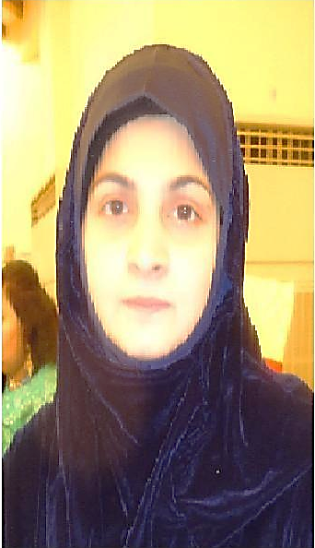 ***Asma Kiran***

*House # 6 Al Qadri Street, 113.Allama Iqbal Road Garhi Shahu, Lahore*

*asmakiran9182@gmail.com dimkiran@gmail.com*

*Contact: 0321-8055551 Whtsap: 0332-4237447*

*.*

***Profile:***

***My professional objective*** *is to secure a challenging position in the field of Islamic Studies which will utilize my qualifications, past experience and passion to share my knowledge through teaching. Trying my level best to learn* ***Quran*** *and* ***Arabic*** *then using my skills and capabilities to transmit that knowledge to others in order to become the best as per our beloved* ***Prophet’s*** *SAW saying:*



* ***Personal summary-*** *As a whole I earned* ***17 years*** *work**experience consisting of teaching & managerial responsibilities. Have been serving as a lecturer at leading academic institutions in different cities of Pakistan teaching students from various social and cultural backgrounds. Got various awards and certificates for dedication, hard work, & management.*
* ***Personal Volunteer Project :***

*Have been delivering lectures related to Quran in different schools and colleges aiming to reconnect our future generation with Allah and His Word in order to secure our values and inculcate moral principles in them. Also used to explain Quranic Surah at Liberty Park for ladies during my routine visits of morning walk. Taking online class of Arabic Grammar via skype.*

*With the blessing of Allah, started a YouTube Channel in 2015 with the help of my son, keeping in view to leave a source of useful information as a Sadqa-e-Jariya. It’s been titled as “Circle of Islam” having Lessons of Basic Arabic Grammar, Quranic Stories, Duas, Lectures of Surah’s translation and brief analysis etc.*

***Career History***

***Pak-Helpline NGO (Nov 2018-Feb2019)***

*Served as a* ***“Trainer/ Instructor”*** *for teacher {Arabic Grammar}.*

***Ali Garh College for Women (Oct 2007-2012 & 2015-2016)***

*Contributed as a* ***“Lecturer”****.*

***University of the Punjab (July’2007-Feb’08)***

*Appointed as an* ***“External Examiner”*** *of the M.Sc. Home Economics (Clothing and Textiles Industrial Management)*

***University of Agriculture FSD. (Aug 2001-Feb 2003)***

*Served as a* ***“Lecturer”*** *and* ***“Asst. superintendent”*** *of the Girls’ hostel.*

***Academic Accomplishments***

*M.A Islamic Studies Ist Div.* ***2017*** *University of the Punjab.*

*Arabic Grammar course Basic* ***2015***  *Khuddam-ul-Quran Institute Faisalabad.*

*Quran in-depth Study Course* ***2015***  *International Islamic University Islamabad.*

*Quranic Stories Course* ***2015*** *International Islamic University Islamabad.*

*M.Sc. Textiles Ist Div.* ***1999*** *University of the Punjab.*

*B.Sc. Home Economics* ***1997*** *College of Home Economics Gulberg, Lhr.*

*Matriculation Ist Div.* ***1993*** *P.R. Lady Griffin Girls High School, Lahore.*

***Systems knowledge & skills***

*Proficient with E-Commerce, Microsoft Word, Excel and Power point, Corel Draw. Have expertise in preparing and analyzing reports /data for management in a presentable and timely manner.*

***Language Skills***

*Well-versed and**Fluent in English / Urdu, Verbal command on Punjabi and Basics of Arabic.*

***Awards & Certificates***

* Completed a Training Course on **“*Effective Teaching*”** at the University of Agriculture Fsd.
* Received ***Maximum Attendance Certificate*** at College of Home Economics Gulberg, Lahore.
* Won the prize for ***Best Management*** in a competition of the hostels at the University of Agri Fsd.
* Nominated as a member of ***Best Sourcing team of JCPenney Purchasing Corp 2007****.*
* Awarded with a certificate of ***Appreciation for Hardwork and Dedication in 2006 at JCP****.*
* Got **First prize for Table Tennis,** 2nd for **Badminton and** forth for **Flat race, Long Jump**

and **Discuss throw.**

***My Publications***includes three research papers and two books;

*“Factors affecting the change in the clothing patterns of adolescent girls” (International Journal of Agri & Bio 2002)*

*“Relationship of Study Habits with the educational achievements” (International Journal of Agri & Bio 2002)*

*“Environmental crisis and its solution in the light of the religious teachings”(NS Religion-Science Interaction 2002)*

*Book of* ***“Arabic Alphabets with Words from Quran”*** *along with ayah ref. for kids and beginners. (2017)*

*Book titled as* ***“Sibga Tul Allah”*** *containing basic information about Quran Surah’s highlighting Do’s & Don’ts mentioned in each individual Surah for practical implementation in one’s life. (Started in 2017 yet to complete)*

***Non-teaching Experience***

**JCPenney Purchasing Corp. (May 2005-To 2016)**

Served as a Quality Co-ordinator

**Leisure Club (Bareeze’) (April 2003-March 2005)**

Worked as a Fashion and Textile Designer

**The Punjab College of Commerce/ Law (May 2000-July 2001)**

Employed as an Administrator.

***References*** *Can be furnished on request.*