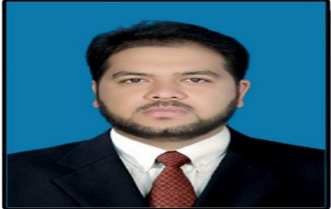CURRICULUM VITAE

**ZEESHAN NASEEM**

Cell: **+92 320-4774-363**

Email**:** [**iishaan77@gmail.com**](mailto:iishaan77@gmail.com)

**Address: House No. 16 Makki Homes Zaildar Road Ichra Lahore.**

**Profile:**

**To seek a challenging career oriented employment in a reputed organization to invest all my professional expertise and educational qualifications to facilitate career growth.**

# Personal Details:

|  |  |
| --- | --- |
| Father’s Name | M.Naseem Zahid |
| Date Of Birth | 16-05-1991 |
| Material Status | Married |
| Religion | Islam |

**Education:**

|  |  |  |
| --- | --- | --- |
| **Degree** | **Major Subjects** | **Board/University** |
| **M.Sc.** | **Mathematics** | **Bahauddin Zakariya University Multan** |
| **B.Sc.** | **MathA+B, Phy.** | **Bahauddin Zakariya University Multan** |
| **F.Sc** | **Pre-Engineering** | **Board of intermediate and Secondary Education Dera Ghazai Khan** |
| **Matriculation** | **Physics, Chemistry, Biology,Maths** | **Board of intermediate and Secondary Education Dera Ghazai Khan** |

Professional Certifications:

|  |  |  |
| --- | --- | --- |
| Certificate | Major | Organization/ Institute |
| MCSE (Microsoft Certified System Engineering) | Networking | Punjab University College of Technology Lahore |
| First Aid | Basic First Aid | Pakistan Red Crescent Punjab Head Quarters Lahore |
| Teaching Skills | Methodology and Teaching skills | Oxford University Press Pakistan |
| Teaching Skills | How to teach Effectively | Paramount Books |
| Self Defense | Basic Martial Arts | ASF Public School Lahore. |

Professional Experience:

* 3 Years Teaching Experience as a Science Teacher in The Educators (Project of Beacon House) Multan Campus.
* Serving as a Senior Section Head in Airports Security Forces Public School Lahore Campus Since 2017.

ICT Skills:

* Microsoft Office
* Networking
* Email

LANGUAGES:

**Proficiency in,**

* **English, Urdu, Punjab**

REFERENCE:

* **Will be furnished on demand**