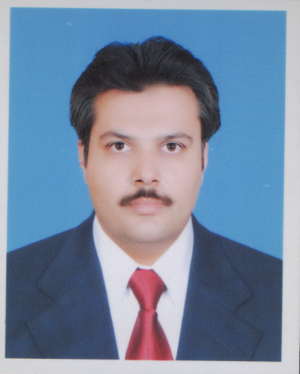

**MUHAMMAD AMIR**

**Address: -** House no 2 mor sao wari Shalimar link road mughal pura Lahore.

**Phone no.** +92 426880742, +923004132362’ +923354132362

**Email Address: -** [amirakbar_78@yahoo.com](mailto:amirakbar_78@yahoo.com), amirakbar090678@gmail.com

**Professional Profile**

An inspiring, self-motivate and dynamic senior teacher with experience in teaching all primary years. With a strong awareness and passion for students learning and development, I enjoy being part of and encouraging inclusive education and promoting good positive learning techniques. Possesses exemplary planning skills and accustomed to operating under considerable pressure, remaining calm and effective and prioritizing wisely. I have always had a passion of teaching and geared my studies and career in this direction as I feel it is extremely valuable to be helping students develop skills they can continue to use throughout their lives.

No looking for a position within an exciting, proactive school where I can contribute to the curriculum, work alongside colleagues and School Boards in order to develop resources for the school.

**Personal Information**

Father Name Muhammad Akbar

DOB 9th June 1978

Nationality Pakistani

Religion Islam

Marital status Married

N.I.C no 35202-3161814-5

Mailing Address House # 2 Mor Sahowari Shalimar link road Mughal

Pura Lahore.

Passport No DW1228141

Contact No. Home 04236880742

Mobile 03004132362, 03354132362

E mail Address [amirakbar_78@Yahoo.com](mailto:amirakbar_78@Yahoo.com)

[amirakbar78@hotmail.com](mailto:amirakbar78@hotmail.com)

[amirakbar090678@gmail.com](mailto:amirakbar090678@gmail.com)

**Education**

M.Phil Chemistry, 2008 1st Div

*Institute of Chemistry University of the Punjab Lahore*

M.Sc Chemistry, 2002 1st Div

*Institute of Chemistry University of the Punjab Lahore*

**Other certificates**

* Achieving Managerial Excellence
* Am I Communicator If Not Why
* Effective Presentation
* Effective Communication
* HSE awareness sessions

**Key Skills & Expertise**

* Experienced at planning/organizing lesson plans
* Passionate about teaching and student’s development
* Excellent knowledge of chemistry subjects
* Experienced in carrying out all the duties associated within the senior teacher role
* Develop lessons plans within the curriculum objectives.

**Career summary**

* Taking responsibility to help children develop key skills.
* Developed creative and imaginative projects for the class to participate in.
* Provided regular feedback to parents and careers regarding work and behavior in class.
* Successfully motivated children with different techniques.
* Confidently attended review meetings.
* Taking and active interest in keeping up to date with changes in the curriculum.
* Looking at each child’s way of learning and developing learning plans around that to help them gain the best in education career.
* Gain knowledge and understanding of personalities within the classroom, preventing any issues becoming serious problems such as bullying.
* Communicating well with all pupils, ensuring them they speak to me if they have any worries at all.

**Knowledge/Skills/Abilities**

* Basic laboratory techniques like, separation, distillation, titration, TLC, chemical handling etc.
* Complete command on Microsoft Office, windows installations, Computer Hard ware software installation and Networking.
* Research work on Pour point depressant, emulsifiers, and reclamation and characterization of used lubrication oil.

**Experience**

* Excellent command on matric subjects (Chemistry, Biology) basic concept development to develop interest of student in subject.
* 10 years’ experience in teaching F.Sc (Pre medical) at both Colleges and academy’s.
* 5 years teaching experience at O/A level Chemistry special expertise on past papers solutions with basic techniques involved.

**References**

Available upon request