R

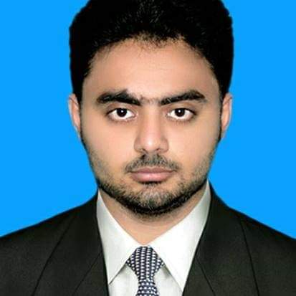esume

**MAILING ADDRESS:**

Mohalla Qureshian Wala Ward No 10 Near Masjid Muhammadi

Tehsil Shorkot City District Jhang:

Cell # 0307-6121958

E-Mail: [ikramnawaz155@yahoo.com](mailto:ikramnawaz155@yahoo.com)

**CAREER OBJECTIVES:**

To commence my career with an organization this provides a congenial work environment and an atmosphere conducive to learning and career progression.

**ACADEMIC QUALIFICATION:**

|  |  |  |  |  |
| --- | --- | --- | --- | --- |
| **Diploma/Degree** | **Major Subjects** | **Division/Grade** | **Passing Year** | **Board** |
| B.Com | Commerce | 2nd/B+ | 2015 | PU Lahore |
| I.Com | Commerce | 1st/A | 2013 | BISE Faisalabad |
| Matriculation | Science | 1st/A+ | 2011 | BISE Faisalabad |
| Diploma in Office Management | IT | 1st/A+ | 2013 | TEVTA Lahore |

**PROFESSIONAL EXPERIENCE:**

* Worked as “Train Manager” in S Jameel & Co from August, 2016 to August, 2019.

**MAJOR RESPONSIBILITIES:**

* Makes sure that the train is in compliance with all orders, signals, rules, and regulations.
* Inspects the equipment on coaches before departure to make sure everything is in good working order.
* Receives and transmits information via the radio or telephone to other conductors or stations.
* Plays a pivotal role in the safety of both passengers and bystanders.

**INTERPERSONAL SKILLS:**

* Proficiency in the use of information technology software tools e.g Ms Office, Ms Excel, Web surfing and Installation & In page.
* Good leadership, communication & interpersonal skills.
* I can effectively lead and monitor team with expert conflict resolution skills.
* I can prepare ledger, all type of vouchers, bank reconciliation and well know how about Trading P& L A/c, Income Statement and Balance Sheet.

**PERSONAL PROFILE:**

Full Name Ikram Ul Haq Father’s Name Muhammad Nawaz Date of Birth 10-04-1996 CNIC # 33203-4587504-9 Marital Status Single Religion Islam Domicile Jhang (Punjab)

**LANGUAGES:** Urdu, English & Punjabi.

**REFERENCES:** Will be furnished on demand.