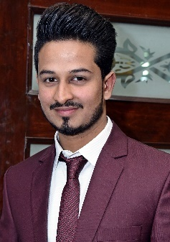**ALI UMAR**

**Contact:** 0323-4548546

**E-mail:** aliumar054@gmail.com

**Career Objective**

*To work in a reputable organization which provides me learning environment and opportunity to grow into a progressive professional way, and influence youth through teaching by imparting knowledge in creative ways and committed to excellence & destined to achieve high laurels****.***

**Personal Information**

|  |
| --- |
| **Date of Birth** February 20th, 1995  **Domicile** Punjab  **Residential address** House 192/7, Al-Karim premier housing scheme, Amir-ud-Din Park, Tajpura  Lahore cantt. |

**Qualification Level**

**BS Mass Communication**

CGPA 3.47

University of Sargodha (2015-19)

**Intermediate (ICS) *Computer Science, Mathematics, Physics (*2012-14)**

**1st Div.**

Govt. Islamia College Civil Lines, Lahore

**Matric Science *(2010-12)***

**1st Div.**

Faiz Foundation School Mustafa Abad Lahore.

**Experience**

|  |  |  |  |  |  |
| --- | --- | --- | --- | --- | --- |
| **Job Title** | **Institute** | | | **Subjects/Responsibilities** | **Duration** |
| Teacher | HUB Academy | | | English & Computer Science | March 2015 – October 2017 |
| News Reporter | | 92 News HD | News and events coverage | | July 2018 – January 2019 |
| Content writer | | WeSeoPro | Writing web based content | | December 2019 – January 2020 |

**Hand on Skills3**

|  |  |  |
| --- | --- | --- |
| **Skill** | **Skill Level** |  |
| MS Office  In page | Intermediate  Intermediate |  |
| Urdu Typing  English Typing | Fluent  Fluent |  |

**Languages**

|  |  |
| --- | --- |
| **Language** | **Proficiency level** |
| Urdu | Fluent |
| Punjabi  English | Fluent  Intermediate |

**References**

References will be provided if required.