file:///C:/Users f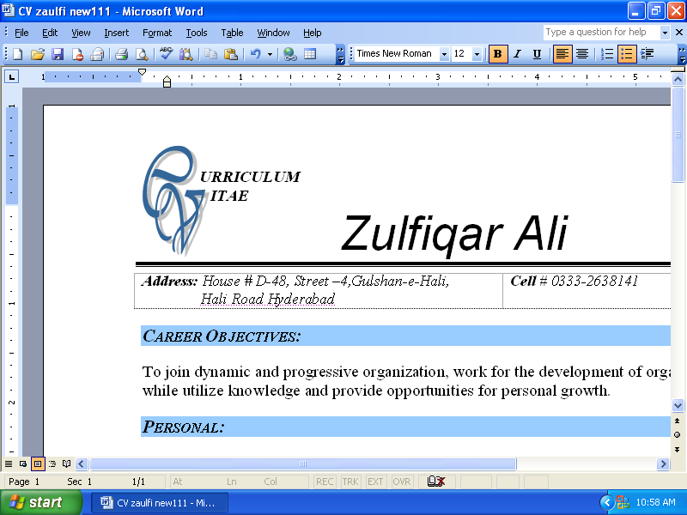



MEHAK SHEIKH

|  |
| --- |
| **Address:** House No 41 New Abadi Hurbuns Pura Lahore Pakistan  **Cell:** +92-307-4520858 and **Email**: [mehakmukhtar678@gmail.com](mailto:mehakmukhtar678@gmail.com)  **Personal Website:zindgiooppss.strikingly.com**  **LinkedIn:https://pk.linkedin.com/in/zindgioopps** |

**Career Objectives:**

* To obtain a position in the Human Resources field which allows me to apply my H.R. training and experience, and utilize my exceptional people skills. I would like to implement my innovative ideas skills and creativity for accomplishing the projects.

**Academic Qualifications:**

|  |  |  |  |  |
| --- | --- | --- | --- | --- |
| **DEGREE** | **MAJOR** | **INSTITUTE NAME** | **PASSING YEAR** | **GRADE /DIVISION** |
| **Master of Business Administration** | Human resource Management | Global Institute Lahore | 2011-2015 | GPA 3.64  A-Grade |
| **Bachelor of Commerce (IT)** | Commerce | Global Institute Lahore | 2009-2011 | A-Grade |
| **Intermediate** | Commerce | Govt. Islamia College Lahore Cantt | 2006-2009 | A-Grade |
| **Matriculation** | Science Group | Bukhari Model Girls High School | 2006 | A-Grade |

**WORKING EXPERIENCE:**

* **Teaching:** I.com, B, com, Nursery to 6th standard **.**Army school, trust school, Bukhari Model Girls High school and tuition 3 years.
* **Teaching 4 years to nursery and different classes Ali public high school**
* **Recruitment Assistant at** "**Passbaan Gas Tarder"**. Part time July 2013- Sep 2013.
* **Internship in the HR Department** Project **"Recruitment & Selection"** Feb 2014 to July 2014 at Qazi & Co an Enterprise.
* **Sales Executive** at "**Dawood Family Takaful Limited"** Aug 2014 to Aug 2015

|  |
| --- |
| Job Description: |

* Data collection
* Teaching, planning, coordinating learning activities
* Customer Dealing
* Prospect searching(CSR)
* Scheduling meetings
* Recruitment & selection
* Attendance management
* Plan, organize, control, monitor and review to achieve the target of assignment
* Manage reports and present summaries to management with suggested solutions.
* Tell employees about the risks and precautions involved in their work.

**PROFESSIONAL Trainings:**

* Takaful Foundation course at **Dawood family Takaful Ltd** (2014) got 2nd position.

**SKILLS:**

* Polite, respectful, and courteous manners.
* Versatile and multi-skilled person.
* Energetic; able to learn on own initiative.
* Proficient in the use of computers and Microsoft office.
* Excellent communication and inter-personal skills.
* Sensitive, caring and professional attitude toward staff.
* Work well under pressure to meet deadlines.

**INTERESTS:**

* Reading books, newspapers, magazines & research papers,socializing,net surfing, tour management, Online job portal, teaching

**LANGUAGES:**

* **English, Urdu, and Punjabi** Can communicate, read and write all the three equally well.

**Personal Information:**

* Name:Mehak Mukhtar
* Father’s Name: Sh. Mukhtar Ali
* Date of Birth: 09-09-1991
* CNIC.No: 35201-9587735-8
* Religion Islam
* Marital Status: Single
* Nationality: Pakistani
* Passport No. AQ0347351

**REFERENCES:**

* Available on request.