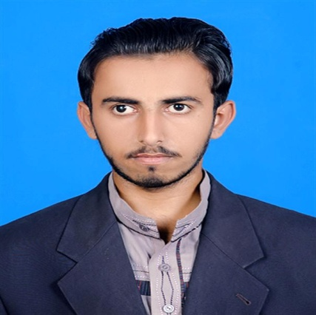

**FATEH MUHAMMAD**







**SKILLS**

 **0341-2931495**

**fateh.jarwar@gmail.com**



* **House# 702, Street# 11, Sector A, Akhtar colony, Karachi, Sindh, Pakistan.**

**CONTACT**

**COMPUTER SKILLS**

**Creative and resourceful in adapting instructional strategies to meet unique student needs. Design positive approaches and proactive interventions advancing learner engagement; academic achievement; cognitive development; and improvements.**

* **Good command of Office Automation Tools (Word™, Excel™ and PowerPoint™)**
* **Good command in using Operating Systems (Microsoft Windows)**

**Home Tutor**

 **Aug, 2017 – March, 2018**

 **Hyderabad**

## UNIVERSITY OF SINDH JAMSHORO

**BS in Sindhi** 2016 - 2019

**THE SZABIST IMC MIRPURKHAS**

**Intermediate** 2013 - 2015

**EXPERIENCE**

**EDUCATION**

**OBJECTIVE**