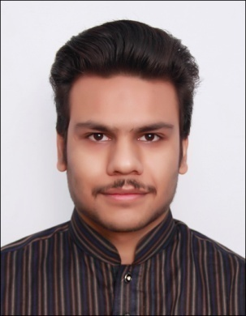 **Muhammad Jawad Ali, S/o**

**Engr. M Iqbal Hussain**

16 Rattigan Road, Near District Court, Bilal Gunj Lahore, Pakistan

Email: mjawadalishah@gmail.com

Contact No. +923216802939

**Date of Birth**: 13-09-1993

**ID**# 35202-1700378-7

|  |
| --- |
| Objective: |

Seeking a career-oriented position as a computer scientist in a dynamic organization where I can utilize and enhance my skills in the best possible way. I am able to fulfill the expectations of my owner.

|  |
| --- |
| Personal Profile: |

.

I am an energetic, enthusiastic person who has developed a responsible approach to any task. My career aim is to work within the field of **computer science,** willing to learn because I enjoy working with computers and enjoy this environment. As a graduate, I am good in communication skills and working with others to achieve certain objectives.

|  |
| --- |
| Educational Details: |

* **BS Computer Science (Final Project ongoing)**

University of South Asia (USA), Lahore, Pakistan

* **FSC** (Intermediate**) (2012)**

Punjab Group of College, Lahore

**Board of Intermediate Secondary Education Lahore, Pakistan**.

* **Matriculation** Science **(2010)**

Central Model School, Lahore, Pakistan

* **Certification** Web Development **(2018)**

Kicks University of Engineering & Technology, Lahore.

|  |
| --- |
| Expertise and Skills: |

* **Programming Languages:** Html5, CSS3, JavaScript, J Query, Bootstrap, PHP
* **Development Tools:** Visual Studio, Sublime Text, PhpStorm
* **Others:** Microsoft office (Certified)
* 5 months internship at Digital logix

|  |
| --- |
| Projects: |

* Kicks UET
* Customer Relations
* E book store, Shopping Mall, BlogApp, Kics UET.
* Internship in software house

|  |
| --- |
| Interests: |

* Graphic Designing
* Web Designing
* I have driving license of both M/Cycle and Car

|  |
| --- |
| Personal Information: |

* **Mobile cell#** +923216802939

**Muhammad Jawad Ali**

**BS Computer Science (Final Project Ongoing)**

**University of South Asia (USA)** Lahore Cantt Pakistan (campus)