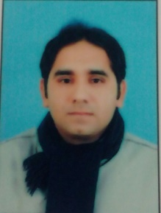

Shehzad Abbas

Islamic Centre, New Campus, Punjab University, Lahore.

DOB: Feb 12, 1987 **Cell No: 03336319884 Email:** [**shehzad.abbas80@gmail.com**](mailto:shehzad.abbas80@gmail.com)

**Objective:**

Committed to secure a high position through hard work and dedication in an organization I work for.

**Education:**

* MPhil in Pakistan Studies 2017

University of the Punjab, Lahore

* Bachelor of Education (B.Ed.) 2013

University of Education, Lahore

* Masters in History & English Literature 2012

University of Sargodha

* Bachelor of Arts (B.A) 2010

University of Sargodha

**Experience:**

I have been teaching English & Pak- Studies in different famous institutions since 2010.

* Lahore Garrison School & Shakar Ganj College Lahore (2010-2012).
* Ad hoc Lecturer ship in Islamabad Model College (2012-2013).
* Naeem Shah Academy, Lahore (2013-2014).
* Kips & Liaquat Foundation Institute, Lahore (2013- Till now).

**Achievements:**

* I have won the quiz competition at Punjab level held by PTV.
* I have also won the quiz competition at Federal level held by PTV.

**Additional Skills:**

1. Diploma in spoken English, good English writing and grammar skills.
2. Diploma in English Linguistics from Punjab University.**3.** Diploma in Computer Applications

**4.** I have good communication, analytical, problem solving and team leadership skills.