# Zahid Saleem

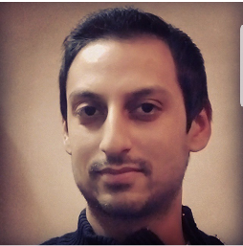**Phone No.** 03349736261

**Email address:** [zahidsaleem87@outlook.com](mailto:zahidsaleem87@outlook.com)

**Address:** 20E/2a Gulshan Park Mumtaz Street, Davis Road Lahore.

## **Career Objective:**

Seeking a career with a profession-oriented and civic organization that can provide the platform for becoming a well-recognized professional and ultimately attaining prestige and pride for myself.

## **Education:**

|  |  |  |  |
| --- | --- | --- | --- |
| **Degree** | **Year** | **Institution** | **CGPA/ Marks** |
| MBA | 2019 | UET, Lahore | 3.595/4 |
| BS (Hons.) Economics | 2016 | Forman Christian College, Lahore | 2.501/4 |
| A’ Level | 2007 | American National School, Lahore | 731/1100 |
| O’ Level | 2004 | Hamdard Public School, Lahore | 553/850 |

## **Certifications:**

2018 **HSK Level 1** Confucius Institute, China

2018 **Chinese Language Course**, Tevta Lahore

2018  **Freelancing Course,** Digiskills Pakistan

2018 **Digital Marketing Course,** Digiskills Pakistan

## **Professional Experience:**

2011 **Internship**

WWF- Pakistan Eco Internship

2008-19 **Teaching**

As home tutor (Grade 1 – 10)

## **Projects & Papers:**

* Free Trade and Economic growth.
* Financial analysis of Johnson & Johnson, Procter & Gamble and Unilever
* Consumer loyalty and Branding.
* Possible Risks threatening the Indus dolphin to extinction.
* Evaluation of Islamic Banking Products.

## **Computer Skills:**

1. Microsoft Office (Word, Excel, PowerPoint)
2. Eviews
3. SPSS

## **Awards & Merits:**

2005 University of South Asia Certificate of Merit.

2018 UET Lahore, Soft Skills Development Seminars.

## **Extracurricular Activities:**

2000-04 Consecutive Distinctions in Boy Scouts Association Lahore.

2019 Represented UET at MUN, Comsats Lahore.

## **Interests:**

Reading newspaper, Novels, Socializing and Sports.

## **Languages:**

English, Urdu, Punjabi, Chinese