**Muhammad Ismail Bahadar**

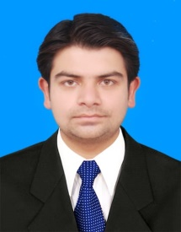

**Address:** Shahab Town Shezan Factory Bund Road, Lahore

**Email:** [bahadarismail@gmail.com](mailto:bahadarismail@gmail.com)

**Cell No:** 0301­-4559230

**Objective:**

Seeking a challenging career that utilizes my skills in my area of competence and enriches my knowledge, and gives me a chance to be part of a team that contributes towards the growth of the organization.

**Education:**

|  |  |  |
| --- | --- | --- |
| **Year of passing** | **Degree** | **Board/University** |
| 2017 | BBA (Hons) Marketing | University of the Punjab |
| 2012 | I.Com | B.I.S.E. Lahore |
| 2010 | Matric | B.I.S.E. Lahore |

**Skills:**

* Operating skills include operating Windows 7, Windows 8 & windows 10.
* Office skills include operating MS office word, MS office power point, MS excel
* Good interpersonal skill.
* Always willing to learn new things.
* Possess strong multitasking abilities to accomplish tasks in a busy environment or Able to effectively develop relationships.

**Experience:**

Secrecy Officer at BISE Lahore 2018-2019

**Certificate:**

**MS Office**

Establishment division, GOP

**Interest and Activities:**

* During my spare time I enjoy relaxing and going out with family and friends.
* Reading books and newspaper.
* Gardening.

**References:**

* References will be provided on demand.