Muhammad ‍‍Babar Qureshi

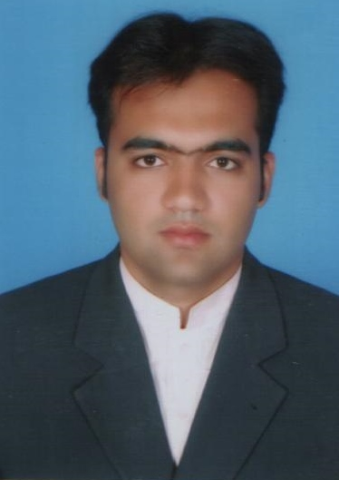

Buraydah Private Colleges, Buraydah, Al-Qassim | +968-9286-9198 | princebabar9@gmail.com

Objectives

I am a CELTA certified, self-motivated and ambitious teacher who believes in making the students appreciate the importance of English Language in our day to day life. I am looking for getting a job in an institution where my knowledge and experience may be exploited to the full extent.

Experience

Lecturer in English | buraydah private collges, ksa | 15-oct-2011 02-Jan-2020

* Preparing the students for IELTS Exam (General and Academic Modules) and train them for IELTS Exam in Buraydah Colleges
* Teaching Bachelors English and Preparatory Year Program (PYP)
* Teaching Reading, Writing, Grammar, Speaking

ielts administrator and invigilator | british council ksa, Kingdom of saudi arabia| june 2014 to January 2020

* Supervising the IELTS EXAM
* Conducting, managing and supervising IELTS Examination in Buraydah Colleges under British Council, KSA.
* Conducting the IELTS Exam and meeting the standards of British Council KSA
* Arrange exam venues and logistics in accordance with local requirements and Exams Quality Standards.
* Handling candidates’ registration, including certain processes of verification.
* Invigilating IELTS Exam

lecturer in English | acme college of excellence, pakistan | nov-2008 to june 2011

* Teach English course according to prescribed outlines and recommended books.

Education

CELTA | 2018 | University of Cambridge

* Certificate In English Language Teaching To Adults

M.Phil | 2013 | G. C. Universtiy faisalabad

* Major: Applied Linguistics
* Minor: Stylistics, Applied Linguistics, Phonetics and Phonology, Critical Discourse Analysis
* Related coursework: Research Methodology

Masters | 2008 | UNIVERSITY OF sargodha

* Major: English
* Minor: English Linguistics, TEFL

B.A English | 2004 | UNIVERSITY OF sargodha

* Major: English

Transferrable Skills

* Commitment
* Communication
* Computer Software Programs
* Team work

Skills & Abilities

* ELT, EFL
* Phonetics, Phonology
* Research
* Excellent abilities to use computer, MS Office, internet.

Communication

* Got 8 Bands in IELTS (General Training 2018).
* Got 7.5 Bands in IELTS (Academic 2013).

Languages

* English
* Arabic
* Urdu

REFERENCE

* Will be furnished upon request.