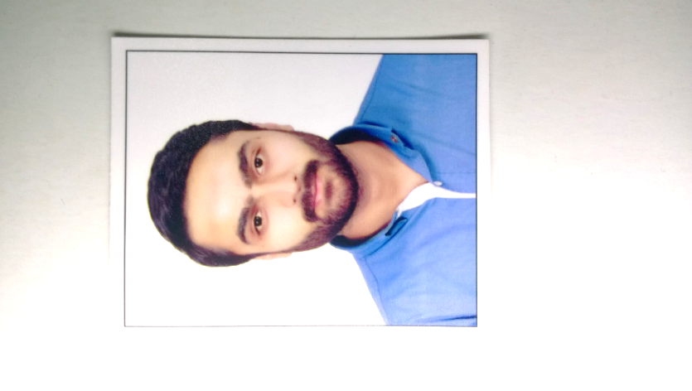

***USAMA BIN NAJAM***

**House# 94 D Sukh Chayn Gardens near Shahkaam chauk, Lahore**

**Mobile: 92-301-5541418**

**E-mail:**[**usamabinnajam@gmail.com**](mailto:usamabinnajam@gmail.com)

|  |  |
| --- | --- |
|  |  |
| **Career Objectives** | **Seeking career in a reputable organization to capitalize my knowledge and skills, by applying maximum devotion. To widen my horizon of knowledge, gain valuable experience. The hallmark of my career would be sincerity and honesty of purpose, professional approach and time bound results orientation with a view to achieve the organization goal.** |
|  |  |
| **Academic**  **Qualification** | **Diploma in Graphic Designing 2019**  **Erozgar**  **Bachelor in Sociology(Honors) 2017**  **Punjab University**  **Intermediate in Computer Sciences 2013**  **Matriculation 2011** |
|  |  |
| **Work Experience** | **KASHF Foundation July 13, 2016 to Aug 26, 2016**  **( Internship )**   * **Data analysis of different functions of Department regarding Punjab & KPK** * **Data Analysis on SPSS and MS-Excel** * **Generation of Report and Presentation Regarding Data Analysis** * **Searching of New Markets for Potential Clients**   **BRITISH COUNCIL PAKISTAN April 2015 to Till Date**  **(Invigilation at British Council Pakistan)**   * **Assist the VS staff unit** * **Customer care** * **Data validation** |
|  |  |
| **Skills** | * **IT Basic** * **MS Office** * **Microsoft Word** * **Microsoft Excel** * **Microsoft Power Point** * **Good Problem solving abilities** * **I believe in ‘Can Do’ attitude towards work** |
|  |  |
| **Languages** | * **English** * **Urdu** * **Punjabi** |
|  |  |
| **Personal Details** | **Date of Birth: 14-02-1993**  **Domicile: Punjab**  **Father Name: Najam-Ur-Rehman**  **Religion: Islam**  **Nationality: Pakistani** |
|  |  |
| **References** | **Reference will be provided upon request** |