***Curriculum Vitae***

|  |
| --- |
| **Muhammad Yaqub Saqib S/O Muhammad Iesa** |

|  |  |  |  |  |  |  |
| --- | --- | --- | --- | --- | --- | --- |
| **Contact & Address** |  | **Adda Peer Di Hatti Okara Road Depalpur.** |  | **0303-4422192**  **0312-4422192** |  | **mys.saqib@gmail.com** |

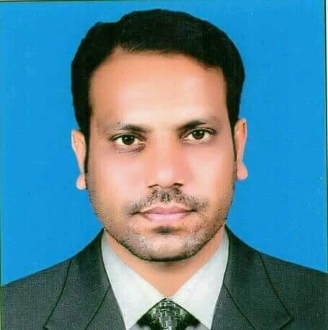

**Nationality :** Pakistani

**Sex :** Male

**Marital status :**Married

**Date of Birth :**03-10-1988

**CNIC No** :35202-4051355-9

|  |  |
| --- | --- |
| Qualification | **B.sc Mathematics (U.O.S)**  **ICS(BISE SAHIWAL)**  **Matric(BISE LAHORE)** |
|  |
| Experince | **2 Years Experience as Mathematic and Computer teacher in Empyreal Academy Okara Road Depalpur..**  **5Years experience as Home tutor.**  **2 Year Experience as Math teacher in Khan Public School Depalpur.** |
|  |
| Skills Gained | * **Ability to establish respect among other staff members.** * **Inspiring new staff.** * **Ability to create an efficient and friendly team.** * **Self motivated & initiative oriented.** * **Capable of handling challenging and difficult situations under pressure.** |
|  |  |
| Computer Skills | * **Microsoft Windows** * **Microsoft Office (Ms Word , Ms Excel, Ms PowerPoint)** * **Internet & E-Mail** |
| Multimedia Computer Skills | * **Adobe Photoshop 7.0** * **Corel Draw 9-12** * **Ulead Video 10** |
| Other Skills | * **Good command at English, Urdu, Punjabi** |
|  |  |