**RAKHSHANDHA HAFEEZ**

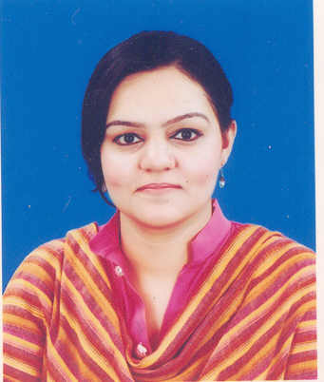H no 12-B Govt M.I.Happy High School Sanda Road National Town Lahore .

## Cell #:0306-4059683

E-mail:guddo_star@yahoo.com

## CAREER OBJECTIVE

To work for a reputed Organization which fosters a competitive environment and where personal

Growth and career enhancement is encouraged.

**PERSONAL INFORMATION**

* Father’s Name: Abdul Hafeez Khan Lodhi
* Date of Birth: 31-12-1988
* Religion: Islam
* Nationality: Pakistani
* Marital Status: Single
* Gender Female

**QUALIFICATION**

.

* Bachelor of Arts from Punjab University Lahore and obtained 2nd Division.
* D.D.M three years diploma with F.A from Poly Technical Institute for women Jain mandir, Lahore.
* Matric from Govt Madrasa Tull Banat High School 15 lake Road, Lahore.

**Experience**

* 3 years teaching experience in English & Urdu School.
* 6months experience at Ghazi Associate.
* 2 Years Experience as a Booking Officer in Deawoo Express.
* 1 Year job in Advertising Newspaper Agency as a Office Assistance & Coordinator.
* Training and Work as COR in Abacus Call Center Shaheen Complex.
* 2 Years Experience To Deal Local and Forigner Clients as a Telephone Operator and Receptionist in Associates House (Philippine Consulate ).

**Computer Skills**

* 4 Months Course Microsoft I.T Certification from GPTIW Jain Mandir Lahore..

**Interest**

**LANGUAGES**

* Reading Books
* News paper

**Other Skills**

* English Language Course in Numal University
* Chines Language Course in Govt Tavta Institute

**Key Skills**

* Extrovert
* Good Teaching Skills
* Polite in Nature
* Have Patience

**Key Qualification**

* Capable of developing and executing age specific hermetic lessons.
* Adept at incorporating activity based learning in subjects like mathematics, language and geography.
* Well versed in conducting all sensorial and paractical life exer4cises accurately.
* Adept at using bead material effectively
* Skilled in developing activity based lessons targeting development of adequate.social skills
* Utilized all age specific sensorial effectively
* Englis

**REFERENCE**

* Will be furnished on Request.