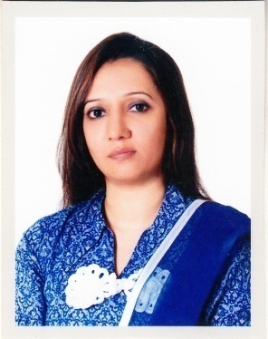

**Hadiqa Iqbal**

**Location:** Lahore, Pakistan

**Experience:** 11 Years

**Contact:** +92331-4337221/+92300-4441899

**CNIC:** 35202-2823101-4  
**Email:** hadiqa_111@yahoo.com

_____________________________________________________________________________

**CAREER OBJECTIVE:**

Seeking a position in an organization where my potential could automatically benefit other people, also provide me an opportunity for increasing levels of responsibility and professional growth to satisfy my flair of leaving

**CAREER PROFILE/SKILLS:**

* Ability to balance workloads efficiently and able to work in a constantly changing work environment
* Ability to maintain strict levels of confidentiality in handling sensitive information
* Flexible, willing to take on more responsibilities as needed and devote time necessary to compete deadlines
* Ability to handle difficult situations /clients with showing good hospitality as well as my working experience made me more professional, well groomed, well manners and professional attitude
* Good organizational skills to work under pressure and able to do multi task, coordinate multiple projects and meet deadlines under stringent time constraints, efficient and attentive to detail

**PROFESSIONAL WORK EXPERIENCE:**

**Organization: Housing Directorate, GHQ Rawalpindi**

(Construction / Engineering)

**Address:**  Al Sadaat Farooq Shaheed Road, Cantt Museum, Cantt Lahore

**Tenure:**  18th September, 2017 – Present

**Designation:** **Human Resource Manager**

**Responsibilities:**

* To assist in selection of suitable manpower
* Development of new policies and procedures for upcoming recruitments, extensions, promotions, increments, bonuses and termination as well
* Redefining of SOPs and policies
* Enable the organization to obtain and retain the skilled, committed and well-motivated workforce
* Assistant to PD housing directorate
* Co-ordinate to ADH (HR), staff officer and other higher management as well as co-employees
* Collection and analysis of CEs data of field setups
* Development of high-performance work system including crystallized recruitment, selection procedures, compensation system, management and training activities
* Training and linking of field officers of housing directorate
* Maintenance of Contract Employee’s data of Lahore sectors under Project Directorate Housing Complex Lahore
* Maintenance of Leave record of CEs
* Welfare packages for CEs
* Implementation and circulation of new policies issue by GHQ Rawalpindi
* Letter writing and drafting
* To arrange meetings and conferences
* To arrange interviews of candidates

**Achievements:**

* Established good working relationships with management, clients and co-workers
* Identified the problems of CEs, management and resolved them
* Actively contributed on team projects and HR projects
* Received awards/commendations from my management in a short time
* Improved customer services satisfaction
* Improve support service level with HR Sec, management and CEs as well
* Developed and implemented HR as well as customer services program

**Organization: Qashqai Iranian Restaurant**

(Food and Beverage)

**Address:**  Al-Muteena Road, Deira Dubai, UAE

**Tenure:**  8th January, 2017 – 20th May, 2017

**Designation:** **Receptionist cum Shift In charge**

**Responsibilities:**

* Customer greetings
* Taking care of VIP and VVIP customers with special services
* Calming and reassuring annoy customers
* Billing receipts
* Online orders and online promotions of new foods and deal of the day
* Coordinate to co-employees and management
* Taking feedback of customers

**Achievements:**

* Established good friendly and working relationships with customers and co-workers
* Improved customer service satisfaction
* Improve support service level with customers and co-workers as well
* Developed and implemented customer service program and promos
* Received performance bonuses based on good services from management
* Actively contributed on team work
* Contributed to outstanding customer service
* Identified the problems of customers & co-workers and resolved them effectively
* Received awards/commendations from my management in a short time

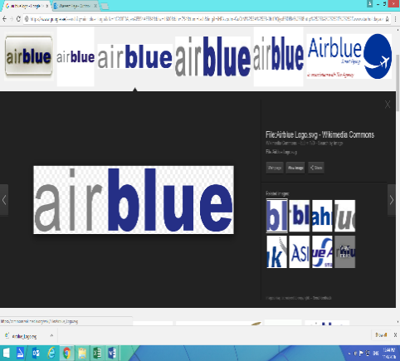**Organization:**  **Air Blue International**

(A private Pakistani Airline)

**Address:** Allama Iqbal International Lahore Airport

**Tenure:**  8th December, 2014 – 9th December, 2016

**Designation:** **Customer Services / HR Executive**

**Responsibilities:**

* Dealing with passenger enquiries about flight departures and arrivals
* Checking passengers in giving seat numbers
* Providing boarding passes and luggage labels telling
* Telling passengers about luggage restrictions.
* Weighting baggage and collecting any excess weight charges
* Taking care of people with special needs, and unaccompanied children
* Calming and reassuring nervous passengers
* Guiding passengers to the aircraft
* Making announcements for passenger information
* To assist in selection of suitable manpower
* Development of new policies and procedures for upcoming recruitments, extensions, promotions, increments, bonuses and termination as well
* Redefining of SOPs and policies
* Enable the organization to obtain and retain the skilled, committed and well-motivated workforce
* Assist and co-ordinate to higher management
* Collection and analysis of data of different setups as well as employees
* Development of high-performance work system including crystallized recruitment, selection procedures, compensation system, management and training activities
* Training and linking of employees and officers with management
* Maintenance of Employee’s data of Lahore sectors
* Maintenance of Leave record of employees
* Welfare packages for employees
* Implementation and circulation of new policies issue by higher management
* Letter writing and drafting
* To arrange meetings and conferences of officers and higher management
* To arrange interviews of candidates

**Achievements:**

* Established good working relationships with passengers and co-workers
* Improved customer services satisfaction
* Improve support service level with passengers and co-workers as well
* Developed and implemented customer service program
* Received annual performance bonuses based on solid evaluations from management
* Actively contributed on team projects
* Contributed to outstanding customer service
* Identified the problems of passengers & official matters and resolved them
* Efficiently resolved many passenger issues
* Received awards/commendations from my supervisors

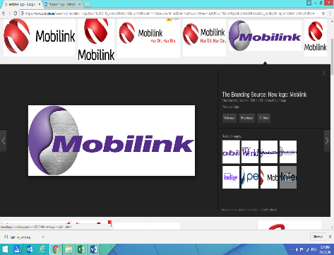**Organization:** **Mobilink Contact Centre**

(A trade name of Pakistani Tele Communications LTD)

**Address:** WTC, DHA Lahore

**Tenure:**  March 2010 to September 2014

**Designation:** **Customer Care/ HR Executive**

**Responsibilities:**

* To assist in selection of suitable manpower
* Development of new policies and procedures for upcoming recruitments, extensions, promotions, increments, bonuses and termination as well
* Redefining of SOPs and policies
* Enable the organization to obtain and retain the skilled, committed and well-motivated workforce
* Assistant and co-ordinate to higher management
* Collection and analysis of data of different setups as well as employees
* Development of high-performance work system including crystallized recruitment, selection procedures, compensation system, management and training activities
* Training and linking of employees and officers with management
* Maintenance of Employee’s data of Lahore sectors
* Maintenance of Leave record of employees
* Welfare packages for employees
* Implementation and circulation of new policies issue by higher management
* Letter writing and drafting
* To arrange meetings and conferences of officers and higher management
* To arrange interviews of candidates
* Assistant to QA department
* Assistant to GPRS department
* Assistant to In bond Helpline Department
* Assistant to 789 JSA/ 111 Multiple Queries

**Achievements:**

* Established good working relationships with customer and co-workers
* Actively contributed on team projects
* Contributed to outstanding customer service
* Efficiently resolved many customer issues
* Received awards/commendations from my supervisors

**Organization:**  **M. Hussain Gohar & Co**

(Tax Consultancy)

**Address:** Temple Road Mozang, Lahore

**Tenure:**  February 2005 – December 2009

**Designations:** **Office Assistant cum Accounts Assistant**

**Responsibilities:**

* Book keeping of Sales Tax & Income Tax prescribed records
* Preparation and filling of Sales and Income Tax Returns
* Preparation of accounts strategies

**Achievements:**

* Established good working relationships with clients and co-workers
* Contributed to outstanding customer service
* Identified the problems of organization and resolved them
* Actively contributed on team projects
* Received annual performance bonuses based on solid evaluations from management

**Academic Qualification:**

|  |  |  |
| --- | --- | --- |
| **Education** | **Institution** | **Year** |
| MBA | Virtual University, Lahore, Pakistan | 2013 |
| B.Com | Punjab University, Lahore, Pakistan | 2003 |
| Intermediate | Board of Intermediate & Secondary Education, Lahore | 2000 |
| Matriculation | Board of Intermediate & Secondary Education, Lahore | 1997 |

**Skills:**

* **MS Office** All versions, MS Word, MS Excel and MS Power Point
* **Internet & Email** Browsing & surfing
* **Languages** English, Urdu, Arabic & Hindi

**Certificate:**

* English Proficiency Certificate **(Virtual University)**
* Handling of Dangerous Goods Training **(Air Blue International)**

**Interest:**

* Book reading, writing & music

**Personal Information:**

**Father’s Name**: Ch. Muhammad Iqbal Punn

**Marital Status** :Single

**Religion** : Islam (Sunni)