**Ahmad Salman**

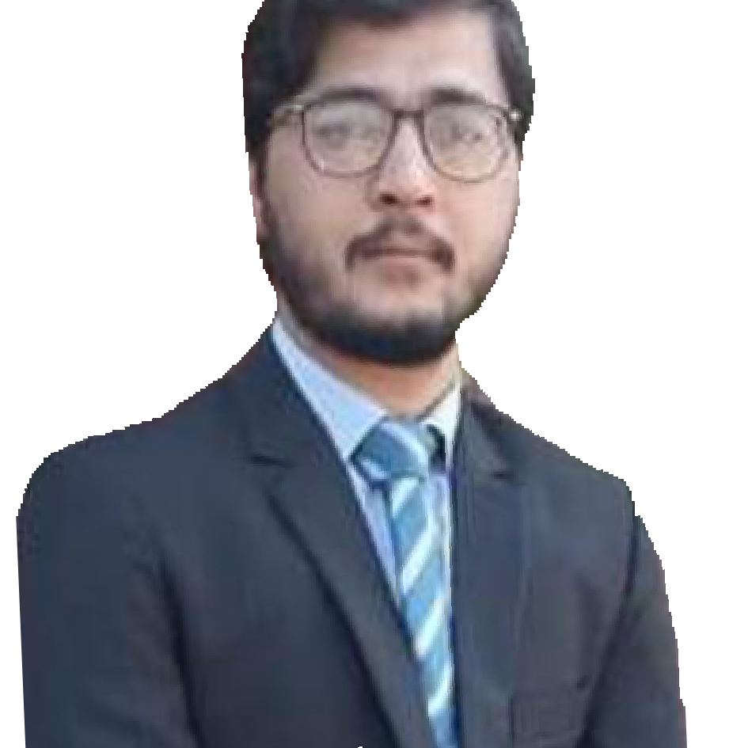

**Father’s Name:**

Hidayat Ullah Khan

**:** Bilal town near tableeghi markaz Lakki marwat.

**:** +92 3059375750

**:** Ahmadsalmanccj[@gmail.com](mailto:sidra_rana86@yahoo.com)

**CNIC No**:

11201-6758997-3

**Date of Birth**:

09th April, 1993

**Marital Status**:

Single

**Nationality**:

Pakistani

**Domicile:**

Sub Division Lakki Marwat (Khyber Pakhtunkhwa)

**References:**

Available on request

**All necessary documents will be provided on demand**

**Qualification:**

|  |  |  |  |
| --- | --- | --- | --- |
| **QUALIFICATION** | **YEAR** | **DIVISION** | **BOARD / UNIVERSITY** |
| **M.Phil. Biosciences** | **2019** | **1st** | **University of Wah Rawalpindi** |
| M.Sc. Botany | 2013-2015 | 1st | Quaid-E- Azam University Islamabad |
| B.Sc | 2011-2013 | 1st | University of Bannu K.P.K. |
| F.Sc (pre medical) | 2009-2011 | 1st | B.I.S.E Bannu. |
| SSC | 2007-2009 | 1st | B.I.S.E Bannu. |

**Experience (Academic):**

* Current Status: Science Teacher of Biology in Dar e Arqam School Shelley valley Range Road Rawalpindi. Principal Sir Irfan Malik 0515160095.
* 1.5 Years work as Lecturer of Biology in Cadet College Jhelum Pakistan. Teaches Biology to class 9th, 10th, 1st year and 2nd year. Boarding college. Principal **Major Raja Shahid**- 03345822217
* Two-year Experience as S.S. Biology at DPS&ICS Sahiwal Pakistan.

From 2016 to 2018 teaches Biology to class 9th, 10th, 1st year and 2nd year. Boarding college. Principal **Brigadier Syed Kermani** - 0404504664 Boarding college.

**Computer & Software Skills:**

* Microsoft Word, PowerPoint, Excel
* Basic statistical operations, Internet
* Windows, MS Project