**PROFILE**

**CURRICULUM VITAE**

0



**WEB PROGRAMING**

**Java / ADVANCE OPP**

**C / C + +/ C #**

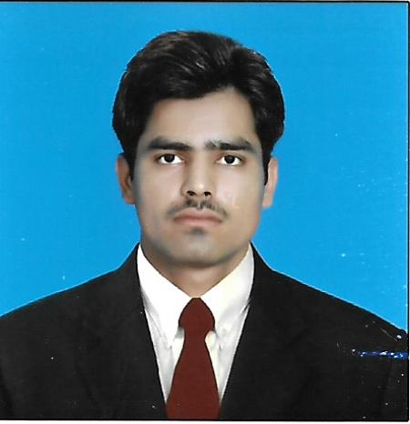

**2. Other**

**Looking for some suitable position in a reputable   
organization having attractive environment, prospects of growth and learning where I can effectively utilize my knowledge and skills.**

**BASIC INFORMARTION**

**CONTACT INFORMARTION**

**Operating System**

Will be furnished on Demand.

**PREFERENCE**

Online Learning

Creative Thinking High Self-esteem

The Internet Good Communication Skills

Media Productions Able to respect deadlines

Traveling Experience Good at team working

**SKILLS & INTERESTS**

1. English 2. Chinese

3. Urdu 4. Sariki

5. Punjabi

**LANGUAGE**

**1. Microsoft Office**

**COMPUTER SKILLS**

2017- Till Now Computer Operator

Youth Computer Bahawalpur

**WORK EXPERIENCE**

**YEAR MARKS INSTITUTE**

2017-2019 2.97/4.0 CGPA Master of Computer Science

Islamia University of Bahawalpur

2015-2017 399/800 Bachelor of Computer Science

Islamia University of Bahawalpur

2013-2015 600/1100 Intermediate (Pre –Engineering)

B.I.S.E Bahawalpur

2011-2013 836/1050 Matriculation

B.I.S.E Bahawalpur

**EDUCATION**

**Kachi Basti new Islami Colony Near City School Yazman Road Bahawalpur**

**Tehsil & District Bahawalpur**

**hussainaftab90@yahoo.com**

**+923443980586**

**FATHER NAME:**  AFTAB HUSSAIN

**NATIONAILITY:**  PAKISTANI

**BIRTH PLACE:**  BAHAWALPUR (PAK)

**DOB:**  04-04-1998

**CNIC:** 31202-4271692-7

**GENDER:** MALE

**CIVIL STATUS:** SINGLE

**AFTAB HUSSAIN**