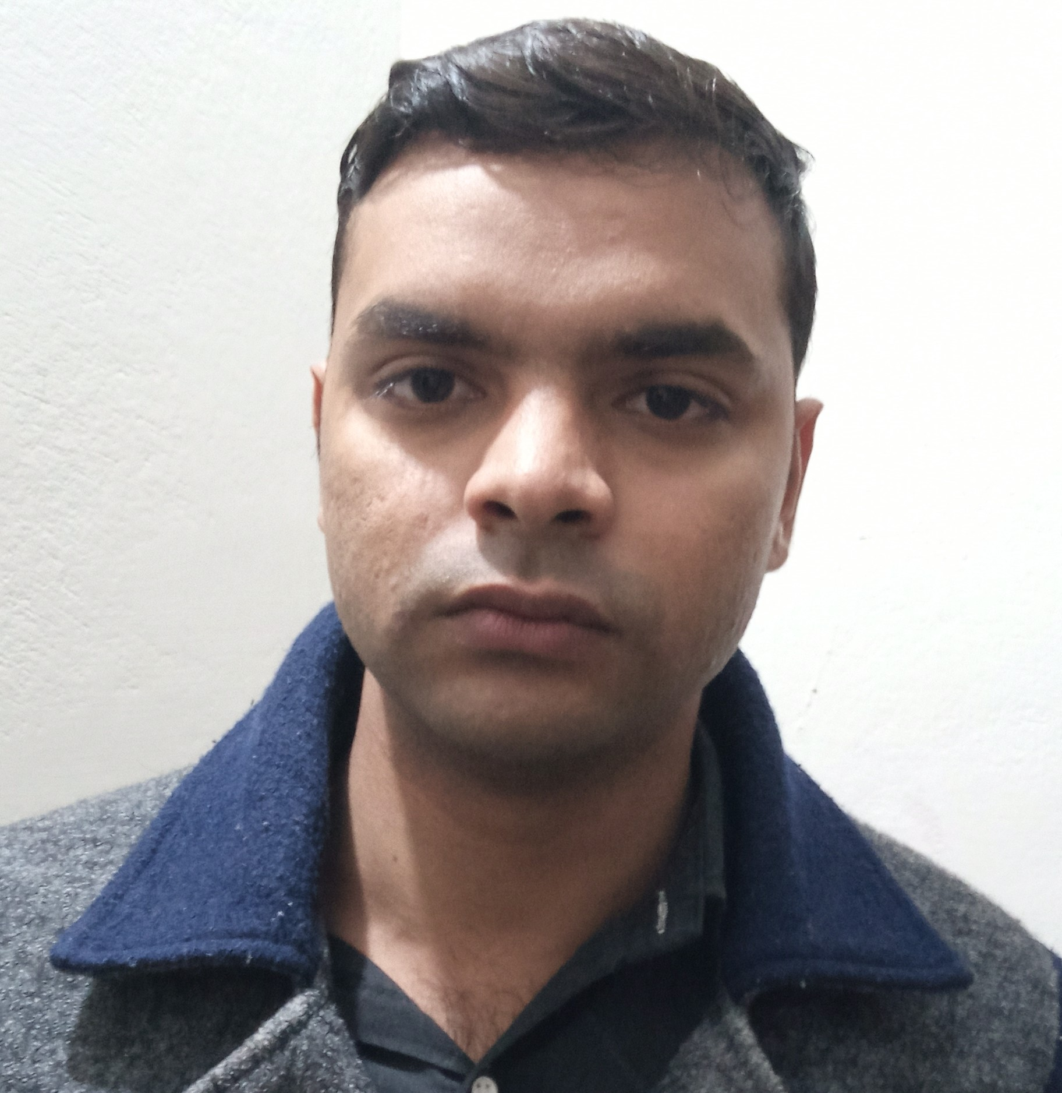

Contact

**Address:**

House # E-1175/A Street # 10 Block F Nishat colony Lahore cant.

**DOB:**

23/09/1995

**Phone:**

+923014053990

**Email:**

Nomansabirali517@gmail.com

Languages

Urdu - punjabi

English - Conversational

**Noman Ahmed**

Skill Highlights

|  |  |
| --- | --- |
| * Typing speed 25 wpm * Student satisfaction * Ms word 2010 * Ms Excel 2010 * Powerpoint 2010 |  |

Experience

* Teach in a cadet college sialkot
* Works as corporate clients.
* Works as a student coordinator

Education

PUNJAB UNIVERSITY

M.SC Mathematics.

PUNJAB UNIVERSITY

Bachelor of Science: Double Maths,Physics.

FEDERAL BOARD

F.SC

LAHORE BOARD

Matriculation

.DIPLOMA OF INFORMATION TECHNOLOGY(2015)

Hobbies

Researching

Internet browsing

Books Reading