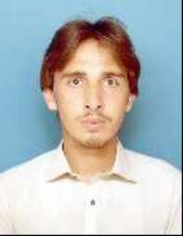

**PERSONAL BIO-DATA:**

* NAME : JUNAID IHSAN
* Father’s Name : ABUL IHSAN
* C.N.I.C No. : 11201-3577287-7
* Domicile : KPK
* Marital Status : SINGLE
* Religion : ISLAM
* Nationality : PAKISTANI
* Present Address : Hostel No. 4 QAU
* Email : junaidihsan580@yahoo.com
* Cell : 0342-9339936

**ACADEMIC QUALIFICATIONS:**

|  |  |  |  |  |  |  |
| --- | --- | --- | --- | --- | --- | --- |
| **Examination** | **Major Subjects** | **Passing Year** | **Marks** | **% age** | **Grade** | **Board/University** |
| S.S.C | Science | 2011 | 914/1050 | 87.04 | A1 | B.I.S.E Peshawar |
| F. Sc | Pre-Medical | 2013 | 915/1100 | 83.18 | A1 | B.I.S.E Peshawar |
| BS | Chemistry | 2017 | 3.80 | 94.2 | A1 | Islamia College University Peshawar |
| M.Phil. | Chemistry | 2019 | 3.6/4 | 80 | A | Quaid-i-Azam University Islamabad |

* ***Merit Certificate of Position holder in BS Chemistry*.**

**EXPERIENCE:**

* One semester Visiting Faculty at QAU
* Teaching at Peshawar Model Degree College.