|  |  |
| --- | --- |
| **CURRICULUM VITAE** | **AAMIR KHAN** |

**PERSONAL PROFILE**:

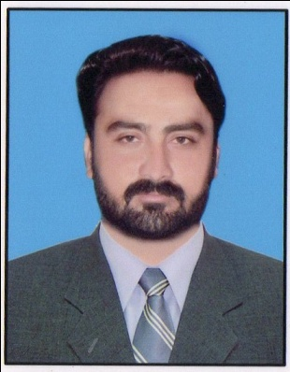Father’ Name Ghulam Muhammad Khan

**Contact:**

**Address:** Mohallah Salar , Shany Khel P.O Daud Khel Tehsil & Distt. Mianwali

**Mob:** 0300-2571938

**G-Mail:** Aamir.niazi0001@gmail.com

Gender Male

Date of Birth 05-04-1992

Religion Islam

Marital Status Single

Nationality Pakistani

CNIC NO. 38302-9184378-9

PEC REGISTRATION NUMBER: ELECT/78233

**ACADEMIC QUALIFICATION**:

Passing Year Degree Specialization Institute / Board

* 2008 Matric Science Sargodha Board
* 2012 Intermediate Pre-Engineering FBISE Islamabad
* 2019 BSc Electrical Engineering Hamdard University

Islamabad Campus

**FINAL YEAR PROJECT:**

* Load shading Management using PLC at Grid Station

**EXTRA –CURRICULAR ACTIVITIES:**

* Participation in “Funfair” at Hamdard University Islamabad Campus.
* Participation in the “Robot Competition” at Hamdard University Islamabad Campus.

**OTHER SKILLS:**

* English & Urdu
* Experienced user of Microsoft Office MS-Excel, MS- Power Point, and MS-Word

**REFERENCE:**

* Will be provided on Request.