**SHEIKH SIBGHATULLAH**

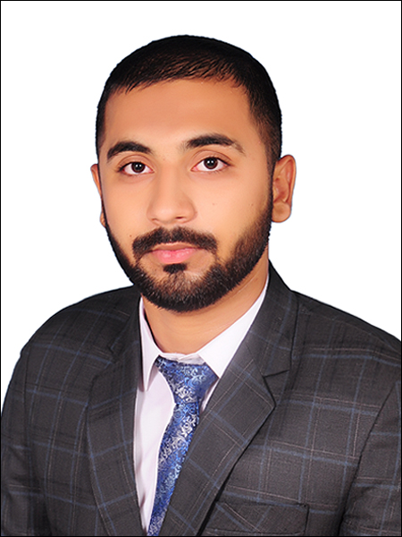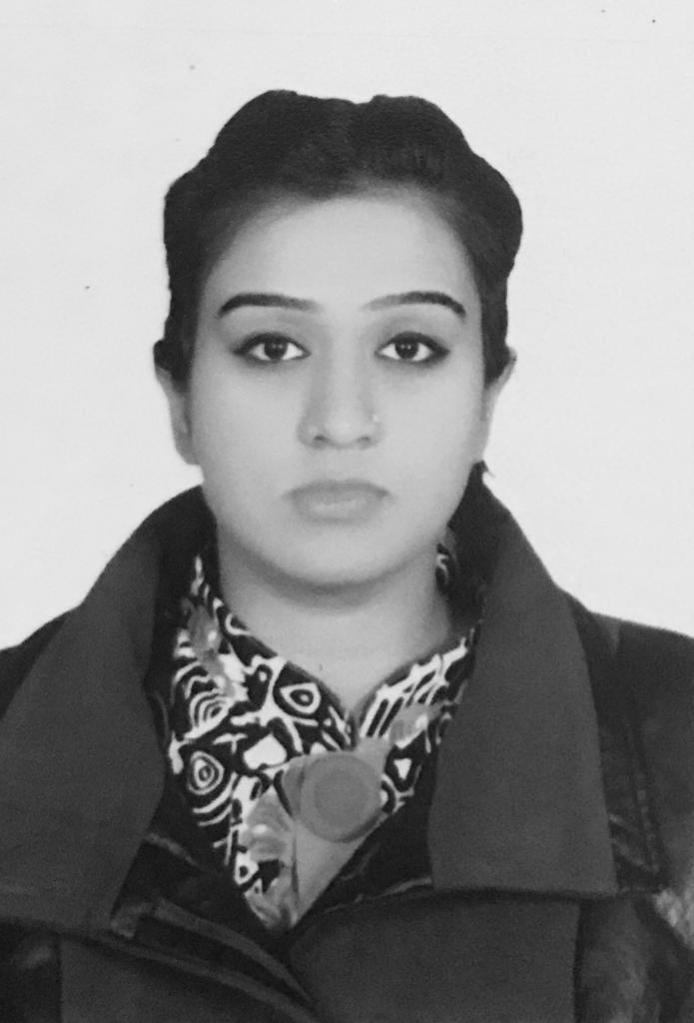

To encourage creativity and higher-order thinking in a way that increases

Student’s performance and to Develop professional skills of teaching

students of every age by providing work-based learning

**I. PERSONAL INFORMATION**

|  |  |  |  |
| --- | --- | --- | --- |
| **Father’s Name** | **DOB & Age** | **Contact No. & Email Address** | **Address** |
| Amir Masood | **DOB:** 29-09-1999 | **Mobile:** 0331-4811539  **E-mail:** sibghatsheikh2@gmail.com | **6-b waseem block hassan**  **Town Multan road Lahore.** |

##### II. ACADEMIC RECORD (in reverse chronological order, highest degree first)

|  |  |  |  |  |  |
| --- | --- | --- | --- | --- | --- |
| **Degree** | **Year passed** | **University/Board** | **Institution** | **Division/Grade** | **Area of specialization/Main Subject(s)** |
| **BS (Hons.)**  **CHEMISTRY** | Continue  (2018-2022) | University Of Central Punjab | Faculty of Life sciences | ______ | Organic and Analytical Chemistry |
| **F. Sc (pre- Med)** | 2018 | BISE Lahore | Govt. college Science Wahdat road, Lhr. | B | Biology |
| **Matriculation** | 2016 | BISE Lahore | Allied School | **B** | Science Group |

##### III. EMPLOYMENT RECORD AND EXPERIENCE (starting from most recent one)

|  |  |  |  |
| --- | --- | --- | --- |
| **Position/Job Title** | **Years of experience** | | **Institute** |
| **From** | **To** |
| **Science Teacher** | 2018 | 2019 | Al quid academy |
| **Science Teacher** | 2017 | 2018 | Unique icon Academy |

##### V. PROFESSIONAL MEMBERSHIP/AFFILIATIONS & ACTIVITIES

WORKSHOPS ATTENDED

- Advances in organic chemistry, 2018 UCP

- **Recent Trends in Life Sciences, 2019 UCP**

- Food n nutrition security conference, 2019 PU

**VIII. COMPUTER PROFICIENCY**

Programming Skills: MS Office: Word, Excel & Power Point.