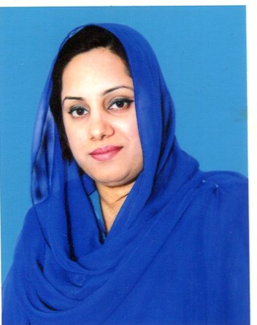

**AYESHA RASHID**

+92-332-4473008

H # 233, St # 6, Govt Employees Cooperative Housing Society Township A1, Lahore

Doctorofpara@gmail.com

**OBJECTIVE**

**EDUCATION**

Seeking a challenging position in an institute that gives me an opportunity to utilize my skills and abilities, self-improvements and provides constant learning of latest teaching upgrades and career growth.

**M.Phil Zoology 2018**

University of the Punjab, Lahore

**EXPERIENCE**

**M.Sc. Zoology 2009**

University of the Punjab, Lahore

Focal person of Govt Dengue Campaign

**VOLUNTEER EXPERIENCE**

Dengue Campaign

**PROFESSIONAL TRAINING**

Worked as a lecturer (CTI), Teaching Zoology, Physiology & Microbiology to BS (Hons.) at **Govt. College of Home Economics** Gulberg Lahore from 2012-2018

Worked as a CTI, Taught Biology to F.Sc, Internship through National Internship program at **Govt. Post Graduate Islamia College (W)** Cooper Road Lahore from 2010-2011

**B.ED 2012**

**B.Sc. 2007**

Govt. Post Graduate Islamia College (W), Lahore

Allama Iqbal Open University, Islamabad

**F.Sc 2005**

P.R. Axis College of Arts & Science, Lahore

**Matriculation 2003**

P.R.St. Andrews High School, Lahore

**KEY SKILLS**

Quick Learner

Good in Art & Designing Skills

Teamwork

Focused & Punctual

Good Communication & Interpersonal Skills

Knowledgeable & Friendly

**REFERENCE**

Qui Reference available on request