DSA Preparation :

1: Give a list of numbers and check is the list has duplicate values or not

Solution:

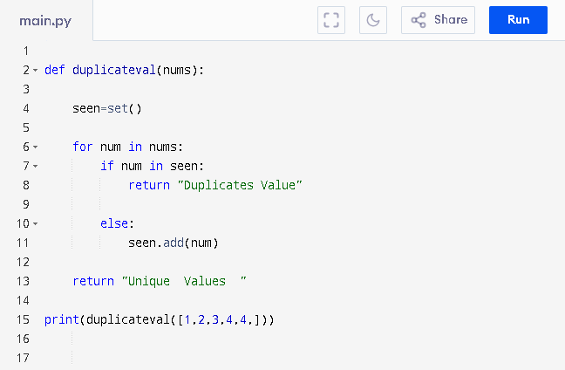

Time Complexity: Big O (n) because we are looping every value of the list as the list grows it will take more time to check and verify by iterating each element.