**NAME**  USAMA HAIDER

**REG NO** 19-NTU-CS-1129

**ASSIGNMENT TITLE**  LAB#3

**SUBMIT DATE** 27-03-2022

**SUBMIT TO** MA’AM AYESHA

MA’AM SARA

Sir Kamran

**Links:**

**1:** [**https://flutter-lab3-q1.web.app/#/**](https://flutter-lab3-q1.web.app/#/)

**2:** [**https://flutter-lab3-q2.web.app**](https://flutter-lab3-q2.web.app)

**Q1:**

**Modify the Lab 2, Task 1 (the UI of the task is given below) by eliminating the code in runApp() method and creating a stateless widget. Note: Your entire code can be re-used in this task.**

**Code:**

import 'package:flutter/material.dart';  
  
void main() {  
 runApp(const MyApp());  
}  
class MyApp extends StatelessWidget {  
 const MyApp({Key? key}) : super(key: key);  
  
 @override  
 Widget build(BuildContext context) {  
 return MaterialApp(  
 home: Scaffold(  
 floatingActionButton: FloatingActionButton(  
 onPressed: null,  
 backgroundColor: Colors.*blue*,  
 child: Icon(Icons.*add*),  
 ),  
 appBar: AppBar(  
 title: Text('Mobile App Dev lab'),  
 backgroundColor: Colors.*brown*,  
 ),  
 body: Center(  
 child: Text('You have pressed this button 0 times'),  
 ),  
 backgroundColor: Colors.*blueGrey*,  
 ),  
 );  
 }  
}

**Output:**

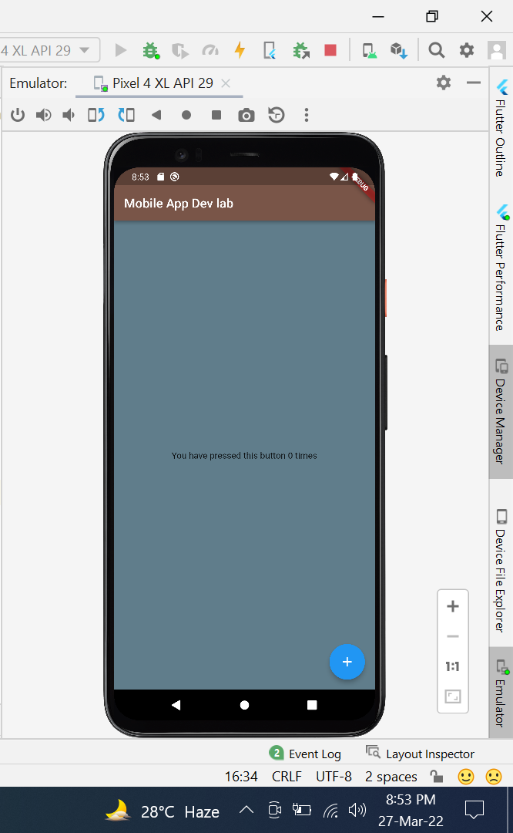

**Q2:**

**Create a contact-card app that shows your contact details as given in following figure. The components and requirements of this app are given below.**

**a. Include safe area**

**b. Grey background**

**c. Contain a circular avatar with an image, and 50 radius.**

**d. Your name with following style guidelines**

**i. Font ZenKurenaido (custom Google font)**

**ii. Bold**

**iii. White Color**

**iv. Font size 30**

**e. Your Designation with following style guidelines**

**i. Font Lato (custom Google font)**

**ii. Bold**

**iii. White Color**

**iv. Font size 20**

**v. Letter spacing 3**

**f. Phone icon and contact number with grey color, white background, padding, and margin**

**g. Email icon and email with grey color, white background, padding, and margin**

**Code:**

import 'package:flutter/cupertino.dart';  
import 'package:flutter/material.dart';  
  
void main() {  
 runApp(const MyApp());  
}  
  
class MyApp extends StatelessWidget {  
 const MyApp({Key? key}) : super(key: key);  
 @override  
 Widget build(BuildContext context) {  
 return MaterialApp(  
 title: 'Flutter Demo',  
 theme: ThemeData(  
 primarySwatch: Colors.*blue*,  
 ),  
 home: const MyHomePage(title: 'Flutter Demo Home Page'),  
 );  
 }  
}  
  
class MyHomePage extends StatefulWidget {  
 const MyHomePage({Key? key, required this.title}) : super(key: key);  
 final String title;  
  
 @override  
 State<MyHomePage> createState() => _MyHomePageState();  
}  
  
class _MyHomePageState extends State<MyHomePage> {  
 int _counter = 0;  
  
 void _incrementCounter() {  
 setState(() {  
 _counter++;  
 });  
 }  
  
 @override  
 Widget build(BuildContext context) {  
 return SafeArea(  
 child: MaterialApp(  
 home: Scaffold(  
 backgroundColor: Colors.*teal*,  
 body: Container(  
 child: Column(  
 mainAxisAlignment: MainAxisAlignment.center,  
 children: [  
 CircleAvatar(  
 backgroundColor: Colors.*red*,  
 radius: 50,  
 ),  
 Text("Usama Haider",  
 style: TextStyle(  
 fontFamily: 'zen',  
 fontWeight: FontWeight.*bold*,  
 color: Colors.*white*,  
 fontSize: 30,  
 letterSpacing: 3,  
 ),),  
 Text("Software Engineer"),  
 Card(  
 margin: EdgeInsets.all(10),  
 child: ListTile(  
 leading: Icon(Icons.*phone*),  
 iconColor: Colors.*teal*,  
 title: Text(  
 "+924357345458",  
 style: TextStyle(  
 color: Colors.*black*,  
 ),  
 ),  
 ),  
 ),  
 Card(  
 margin: EdgeInsets.all(10),  
 child: ListTile(  
 leading: Icon(Icons.*email*),  
 iconColor: Colors.*teal*,  
 title: Text(  
 "ahad@gmail.com",  
 style: TextStyle(  
 color: Colors.*black*,  
 ),  
 ),  
 ),  
 )  
 ],  
 ),  
 ),  
 ),  
 ),  
 );  
 }  
}

**Output:**

