# Task 1: Image Segmentation and Detection

## 1) Three Skin Images

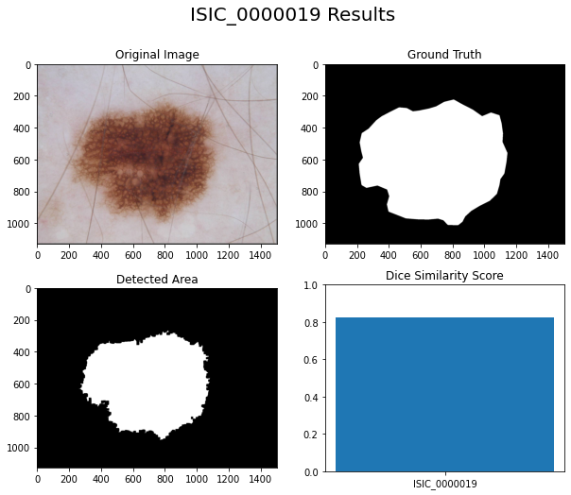

Figure 1: Results of ISIC_0000019 image

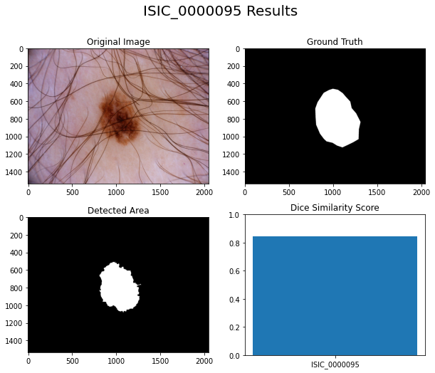

Figure 2: Results of ISIC_0000095 image

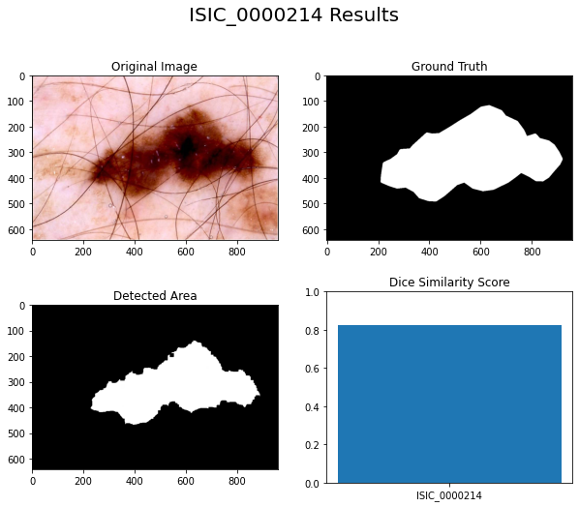

Figure 3: Results of ISIC_0000214 image

## 2) Bar graph of DS of all images

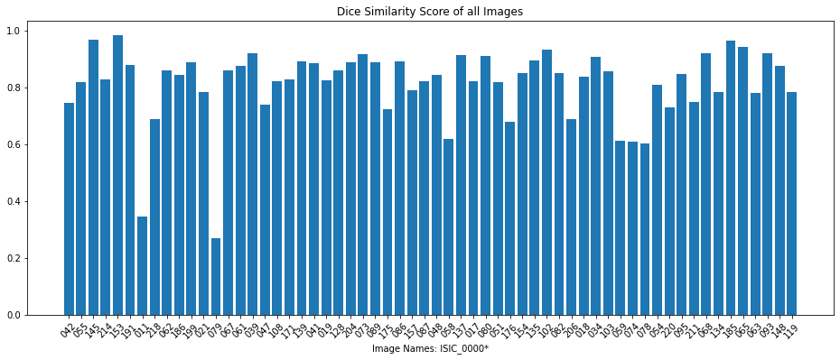

Figure 4: DS score of all Images

## 3) Mean and standard deviation

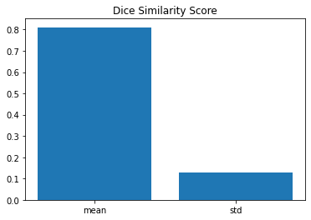

Figure 5: Mean and Standard Deviation

## 4) Methodology Description

The methodology used to detect the required area from the image includes following steps

* Removing noise by applying gaussian blur
* Apply thresholding technique to extract the required area. Instead of applying global thresholding OTSU thresholding gives better results.
* Remove unwanted areas using morphology techniques like erosion
* Pick the binary area with the largest pixel size and closer to the center of the image.

The algorithm gives around 80% accuracy on given data.

# Task 2: Feature Calculation

In feature calculation of frequency domain images, it can be seen the impact of radius for low pass filter. By looking at results, it can be seen that on a smaller radius for low pass filter images become blurred and by increasing the radius of filter the detail in output image increases which means low frequencies have most of the information about the image and higher frequencies only provide detail about image.

It can be verified on high pass filters on frequency domain too where the smaller distance gives more of the image and higher distances only provide the details like edges information.

Gray level run matrix provides texture features with higher order. It gives a line of pixels with the same values that run in the same direction. Gray level co occurrence matrix on the other hand retrieve features by considering the image visual information