

MNIST FASHION CLASSIFICATION

USAMA KHALID

19I-1236

MS(DS)-B

1. **What features did you use and why?**

I used HOG features because it is good for object and shape detection. So it would extract features of different shapes of shirts and SVM would hopefully learn to differentiate between them.

1. **What classification techniques did you try?**

SVM with polynomial and sigmoid kernels and KNN

1. **Which of the methods (and for what hyper-parameters) showed best cross-validation performance?**

KNN and SVM both yielded similar performance of 80% accuracy. Although the average scores during hyper-parameter tuning were greater for KNN. Following were the hyper-parameters.

For SVM

C=0.1 gamma=0.1 kernel=polynomial

For KNN

distance metric = manhattan K neighbours = 15 weights = distance

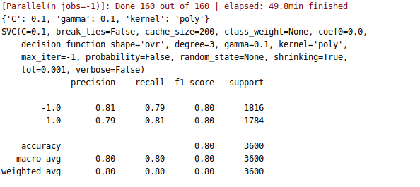

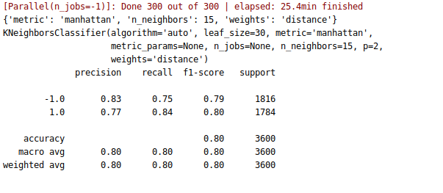

1. **What test accuracy are you expecting?**

A test accuracy of around 80% because the results on training data were around this value.