Visual XPath 0.1

Author: Nauman Leghari
Email: laghari78@yahoo.com / noman@csquareonline.com

Note: Email me if you have any type of comments, feature-requests and suggestions, either constructive or destructive (in case they are in the destructive category, please provide your opinion). I also need to know if there are any bugs, errors in the software. The source code is also included with the download. It is not very well documented therefore you can also email me if you want to know any part of source code or you want to know “how I code this function?” etc.

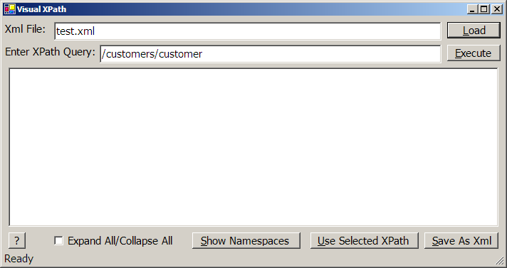

Changes:
All the changes are specified in the changes.txt file. In this Help Document, some of the images are taken from the old version. Whereas any newly implemented feature is documented at the end of this document.

What is Visual XPath?

Visual XPath is a graphical way of generating XPath query results. It can also be used to generate XPath queries dynamically by select XML nodes shown in the form of Tree.

What not is Visual XPath?

Visual XPath is not an XPath Parser. It utilizes Microsoft .NET XPath parser and other XML related APIs. It does not validate XML document against DTD or Schema. Although it will display error, if the XML document is not Well Formed. It is not an XML Editor therefore I removed Editing XML and Save As XML functions from the latest version. Although the XML file, if present on your hard disk, can be opened in the Notepad from the Utility.

How do I use Visual XPath?

The following steps show you how to load a simple XML document into Visual XPath and generate/execute XPath queries against the document.

- After running Visual XPath, press the Load button and select the XML document.

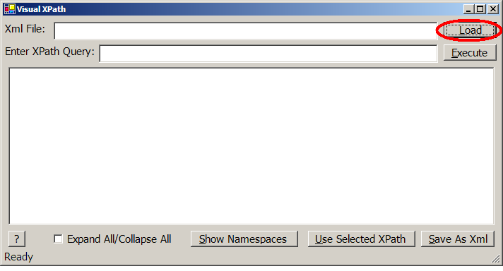

This shows a File Open dialog box where you can select any kind of XML file. After the XML document is selected, it is then loaded in the tree. You can also see the Load time in the status bar. This is useful if you want to test the performance of loading an XML document using the .NET XmlDocument class.

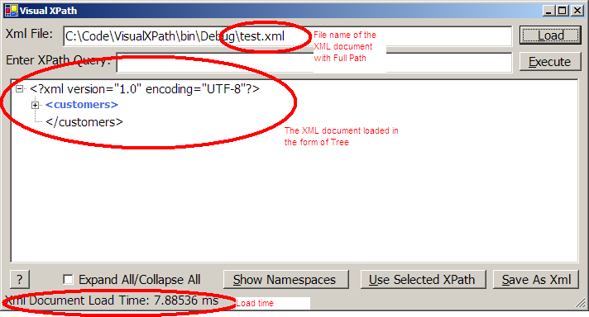

The “Expand All/Collapse All” checkbox can be used to expand all the nodes of the tree or vice versa.

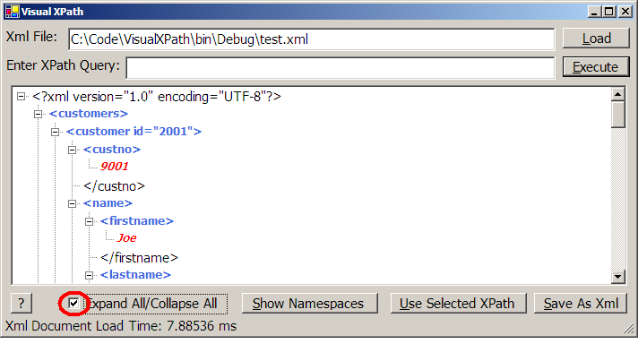

- Now, you can enter the XPath query into the “Enter XPath Query” text box and press the Execute button to get the results. You can also view the execution time for the XPath query in the status bar.

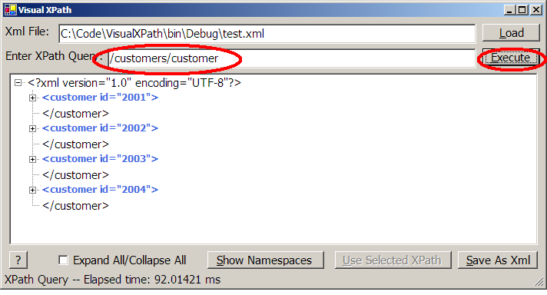

You can note here that the tree contains only the result that is obtained by running the execute query. To get back the document, enter ‘/’ (without the quotes) into the “Enter XPath Query” text box and press “Execute”.

[THIS FEATURE IS REMOVED FROM THE LATEST VERSION]
- You can also edit any XML node by single clicking on any node except the top most tag. After clicking, wait a while so that the tag becomes editable. After changing the node, click the “Save As Xml” button to save into existing file. The document is checked for Well-form(ness), when saving. If there is some error then the document will not be saved and an error is displayed. Although, the changes made are not automatically rolled back nor they are selected.

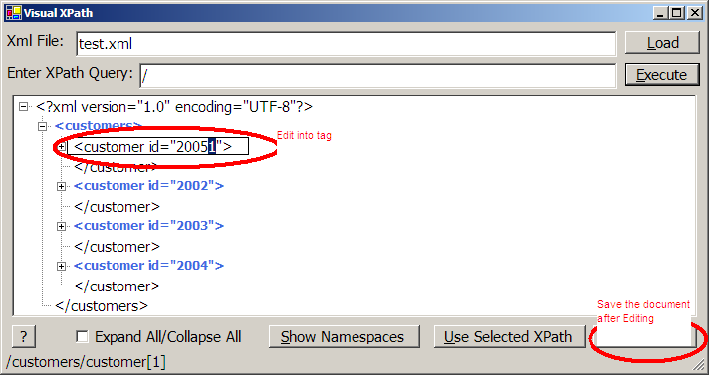

- Another important feature which you see while selecting any node is automatic generation of XPath queries in the status bar.

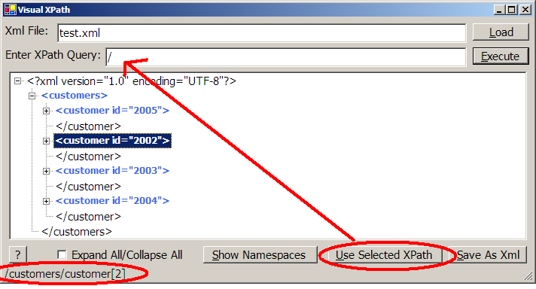

You can press the “Use Selected XPath” button to insert the currently generated XPath query into the “Enter XPath Query” text box so that you can execute it by only pressing “Enter”. Note that when you execute any XPath query, the “Use Selected XPath” and the “Save As Xml” buttons grayed out. They are disabled because (as mentioned above) when you run any XPath query, then only the results are showed in the tree. So you can’t run XPath on the results or save only the results. To get back the whole document, you should enter ‘/’ (without the quotes) into the “Enter XPath Query” and press “Execute”.

- The Show Namespaces button is used when you load a document which contains XML namespaces.

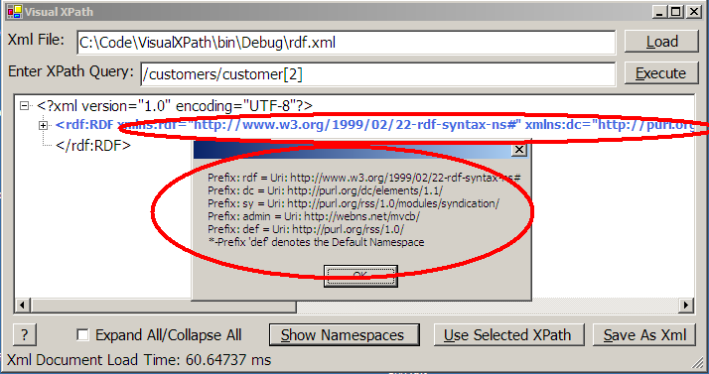

Another feature of Visual XPath is to load namespaces automatically. Even though, when entering the XPath Query, you need to mention it explicitly to get the correct results. You can select nodes to get the correct XPath queries even with Namespaces.

There are some assumptions which are made in case the default namespaces are used in the XML document. This and along with any potential questions can be viewed by pressing the Help button on the button left of the window.

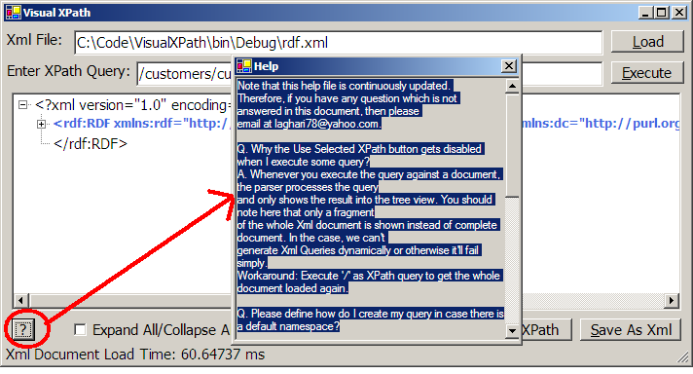

- If you want to generate the source code to use in your project, you can use the “C# Code” button to generate and copy the code to Clipboard.

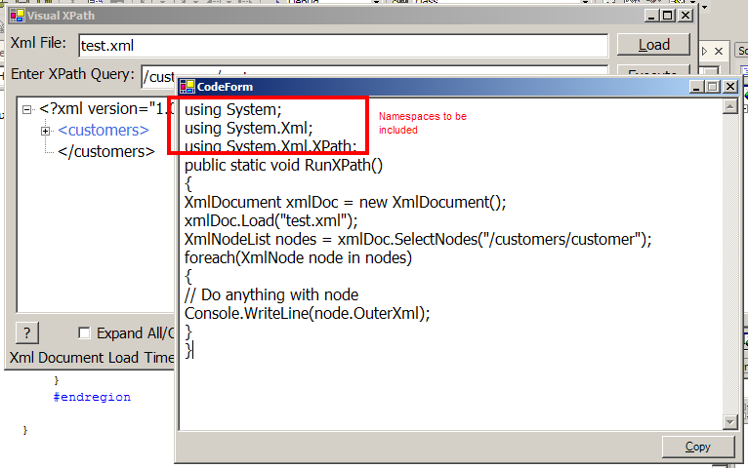

In this Code form, you can copy the code to clipboard. To use that code, you just need to include the namespace specified at the top. The functions can be put anywhere and they don’t need to be static. To use this function, just call it.

If you view the source code of the project, then you can see that this source generation is not implemented using CodeDOM. I just use string to define predefined code structure. Some dynamic variables such as XPath expression and the XML document filename are inserted at appropriate places.

- You can generate XPath queries for Attributes in an XML Node. Just follow the node and right-click to get the list of all the attributes present on the node. Then select the attribute to generate its XPath Query.

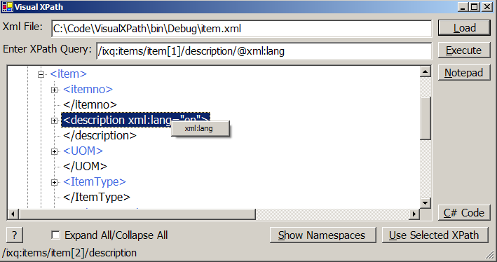

- In version 0.3, I added the support for generating verbose output for XPath queries in addition to the abbreviated query. There is a menu item to switch to either of the two options.

Feedback/Bugs:

Note that this is just the basic version of code-generation. All other enhancements are bug-fixtures are only possible on your feedbacks.

