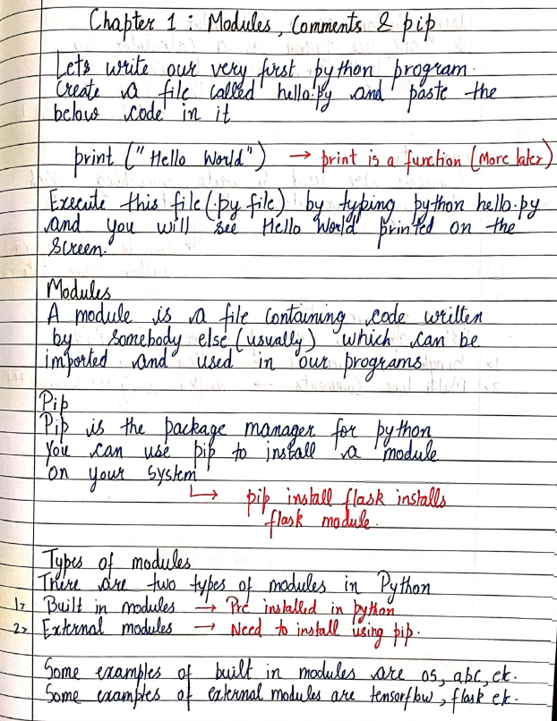

**Gemini 2.0**

**Chapter 1: Modules, Comments & pip**

Let's write our very first python program.  
Create a file called hello.py and paste the below code in it.

print ("Hello World") -> print is a function (More later)

Execute this file (.py file) by typing python hello.py and you will see Hello World printed on the screen.

**Modules**

A module is a file containing code written by somebody else (usually) which can be imported and used in our programs.

**Pip**

Pip is the package manager for python.  
You can use pip to install a module on your system.

-> pip install flask installs flask module.

**Types of modules**

There are two types of modules in Python.

1. Built in modules -> Pre installed in python
2. External modules -> Need to install using pip.

Some examples of built in modules are os, abc, ck.  
Some examples of external modules are tensorflow, flask ck.

**ChatGPT 4o mini:**  
Chapter 1: Modules, Comments & pip

Let's write our very first Python program.

Create a file called hello.py and paste the below code in it:

print("Hello World")  → print is a function (More later)

Execute this file (by file) by typing python hello.py

and you will see Hello World printed on the screen.

Modules

A module is a file containing code written by somebody else (usually) which can be imported and used in our programs.

Pip

Pip is the package manager for Python.

You can use pip to install a module on your system.

pip install flask installs flask module.

Types of modules

There are two types of modules in Python:

Built-in modules → Pre-installed in Python.

External modules → Need to install using pip.

Some examples of built-in modules are os, abc, etc.

Some examples of external modules are tensorflow, flask, etc.



**Gemini 2.0 Flash**

Unit-1

Introduction Date: / /

Database Management System is a software for Storing and retrieving user data by considering appropriate security measures. It allows users to create their own databases as per their requirement.

It consists of a group of programs which manipulate the database and provide an interface between the database. Some commercially available database are Oracle, Sybase, MySQL.

Database: The database is a collection of inter-related data which is used to retrieve, insert and delete the data efficiently. It is also used to organize the data in the form of a table, schema, views, and reports etc.

DBMS allows users for following tasks:

1. Data definition: It is used for creation, modification and removal of definition that defines the organization of data in the database.
2. Data Updation: It is used for the insertion, modification, and deletion of the actual data in the database.
3. Data Retrieval: It is used to retrieve the data from the database which can be used by applications for various purposes.
4. User Administration: It is used for registering and monitoring users, maintain data integrity, enforcing data security, dealing with concurrency control, monitoring performance and recovering information corrupted by unexpected failure.

Advantages of DBMS:

1. Controls database redundancy.
2. Data Sharing

Scanned with CamScanner

Sources and related content

**ChatGPT 4o mini**

**Unit - 1**  
**Introduction**

Database Management System is a software for storing and retrieving user data by considering appropriate security measures. It allows users to create their own database as per their requirement.  
It consists of a group of programs which manipulate the database and provide an interface between the database.  
Some commercially available databases are Oracle, Sybase, MySQL.

**Database**: The database is a collection of inter-related data which is used to retrieve, insert and delete the data efficiently. It is also used to organize the data in the form of a table, schema, view, and reports, etc.

**DBMS allows users for the following tasks**:

1. **Data definition**: It is used for creation, modification, and removal of definition that defines the organization of data in the database.
2. **Data updation**: It is used for the insertion, modification, and deletion of the actual data in the database.
3. **Data retrieval**: It is used to retrieve the data from the database, which can be used by applications for various purposes.
4. **User Administration**: It is used for registering and monitoring users, maintaining data integrity, enforcing data security, dealing with concurrency control, monitoring performance, and recovering information corrupted by unexpected failure.

**Advantages of DBMS**:

1. Controls database redundancy
2. Data sharing

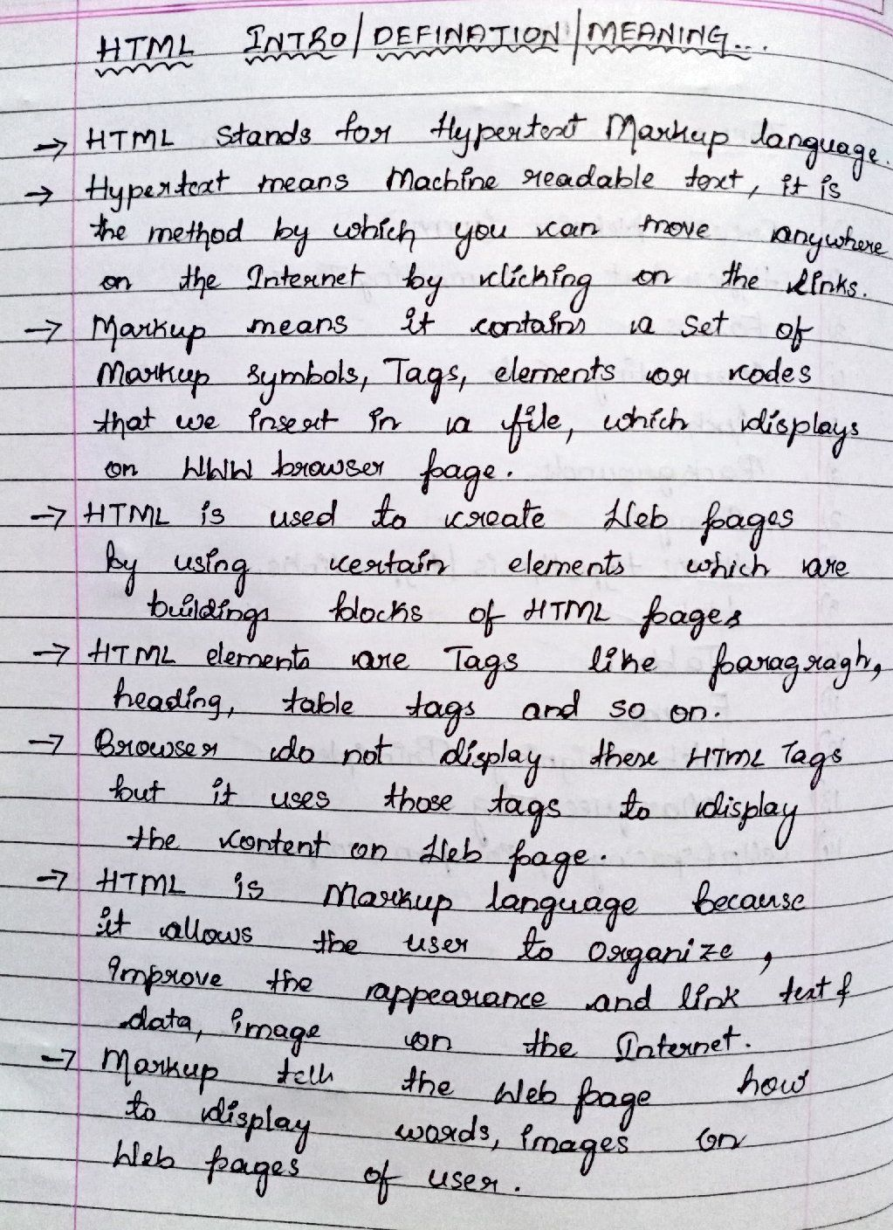

**Gemini 2.0 Flash**

HTML INTRO/DEFINATION/MEANING...

→ HTML Stands for Hypertext Markup language.

→ Hypertext means Machine readable text, it is

the method by which you can move anywhere

on the Internet by clicking on the links.

→ Markup means it contains a set of

Markup symbols, Tags, elements or codes

that we insert in a file, which displays

on WWW browser page.

→ HTML is used to create Web pages

by using certain elements which are

buildings blocks of HTML pages.

→ HTML elements are Tags like paragraph,

heading, table tags and so on.

→ Browser do not display these HTML Tags

but it uses those tags to display

the content on Web page.

→ HTML is Markup language because

it allows the user to Organize,

Improve the appearance and link text of

data, image on the Internet.

→ Markup tells the Web page how

to display words, images on

Web pages of user.

**ChatGPT 4o mini.**

HTML INTRO/DEFINITION/MEANING

* HTML stands for Hypertext Markup Language.
* Hypertext means Machine-readable text, it is the method by which you can move anywhere on the Internet by clicking on the links.
* Markup means it contains a set of markup symbols, Tags, elements, or nodes that we insert in a file, which displays on a WWW browser page.
* HTML is used to create web pages by using certain elements which are building blocks of HTML pages.
* HTML elements are Tags like paragraph, heading, table tags, and so on.
* Browser does not display these HTML Tags but it uses those tags to display the content on the web page.
* HTML is a markup language because it allows the user to organize, improve the appearance and link text and data, image on the Internet.
* Markup tells the web page how to display words, images on web pages of the user.

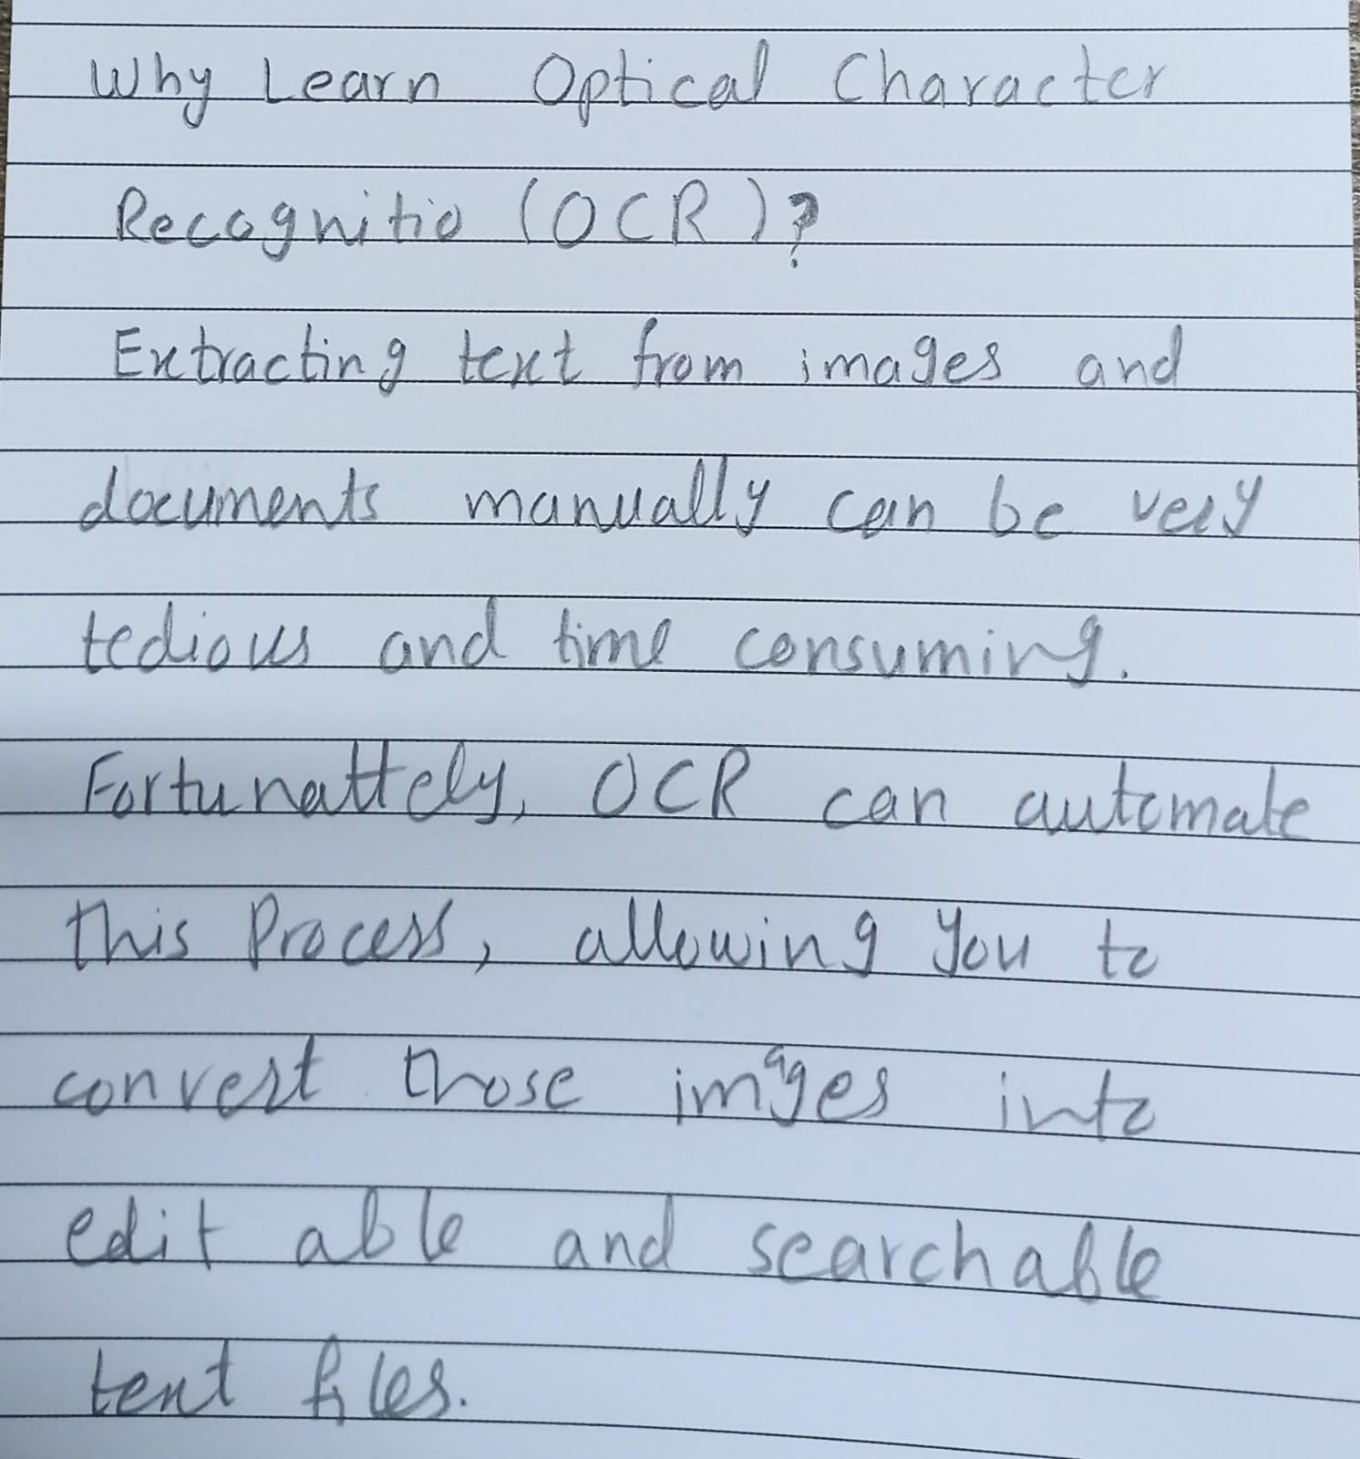

**Gemini 2.0 Flash**

Why Learn Optical Character

Recognition (OCR)?

Extracting text from images and

documents manually can be very

tedious and time consuming.

Fortunately, OCR can automate

this process, allowing you to

convert those images into

editable and searchable

text files.

**ChatGPT 4o mini:**

Why Learn Optical Character Recognition (OCR)?

Extracting text from images and documents manually can be very tedious and time-consuming.

Fortunately, OCR can automate this process, allowing you to convert those images into editable and searchable text files.

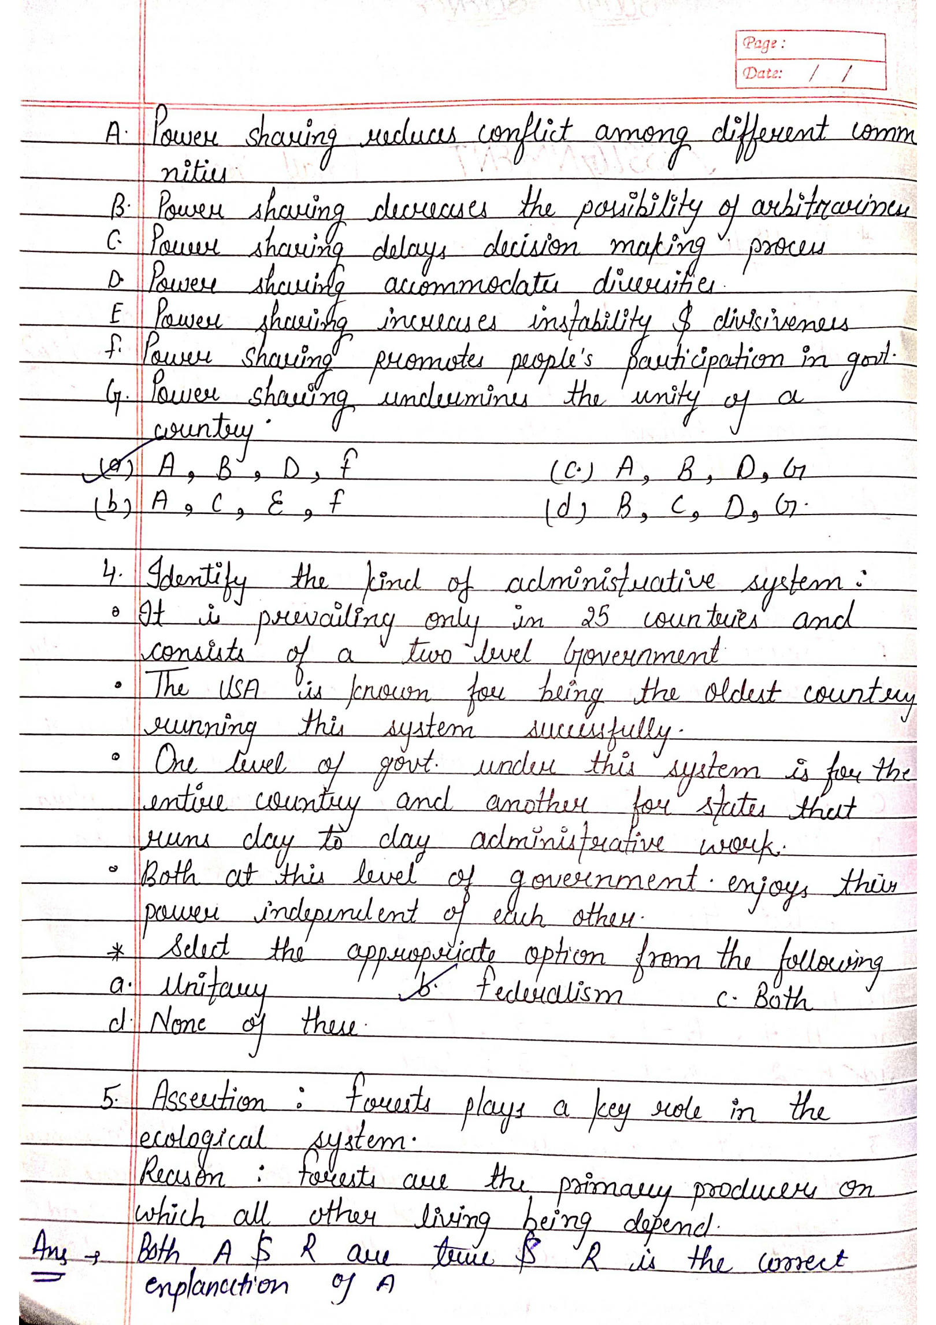

**Gemini 2.0**Page: 1 / 1

Date: / /

A. Power sharing reduces conflict among different communities.

B. Power sharing decreases the possibility of arbitrariness.

C. Power sharing delays decision making process.

D. Power sharing accommodates diversities.

E. Power sharing increases instability1 & divisiveness.

F. Power sharing promotes people's participation in govt.

G. Power sharing undermines the unity of a country.

(a) A, B, D, F (c) A, B, D, G

(b) A, C, E, F (d) B, C, D, G

1. Identify the kind of administrative system:

* It is prevailing only in 25 countries and consists of a two level Government.
* The USA is known for being the oldest country running this system successfully.
* One level of govt. under this system is for the entire country and another for states that runs day to day administrative work.
* Both2 at this level of government enjoys their power independent of each other.
* Select the appropriate option from the following: a. Unitary b. Federalism c. Both d. None of these3

1. Assertion: Forests plays a key role in the ecological system. Reason: Forests are the primary producers on which all other living being depend. Ans → Both A & R are true & R is the correct explanation of A

**ChatGPT 4o mini**

**ERROR**