

See discussions, stats, and author profiles for this publication at: [https://www.researchgate.net/publication/350193293](https://www.researchgate.net/publication/350193293_Mobile_application_model_for_solid_waste_collection_management?enrichId=rgreq-ecb2661c7b2426787fa72d0a038df4a4-XXX&enrichSource=Y292ZXJQYWdlOzM1MDE5MzI5MztBUzoxMDA2Mjk4OTIxNDQ3NDI0QDE2MTY5MzE3NjczNjA%3D&el=1_x_2&_esc=publicationCoverPdf)

[Mobile application model for solid waste collection management](https://www.researchgate.net/publication/350193293_Mobile_application_model_for_solid_waste_collection_management?enrichId=rgreq-ecb2661c7b2426787fa72d0a038df4a4-XXX&enrichSource=Y292ZXJQYWdlOzM1MDE5MzI5MztBUzoxMDA2Mjk4OTIxNDQ3NDI0QDE2MTY5MzE3NjczNjA%3D&el=1_x_3&_esc=publicationCoverPdf)

**Article** *in* SSRN Electronic Journal · March 2021

DOI: 10.2139/ssrn.3808542

CITATIONS

4

READS

7,522

**1 author:**

[Henrys Kasereka](https://www.researchgate.net/profile/Henrys-Kasereka-2?enrichId=rgreq-ecb2661c7b2426787fa72d0a038df4a4-XXX&enrichSource=Y292ZXJQYWdlOzM1MDE5MzI5MztBUzoxMDA2Mjk4OTIxNDQ3NDI0QDE2MTY5MzE3NjczNjA%3D&el=1_x_5&_esc=publicationCoverPdf) Dreamline

**5** PUBLICATIONS **24** CITATIONS

[SEE PROFILE](https://www.researchgate.net/profile/Henrys-Kasereka-2?enrichId=rgreq-ecb2661c7b2426787fa72d0a038df4a4-XXX&enrichSource=Y292ZXJQYWdlOzM1MDE5MzI5MztBUzoxMDA2Mjk4OTIxNDQ3NDI0QDE2MTY5MzE3NjczNjA%3D&el=1_x_7&_esc=publicationCoverPdf)

All content following this page was uploaded by [Henrys Kasereka](https://www.researchgate.net/profile/Henrys-Kasereka-2?enrichId=rgreq-ecb2661c7b2426787fa72d0a038df4a4-XXX&enrichSource=Y292ZXJQYWdlOzM1MDE5MzI5MztBUzoxMDA2Mjk4OTIxNDQ3NDI0QDE2MTY5MzE3NjczNjA%3D&el=1_x_10&_esc=publicationCoverPdf) on 28 March 2021.

The user has requested enhancement of the downloaded file.

Mobile application model for solid waste collection management

Kasereka Henrys

# MSc in Software Engineering Bugema University

Published Mars 2021, HKCorporation [arisjokov@gmail.com](mailto:arisjokov@gmail.com)

## ABSTRACT

The quantity and generation rate of solid waste will continuously increase tremendously as long as human activities continue to exist. The consequence caused by badly management of solid waste, it is very dangerous to the world and human health this calls for the need to salvage the situation before it gets out of hand. That conducts us to use best practices to properly manage solid waste collection following the new trend of mobile technology, this research developed a solid waste collection management model with the aim to design a Mobile Application model for solid waste collection management which will help to improve the quality of management in Solid Waste collection and impacting positively the environment by reducing the quantity of Solid waste. This model put the solid waste generators on the central of the solid waste collection system because they are the principal actors producing solid waste, helping Solid waste companies during their solid waste collection process and provides an efficient tool to the municipality council to have an overview to the all activities concerning solid waste collection and oriented their decisions. In this research we provided all necessary and recent mobile technology and a model can be applying to achieve efficient solid waste collection system for household.

**Keywords :** Solid waste Collection , municipal solid waste Management, mobile applications

# i

## INTRODUCTION

* 1. **Background**

A degraded urban environment is the enemy of sustainable development. Environmental protection is a prerequisite for effective economic development not an alternative to economic growth (UN, 1992).

Modern metropolitan centers consume a lot of resources, including energy, water, food and raw materials, and therefore they produce huge amounts of waste. The city's ability to manage the solid waste challenge would indicate the city's effectiveness in working together to solve major problems such as urban environment problems (Middleton, 1995).

In the majority of Africa’s urban areas, Solid waste collection management is eventually the responsibility of Municipal Councils, concerning the rural era, most of the population handles them at the household level (Mabogunje, 1995). Solid waste management has become a major problem and big challenge in the majority of urban centers, especially in the rapidly growing cities. Rapid urbanization, industrialization, and population growth contribute now to increasing solid waste (Moniruzzaman, 2013).

The environment is the key to the existence of life on the earth. Recently, most environmental researchers have looked at how people affect the environment. This research reveals that we are the source of floods, air pollution and other problems that lead to a dangerous situation for the earth and for ourselves.

Poor management of waste collection has a huge negative impact on the environment. Not all solid waste will be rotten, some may possibly stay in the same condition, during the process, it may smell and be a source of explosives caused by methane gas generated by solid waste and also lead to the greenhouse effect. Not only have that, but waste also smelled attract insects such as mosquito which are the main cause of malaria. Children in Africa like playing in a dirty area and go swimming in a river that is infected by bacteria, which leads to typhoid and other dermatological diseases. Malaria and typhoid are the main cause of mortality in the world and Africa in particular.

In 2018 during the conference about global warming, the UN decided to reduce plastic pollution one of the causes of flooding through modern cities. 127 countries had

adopted legislation to regulate plastic bags, 27 countries had enacted legislation banning specific products, materials or production levels, 27 countries have instituted taxes on the production of plastics bags, 30 countries charged consumed fees plastic bag, 8 countries had established bans of micro beads through national laws or regulation. Despite the need for the UN many countries did not act. Africa is one of the continents where the impact of world warning has a hugely negative impact (UNEP, 2018).

Without a doubt, the future lies in mobile applications. The new trends in digital and mobile developments mark a new era that influences human behavior and global governance. Mobile applications play an important role in many application areas such as industry, home, environment and health. This approach can be applied in the field of solid waste management to improve the way it works nowadays.

It was reported by the GSM Association in sub-Saharan Africa, around 239 million people use regularly mobile internet which equivalent to 23% of the population. There were 456 million unique subscribers in sub-Saharan Africa in 2018, an increase of 20

million over the previous year. With a compound annual growth rate of 4.6% and 167 million additional subscribers by 2025 Sub- Saharan Africa will remain the fastest growing region in the world. This will bring the total to subscribers to just over 600 million about half of the sub-Saharan population. (GSMA, 2019).

The penetration between 2014 and 2018 of Smartphone was increased in Sub- Saharan Africa from 10% up to 30% as result more Africans can use their phones to access internet services, it is now more viable for network operators to move voice traffic to 3G by reframing part of their 900 MHz spectrum, especially as some U900 technologies can easily be deployed through remote software upgrades and allow dynamic spectrum allocation between 3G and legacy services (GSMA, 2019).

New generation mobile phone or Smartphone, technology 3G/4G networks with new built-in functions, and a plethora of mobile applications is the latest achievement realized in mobile technology. It was the result of the spread of mobile internet and rapidly declining prices of mobile devices which though years become an affordable tool to reduce the digital

gap between developed and developing countries (Mavropoulos, 2013).

With the progression and record of the number of tablets and smart phones registered in the world. The impact is manifesting itself on the number of mobile broad band subscriptions and Internet users and is strengthening the shift from mobile voice to mobile data traffic. As a result, major network upgrades, higher speeds and more spectra will be required. The development of mobile applications has provided more opportunities for mobile users, who influence their daily activities by using mobile applications. According to International Data Corporation, most popular apps are games, maps, news, music, and social networking. During the last 3 years, their number has grown significantly rising 300000 in 2010 up to 850000 in 2011 and over 1200000 in 2012. Around 84 billion downloads of mobile applications were registered in 2012 and in 2015 it was nearly expected to reach 182.7 billion. The average in 2011 of an application installed on each smart phone device was 32 apps and 41 in 2012. What is true, the future of the mobile app industry shows no signs of slowing down anytime soon (IDC, 2012).

Waste generation rates are rising around the world. 2.01 billion tons of solid waste has been generated in 2016. Sub-Saharan Africa generated 174 million tons of waste in 2016. Waste generation in 2030 is expected to triple in Sub-Saharan Africa. The annual estimation of waste generation around the world is expected to increase by 70% from 2016 to 3.40 billion tons in 2050 (Silpa Kaza, 2019). We can see by those statistics the importance to act now to prevent the consequence of bad waste collection management. One of the causes of mortality in sub-Saharan is malaria and typhoid which killed in 2018 around 405 000 people though the world 94% from Africa according to the World Malaria Report released in December 2019 (WHO, 2019). Using mobile technology to improve the waste collection management will be one of the solutions because the average of waste collection in sub-Saharan until now is 46% according to the last World Bank report.

Our motivations come from the importance of improving the Solid waste collection management process using mobile technology by offering a mobile model matching with the new solid waste collection management challenge. This seemed urgent to

us because one of the causes of death in Africa is malaria and typhoid caused by a dirty environment.

## Statement of the Problem

Solid Waste Management Collection cannot stay behind without being affected if human behavior changes globally. There are new Solid Waste Management Collection practices that have come up as innovation to modify the existing one. Solid waste tons by day are approximately 1.3 billion per year around the world. In 2025 it expected to reach approximately 2.2 billion tons per year. This represents a significant increase in per capita waste generation rates, from 1.2 to 1.42 kg per person per day in the next fifteen years (Hoornweg, 2012). Uncollected waste and poorly disposed waste cause significant health and environmental problems. Especially solid wastes from households are a serious health hazard and can cause the spread of serious infectious diseases (Wordbank, 2018). After tedious to manage with the permanent increase in the amount of solid waste and the number of people who wish to use the solid waste collection service, there is a need to develop a Mobile Application model for solid waste

collection management, the traditional method has lost its effectiveness. The challenge facing the municipality in waste management today includes customer and billing management, routing planning, and report filling (Mitsuo, 2018).

## Aim of Study

This study’s aim is to improve the quality of management in Solid Waste collection and impacting positively the environment by reducing the quantity of Solid waste.

## Scope of Study

The study is based on solid waste management concept and the importance of using mobile technology to improve the way solid waste collection management work. Design a model accompanied by a mobile prototype application that can connect the different solid waste generators with waste collectors. Through our system, the solid waste generators are able to inform waste collection enterprises when the garbage bag is full. According to this information, solid waste collectors can plan how to collect solid waste by an optimized waste collection route.

## Justification of the Study

Using mobile applications to allow a waste producer to request a waste collection service and allow the municipality to manage all aspects of waste management will be one of the best ways to reduce the amount of solid waste.

* 1. **Significance of Study**

# This study helps us:

* To bring out a model that will be a benefit to the community by improving the solid waste collection management field?
* To connect Solid waste producers to the structure in charge of solid waste collection management.
* To have waste collectors optimize the waste collection route, hence a reduction in the cost of waste collection.
* To enable the Municipality to improve the quality of data on which making decisions is based on the annual waste budget.
* To serve as a guide for those who wish to conduct their research in the same field

## LITERATURE REVIEW

* 1. **Overview**

The exponential growth of industrialization and urbanization brought waste management issues. Mitigate with this problem is one of the roles of the municipality. Solid Waste management covers all activities beginning with the collection to recycling and waste reuse. All these activities can benefit from technology to improve functioning at each level.

Waste (also known as trash, refuse, rubbish, garbage, and junk) is unwanted or useless materials (Haghi, 2010). As its name sounds, waste is an unwanted and unprofitable material that attracts less attention from the community. It is one of the reasons why not much work in that field about software development aimed or targeted to improve the work of society or organization, has been set up for its management (Adebayo, 2014).

Solid waste is the term used to describe non-liquid waste materials arising from domestic, trade, commercial, agricultural, industrial activities, and public services (Palniktar, 2018). Solid waste which is one of the sources and causes of environmental pollution has been defined under the Resource

conservation and recovery Act as any solid, semi-solid liquid or contained gaseous materials discarded from commercial, industrial, mining, or agricultural operation and community activities (Omeleka, 2004). For Chris Zurbrugg solid waste is material, which has no value to a person who is responsible for it, and is not in liquid form (Zurbrugg, 2002). The concept of municipal solid waste refers to solid wastes from streets and public places, houses, shops, hospitals, and offices, which are very often the responsibility of municipal or other governmental authorities.

Solid waste management is defined as practices used for the collection, transportation, recovering, and disposal of waste along with the supervision of such operations and after- care of the disposal sites (Parliament, 2008). Solid Waste Management is a fundamental aspect of any society's well-being and necessary for preventing possible environmental degradation. In its scope, solid waste management includes all administrative, financial, legal, planning, and engineering functions involved in the whole spectrum of solutions to problems of solid wastes thrust upon the community by its inhabitants (Opera, 2008).

## Status of the Existing Solid Waste

**Collection**

It is estimated around the world, cities currently generate 1.3 billion tons of waste annually, which is expected to increase to 2.2 billion by 2025 (Hoornweg, 2012). Every town, city, or municipal is responsible for setting up waste processing and disposable facility. For enforcement of the provisions of the rules and regulations is the responsibility of the central government and district. In most of the African cities and urban centers, solid waste accumulation is estimated at 0.5 kg per capita/day with a density ranging from 205 to

370 kg m-3 and in other cities where the population is 3.5 million people, research reveals that one million m3 of solid waste is generated per year (Palczynski, 2014).

Table 1: Waste Generation Projections for 2025 by Income (Hoornweg, 2012)

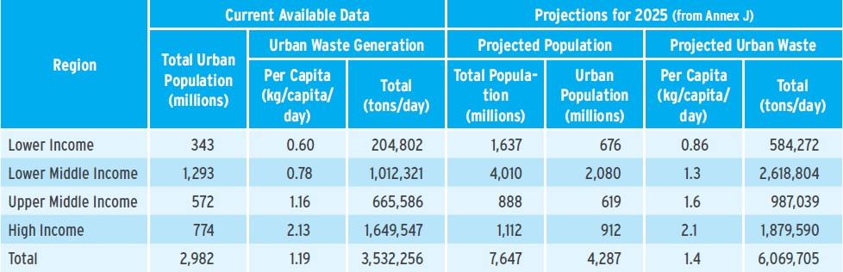

The condition of the municipal solid waste management of Africa is critical. Due to

population expansion and urbanization, the amount of municipal solid waste is increasing drastically. Africa is the fastest-growing main area of population growth and is the only world region projected to have strong population growth for the rest of this century. Between 2020 and 2100, Africa’s population is expected to increase from 1.3 billion to 4.3 billion (Anthony Cilluffo, 2019). According to Mitsuo the public authority capacity to implement the municipal solid waste management service in each country is limited. As a result, many municipal solid wastes are not collected or treated appropriately, which has caused environmental problems and public health issues (Mitsuo, 2018).

## Waste Collection Process

Municipal solid waste is collected in several ways (Hoornweg, 2012):

* House-to-House: Waste collectors visit each house to collect garbage. Generally, the user has to pay a fee for this service.
* Community Bins: Users bring their garbage to community bins that are placed at fixed points in a neighborhood or locality. Waste is

picked up by the municipality, or it’s designate, according to a set schedule.

* Curbside Pick-Up: Users leave their garbage directly outside their homes according to a garbage pick-up schedule set with the local authorities (secondary house-to-house collectors not typical).
* Self-Delivered: Generators deliver the waste directly to disposal sites or transfer stations, or hire third-party operators (or the municipality).
* Contracted or Delegated Service: Businesses hire firms (or municipality with municipal facilities) who arrange collection schedules and charges with.

Hardoy, Mitlin and Satterthwaite remark in collection solid waste, the commonly used method is a door to door collection to various households in urban areas. After they remarked also in most suburbs and cities, each house owner puts wastes in plastic bags, sacks, baskets, or other suitable materials at the door site so that waste collectors pick up and bring waste using the pushcart to common temporary (Hardoy, 2001).

## Type of Waste

Generally, waste could be liquid or solid waste. According to the World Bank, there are eight main classifications of solid waste generators (Griffin, 2018), as indicated the first seven can be classified as municipal waste.

* Residual - Single and Multifamily Dwellings
* Industrial - Light and heavy manufacturing, construction sites, power and chemical plants
* Commercial - Stores, hotels, restaurants, markets, office buildings
* Institutional - Schools, hospitals (non- medical waste), prisons, government buildings, airports
* Construction and Demolition - New construction sites, road repair, renovation sites, demolition of buildings
* Municipal Services - Street cleaning, landscaping, parks, beaches, other recreational areas, water and wastewater treatment plants
* Process - Heavy and light manufacturing, refineries, chemical

plants, power plants, mineral extraction, and processing.

## Route Optimization in Solid Waste

**Collection Process**

Efficient routing of collection trucks is one way to improve solid waste collection performance. Routing represents a path between locations such as an origin and a destination for the routed object (Reinhardt, 2011). To offer competitive prices and service, transportation today must be profitable. One of the challenges facing solid waste collection system is routing optimization because we are all forced to look for ways to cut spending. In solid waste collection, routing involves planning and defining routes for trucks to cross during the collection process. Failure to apply scientific or technological interventions in the selection of routes taken by collection trucks results in poor and expensive collection systems (Tavares, 2009).

There is many kind of algorithm which helps to solve the routing optimization by giving us the shortest path between nodes. In 1956, a scientist called Edsger Dijkstra devised one of the best-known algorithms for solving the shortest path problem. This algorithm is

often used in routing and as a subroutine in other graph algorithms. It solves the shortest path problem for any weighted directed graph with non-negative weights, producing a shorter path tree. Vertex (node) in the graph, the algorithm finds the path with the lowest cost (i.e. the shortest path) between this peak and all other peaks (Dijkstra, 1956).

## Importance of Mobile Apps in Solid Waste Management

Solid waste had to be properly stored, collected, transferred, treated, and disposed of, and the main effort was to minimize the impact on the environment and health. Thus, the engineering and logistics tools were sufficient to plan and implement waste management systems. But today, resource management and social behavior are an integral part of all waste management systems, increasing the need to develop mobile applications for the sector (Antonis Mavropoulos, 2015). Mobile technology is starting to change the way solid waste and recycling companies do business. New tools enable business owners and the average consumer of waste and recycling to take advantage of access to information on

services, planning, etc., while helping them make smarter decisions about results.

## Related Solid Waste Management System and Models

A system which is called Development of A web-based GIS Waste Disposal Management System for Nigeria was developed using Expensive Hypertext Markup language, cascading style, and asynchronous java scripting with XML using Mysql as a database. This system can enable local authorities in Nigeria to manage solid waste and mitigate the spread of an outbreak to keep everyone safe by locating all waste collection tanks that would be monitored, managed and maintained in the area using the waste collection management system (Adebayo, 2014).

A Web-based Solid Waste Management System for Sierra Leone is a prototype developed using C# as the programming language and it is an ASP.NET Web-based application. The main objective of this application was to develop a web-based solid waste management system that will be able to capture and display data related to municipal solid waste. It helps youth groups’ start-up

companies in waste management to be more efficient in their waste management activity activities using the system to register their customers and get information about how they can make money with garbage. Besides, staff from local councils or NGOs working in the waste sector management can use the system to promote waste management in their localities of the system to track important related data (Kayleemasa, 2018).

Integrated Municipal Solid Waste Management System is a model accompanied by a prototype. The system guarantees solid waste reduction through collection monitoring, waste monitoring initiatives and environmental education. It is an embedded system integrating a global positioning system, radio frequency identification technology, which is interfaced with a microcontroller and a web graphical user interface accessible from anywhere. Web GUI enables real-time central office interaction with waste collection processes (Lovemore, 2016).

Yo-Waste (yowasteapp, 2019) is a tech waste management company that provides waste collection & recycling services to homes and businesses through mobile apps currently operational in Kampala, Uganda. But it doesn't cover all aspects concerning waste management

collection. The first problem is intended for use by a single solid waste company. Secondly, it does not take into account the functioning of the municipality, which we observe during our research, most municipalities work with many private companies to help them collect waste and each company has a specific area where it operates in this kind of situation.

## METHODOLOGY

This section presents different methods that were been used during our research study. The chapter describes the research design, the research approaches, requirement information for the model, design, development, testing, validation, and different tools which helped us to achieve our research study. Data for this research was been collected directly from secondary data and direct observation.

## Research design

The study had used a qualitative approach that involved the collection of requirements and information to better understand the challenges facing towns in managing solid waste collection. It makes use of the design science approach for producing and presenting information system research (Ken Peffers T. T., 2006). The study was being

developed to understand how the mobile model could effectively contribute to an excellent management of Solid Waste collection management, in-depth exanimate all necessary information and detail which were important to achieve our first objective of the research study concerning gathering information, study them and analyze. The purpose was to contribute design knowledge in the field of Solid Waste Collection management. Later it involved designing, implementing, testing, and validating of the Solid waste management system model.

## Gathering Requirement

**Information**

## Observation Technique

The observation method will be used to collect data on the current situation (Patton, 2002). The observation technique was considered in our research to have an overview and direct experience on all Solid waste collection process. Start with the collection, transport, and disposal sites.

## Secondary Data Collection

**Methods**

Secondary data is obtained from Journals, Textbooks, Reports, Newspapers as

well as internet sources. The secondary source of data was therefore used to enrich the researcher with literature and knowledge based on theories, making critiques and ease to an analysis of the collected data. (Bryman, 2004).

Sometimes, information can be used to plan, monitor, or evaluate that has previously been collected by other people or organizations for their purposes. The previous information collected is known as secondary data. In any stage of a project cycle, secondary data can be used (INTRAC, 2017).

## 3.3 Requirement Analysis

After direct observation and deep analysis of content obtain using the secondary data collection method, we identified Solid waste collection management requirements, specifications, and constraints which helped us to design and implement our system. During our investigation, we discovered the weakness of not collecting solid waste over time and not reporting waste in time. Based on the new model we proposed shows us the advantage of using the on-demand service to collect solid waste in time and the advantage of collecting solid waste in time.

## DESIGN MOBILE MODELFOR SOLID WASTE COLLECTION

In this section, we presented the proposed model for Mobile Application for solid waste collection management. We described the model using modeling language. Design model is an object-based picture that represents the system or in another way, it can be defined as the means to describe a system’s implementation and source code in a diagrammatical fashion.

## System Architecture

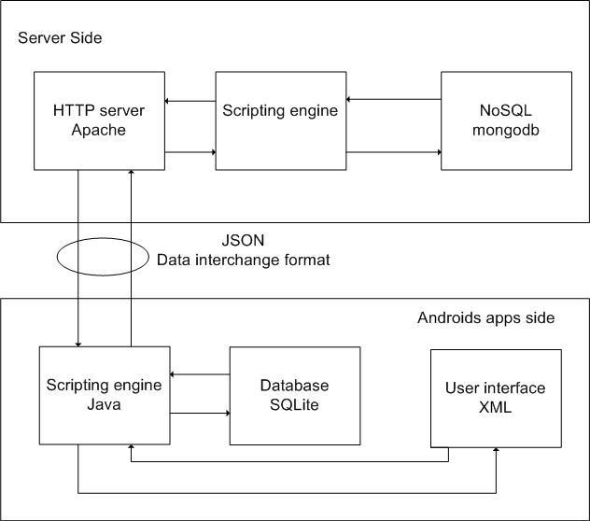

Figure 1: System Architecture for Solid Waste Collection Management

Through this architecture above, we can see different components which compose our system. Solid Collection Waste Management uses the structure of the web and mobile technology because we need data to be accessible everywhere in real-time. Web server

its main function is to store, process, and deliver information requests by the client. Android app will communicate with the web server using JSON technology. Each technology has a specific role to players in our system architecture.

## Design Model

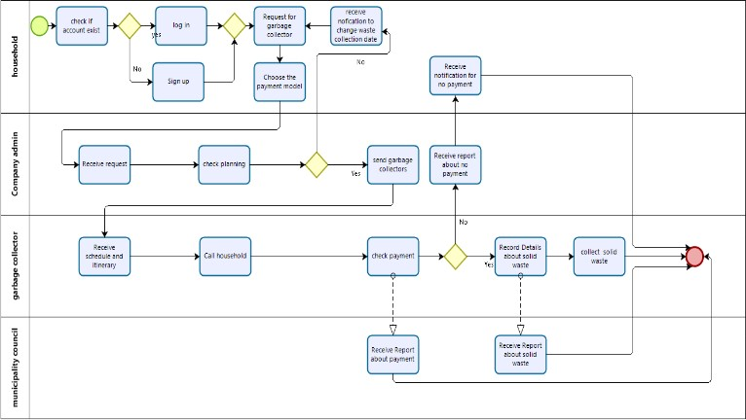

Figure 2: Design Model for Solid Waste Collection Management (Author’s design)

## Use case

One of the biggest problems in software development is capturing what we want to build. This is why we choose a modeling language to help us to bring out different artifacts of our model. The aim of a use case diagram UML is to describe how different users who can be a human or external system interact with the system. In our system, we have four actors (Household, garbage collector, waste Company administrator, and

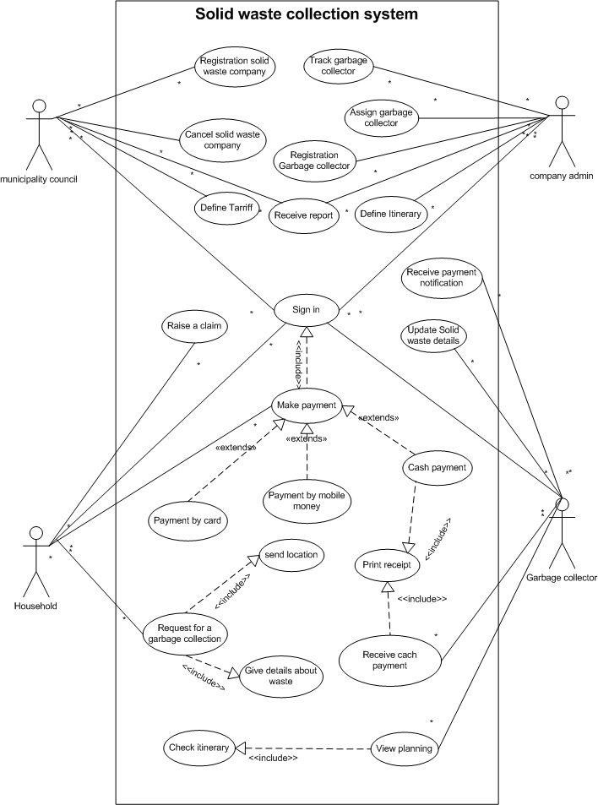municipality council) who interact with the system.

Figure 3: Use Case Diagram: Solid Waste Collection Management

The municipality council has the role to register new solid waste companies and give them access to the system. In the same logic, the municipality council can cancel or switch of the waste company account in case they do not respect their engagement or commitment. The tariff will be set by the municipality council because it depends on the area where the

company will collect the waste. Most cities work with private companies and it is the role of the municipally according to the

income of the population to set the amount that will be accessible by all. The municipality council will receive all statistics concerning the solid waste collection activities through the system; these statistics will help decision-makers and influence the future projection for solid waste collection management.

The company administrator is the one who has the privilege or the responsibility to manage the company session in the application. The first task for the admin is to assign a

garbage collector when a household requests for Solid waste collection service. Then make planning and define itinerary. At this point, the software should be able to suggest a shortest path which can be correct and improve or correct by the admin according to the location of the households. Each waste collector company can have more employees (garbage collectors …etc) and it is the role of the admin to register them in the system. Track garbage during the waste collection process is very

important for the effectiveness of the work; it will help to control in real-time and to have an overview of all activity.

The household when he/she requests for garbage collector, he can record details about his location and waste. Those details will help during the planning and dispatching of garbage collectors. The household can raise a claim and use different kinds of payment for waste charges.

The garbage collectors can see the planning made by the company administrator and check the itinerary. For solid waste collection, the company admin can send a team of garbage collectors. The garbage collector can receive money if the household chooses to pay in cash, but he must give him a receipt because of the traceability of money. However, the household pays using another kind of payment; the garbage collector will receive online a notification for confirmation of payment.

## DISCUSSION, RECOMMENDATIONS AND

**CONCLUSION**

## Discussion

The research responds to the need to develop a Mobile Application model for solid

waste collection management to aid in the promotion of a sustainable Solid waste collection management system and contributes to the knowledge about the importance of using mobile technology in solid waste collection management. The purpose of this research was to analyze and examine the solid waste collection management status and to design a Mobile Application model for solid waste collection management. One of the stages in Solid waste management it is solid waste collection, globally solid waste collection generation continues to increase year after year, urgently solid waste collection method becomes necessary (Bamodu, 2013).

Mobile technology is more and more a part of our lives, it positively affects our existence by allowing us to access various online services without leaving home. Nearly

3.7 billion people will access the web via their smart phone by 2025, which represents three quarters (72.6%) of internet users (WARC, 2019). Use this technology to change how solid waste collection is actually managed; we will be one of the best solutions because of its ease of use and accessibility. The benefit of using mobile technology in solid waste collection allow for integrated command and operations

that allow the municipality to monitor the city's solid waste collection services in real time, improve and synchronize solid waste collection activities by reducing collection time.GPS is another advantage of the mobile technology that is offered to us as it can be used to locate solid waste generators when they request a solid waste collection service and allow the garbage collector to geo-tag the solid waste generators and find the shortest way to reach each solid waste generator that will have a positive impact on the municipality's budget.

During our research we find some existing systems models which don't cover all solid waste collection management activities and technology used does not meet with the actual mode where mobile technology dominates the world. Using our model, the solid waste generators can request to pay for solid waste service in real-time and keep in touch with them. As we know Solid waste collection management, is one of the tasks of the municipality council which works with private solid waste collection companies linking by contract. Getting power by using an effective model will help the municipality to have an overview and control of all activities concerning the solid waste collection process.

The municipality council will get real data that will influence their decision making. Municipality authorities spend 20 to 50 percent of their budget for solid waste collection service. However even as such a level of budget, they can only collect around 50 to 70 % which includes coverage of less than 50 percent of the population (Chris Zurbrugg, 2015).

Using our model based on mobile technology will reduce the municipality authorities’ budgetary expenditure for solid waste service and help the municipality to cover more people in solid waste service. The solid waste companies will have the possibility of monitoring its activities by receiving households request, benefit of route optimization, planning for solid waste collection, and manage the team of garbage collectors.

## Recommendations

Human activities create solid waste daily; it is the way these wastes are treated in particular during the collection activities which can present a risk to the environments and health publics. With these rapidly urbanizing cities, problems, and issues of solid waste collection are immediately important. This is

why the use of the proposed model is strongly recommended. Mobile technology is used by everyone around the world even people have little computer knowledge. To assure effective solid waste management, the municipality should strive to involve the community at large and mobile technology is one of the solution can help to contribute to it.

## Conclusion

The research provides a Mobile Application model for solid waste collection management that could be successfully used to solve solid waste collection management problems. Observing the solid waste collection process has shown us the importance of proposing a solution that could be simple and respond to the trend of technology. The proposed model based on mobile technology will help to improve the solid waste collection management process by providing a powerful model that includes solid waste collection on- demand and route optimization. By using a Mobile Application model for solid waste collection management, the solid waste generators will contribute to mitigate the risk and effect that are often felt as a result of the careless handling of solid waste. This research work emphasizes the effectiveness and

effective ways for solid waste collection management using mobile technology, to guarantee a healthy lifestyle. Every day more and more devices are being connected to the internet. I will encourage researchers to work in this domain especially how to use IoT in solid waste collection management.

## REFERENCES

Adebayo, E. l. (2014). Development of A Web based GIS waste Disposal Management System for Nigeria.

*Information Engineering and Eletronic Business*, 1.

Alejandro, P. V. (2003). *ArgoUML User Manuel, A tutorial and reference description Page 1.*

Anthony Cilluffo, N. G. (2019, 07 17).

*World’s population is projected to nearly stop growing by the end of the century*. Retrieved 13 2, 2020, from pewresearch: https://[www.pewresearch.org/fact-](http://www.pewresearch.org/fact-) tank/2019/06/17/worlds-population-is- projected-to-nearly-stop-growing-by- the-end-of-the-century/

Antonis Mavropoulos, M. T. (2015, 5).

*researchgate*. Retrieved 14 2, 2020, from [www.researchgate.net:](http://www.researchgate.net/) https://[www.researchgate.net/publicati](http://www.researchgate.net/publicati) on/274398634_Urban_waste_manage ment_and_the_mobile_challenge

Bamodu, O. (2013). Application of Mobile Technology in Waste collection.

*Staffordshire*, 1.

Brian, C. M. (2004). *Entreprise Java Development on a Budget pp 27-77.* Berkeley: A Press Media.

Bryman. (2004). *Social Research Methods.*

London: Oxford University Press.

Chris Zurbrugg, R. S. (2015). Main Problem and issues of municipal solid waste management in developping countries with emphasis on Problems Related to Disposal by Landfill. *SANDEC AND EAWAG*, 3.

Dijkstra, E. (1956). *A note on two problems in connexion with graphs.* Numerische Mathematik.

D-Waste, P. (2013). *Mobile applications waste management recycling*. Retrieved from <http://www.dwaste.com/reports/wp_m> obile_applications_waste_managemen t_recycling_personal_behavior_logisti csdetail.html#.UfkOidJffVF (April 14,

2013) .

Elsevier. (2014). *The innovator role of technologies in waste management towards the sustainable development.*

Frank, M. (2016). *The Public-Private Sector Approach to Munincipal solid waste managemnet, How does it Work in Makindye Division.* Kampala, Uganda. Retrieved 02 02, 2020, from web.mit.edu: <http://web.mit.edu/africantech/www/ar> ticles/EnvChall.htm

Griffin, C. (2018). *What a Waste: SolidWasteManagement in Asia.* World Bank.

GSMA. (2019). *The Mobile Economy Sub- Saharan Africa .* London: GSMA.

Haghi. (2010). *Waste and waste management.*

New York, United States: Nova Science Publishers Inc.

Hardoy, M. a. (2001). *Environmental Problems in an Urbanizing.World: Finding Solutions for Cities in Africa, Asia and Latin America.* London: Earthscan.

Hoornweg, D. B.-T. (2012). *What a waste: a global review of solid. Urban*

*Development Series, Knowledge Papers (15).* Wordbank.

IDC. (2012, 03 13). *Media Tablet Shipments Outpace Fourth Quarter Targets; Strong Demand for New iPad and Other Forthcoming Products Leads to Increase in 2012 Forecast*. Retrieved from <http://www.idc.com/getdoc.jsp?contai> nerId=prUS23371312

International, O. (2017, September). *Waste Disposal Practices. 5th World Convention on Recycling and Waste Management*.

INTRAC. (2017). SECONDARY DATA SOURCE. *INTRAC*, 1.

J Singh, R. S. (2018). *The Importance of Waste Management to Environmental Sanitation: A Review. Adv. Biores.Vol 9.*

JSON. (2020). *json.* Retrieved 04 20, 2020, from json: https://[www.json.org/json-](http://www.json.org/json-) en.html

Kathleen, L. (2003). *Foundations for Research.* New Jersey, USA: Lawrence Elbaum Associates.

Kayleemasa, K. (2018). *A Web-based Solid Waste Management System for Sierra Leone.* Bergen: University of Bergen Norway.

Ken Peffers, T. T. (2006). *THE DESIGN SCIENCE RESEARCH PROCESS:A MODEL FOR PRODUCING AND PRESENTING INFORMATION*

*SYSTEMS RESEARCH.* Claremont: DESRIST .

Ken Peffers, T. T. (2007). A Design Science Research Methodology for Information Systems Research.

*Journal of Management Information Systems*, 45-77.

KNOWARTH, T. (2017, 3 28).

*@KNOWARTH.* Retrieved 2 25, 2020, from medium.com: [https://medium.com/@KNOWARTH/](https://medium.com/%40KNOWARTH/)

9-advantages-of-mobile-apps-over- responsive-ecommerce-websites- 6aed1e6db0d8

Lovemore, M. N. (2016). Integrated Municipal Solid Waste Management System.

*Mauritius Conference on Biological, Chemical and Angricultural Sciences (BCAS-16)* (p. 1). Bulawayo: Mauritius.

Mabogunje, A. L. (1995). *web.mit.edu.*

Retrieved 02 02, 2020, from web.mit.edu: <http://web.mit.edu/africantech/www/ar> ticles/EnvChall.htm

Mavropoulos, A. A. (2013). Mobile Applications & Waste Management. *D-Waste*.

Mitsuo, Y. (2018). *Situation of Municipal Solid Waste Management in African Cities .* Rabat: JICA.

*Mobile App*. (2018, 2 7). Retrieved 2 10, 2020, from study.com: https://study.com/academy/lesson/mob ile-app-definition-development- management.html

Moniruzzaman, B. ,. (2013). RECYCLING APPROACH OF WASTE PAPER AND PLASTIC IN KHULNA CITY

OF BANGLADESH. *Journal of Engineering Science* , 1.

Omeleka. (2004). Management of Environmental polution in Ibadan, An African City : The challenges of health hazard facing Goverment and the people. *Journal of human ecology*, 265-275.

Opera, J. (2008). Urban waste control and Management: Issues and challenges. *Journal of environemental management and Eduction*, 1-61.

Palczynski, J. (2014). *Study on solid waste management options for Africa.*

Abidjan, Cote d'ivoire: African Development Bank.

Palniktar. (2018). *Manual of solid waste management.* Mumbai: AIILSG.

Parliament, E. (2008). DIRECTIVE 2008/98/EC OF THE EUROPEAN PARLIAMENT AND OF THE

COUNCIL. *Official Journal of the European Union*, 10.

Patton. (2002). *Qualitative Research and Evaluation Methods.* London: Sage.

Rafferty, J. P. (2019, September). *Waste disposal. The collection, processing, and recycling or deposition of the waste materials of human society.*

Retrieved from https://[www.britannica.com/technolog](http://www.britannica.com/technolog) y/incinerator

Reinhardt. (2011). *Routing and scheduling problems.*

Rouse, M. (2013, 02). *searchsoftwarequality.*

Retrieved 04 20, 2020, from https://searchsoftwarequality.techtarge

:

https://searchsoftwarequality.techtarge t/definition/native-application-app

S, C. (2012). Sustainable Electronic Waste Management and Recycling Process. *American Journal of Environmental Engineering*, Vol. 2 No. 1, 2012, pp.

23-33. doi: 10.5923/j.ajee.20120201.05.

Shadi. (2020, 01 01). *Study.com.* Retrieved 07

11, 2020, from Study.com: https://study.com/academy/lesson/desi gn-process-in-software-engineering- steps-attributes-changes.html

Shukla, A., & Gehlod, L. (2014). A survey on phishing detection and prevention technique. *International Journal Of Engineering And Computer Science ISSN: 2319-7242*, 6255-6259.

Silpa Kaza, L. Y.-T. (2019, 09 20). *WHAT A*

*WASTE 2.0 A Global Snapshot of Solid Waste Management to 2050.* Wordbank. Retrieved 02 02, 2020, from https://[www.worldbank.org:](http://www.worldbank.org/)

https://[www.worldbank.org/en/topic/u](http://www.worldbank.org/en/topic/u) rbandevelopment/brief/solid-waste- management

Solanki, J., & Vaishnav, R. G. (2016). Website Phishing Detection using Heuristic Based Approach. *International Journal of Engineering and Technology*, 2044-2048.

Swarthout, S. (2020, 02 24). *android*

*developer.* Retrieved 04 20, 2020, from https://android- developers.googleblog.com/: https://android- developers.googleblog.com/2020/02/a ndroif-studio-36.html

Symantec. (2019). *2019 Internet Security Threat Report.* USA: symantec.

Tavares, Z. S. (2009). *Optimisation of MSW collection routes for minimum fuel consumption using 3D GIS modelling.* Google Scholar.

UN. (1992). *The Urban Environment in Developing Countries, Environment and National .* NewYork: UN.

UNEP. (2018, 12 23). *Legal Limits on Single- Use Plastics and Microplastics: A Global Review of National Laws and Regulations*. Retrieved 12 10, 2019, from wedocs.unep.org: https://wedocs.unep.org/bitstream/han dle/20.500.11822/27113/plastics_limit s.pdf?sequence=1&isAllowed=y

UNESCO. (2019). *New Methodology Shows that 258 Million Children, Adolescents and Youth Are Out of School.*

UNESCO institut for statics.

WARC. (2019, 01 24). *cnbc*. Retrieved from cnbc: https://[www.cnbc.com/2019/01/24/sm](http://www.cnbc.com/2019/01/24/sm) artphones-72percent-of-people-will- use-only-mobile-for-internet-by- 2025.html

WHO. (2019, 12 04). *World malaria report*

*2019*. Retrieved 12 5, 2019, from [www.who.int:](http://www.who.int/)

https://[www.who.int/news-](http://www.who.int/news-) room/feature-stories/detail/world- malaria-report-2019

Williams. ((2003)). Green waste collections and public recycling behavior in the borough of wyre resources,Conservation and Recycling, Elsevier Applied Science Publisher. *, vol. 38,*, pp. 139-159.

Wordbank. (2009). *Environmental Guidelines for Small-Scale Activities in Africa (EGSSAA) (IRG), Chapter 15 Solid waste: generation, handling, treatment and disposal.* Newyork.

Wordbank. (2018, 09). *What a Waste: An Updated Look into the Future of Solid Waste Management.* Retrieved 04 29,

2020, from https://[www.worldbank.org/.](http://www.worldbank.org/)

yowasteapp. (2019). *yowasteapp*. Retrieved 15

2, 2020, from yowasteapp.com: https://yowasteapp.com/

Zurbrugg, C. (2002). Solid Waste Management in Developing Countries. *SANDEC / EAWAG*, 1.

## BIOGRAPHY OF AUTHORS

**Kasereka Henrys**, he received his B.Sc. Degree in Computer Science from the University of Kinshasa. He completed his Master of Computer Science degree from Bugema University in



software engineering. Got an online specialization in Data Science on coursera provided by Johns Hopkins University. He is interested in the field of data science, mobile and web programming.

# 19

[View publication stats](https://www.researchgate.net/publication/350193293)

Electronic copy available at: https://ssrn.com/abstract=3808542