# Private endpoint zone shares a file on a private network Restrict Public Access

**Abstract**

In this project we are fixing storage account problems, for example, we have a company that has a file storage server and these servers are connected to many networks if we are connected to a network then we can switch from one network to another easily. For example, my system is connected to a single network which is 192.168.3.0 (the public network of the company) and the private network of that company is 10.70.0.1 now I can easily switch between these two networks both have their firewalls but both are connected to a single router. In this way, a person who is not a part of the admin can easily access file storage servers and can retrieve important information. So, to fix this problem we switch from non-cloud to cloud. And use the private endpoint zone. In this project, we will share a file from one computer to another using personal finish purpose on azure utilizing a personal network and constructing a private DNS zone.

This release aims to help organizations get the safe arrangement of Domain name System (DNS) administrations throughout a venture. It offers practical, certified guidance on gaining each facet of DNS within the association visible of associate examination of the operational environment and associated hazards. Right now, the DNS not being the objective of many assaults, but as hosts become bigger guard conscious, and applications begin to depend on the DNS framework for the tasks of networks, the DNS foundation can be converted into a very attractive objective. A definitive objective for DNSSEC is complete cause complete space tree on the inspiration aspect, and execution in the applications which will request the administrations given by DNSSEC. Nowadays there are not any useful hubs within the DNS space tree that offers DNSSEC capacities. So the initial move towards full organization is to offer DNSSEC the ability to space subtrees that have more security desires. Once DNSSEC skills are typically accessible within the framework, application engineers can truly wish to foster DNSSEC-mindful applications and then afterward use DNSSEC as a way for network security.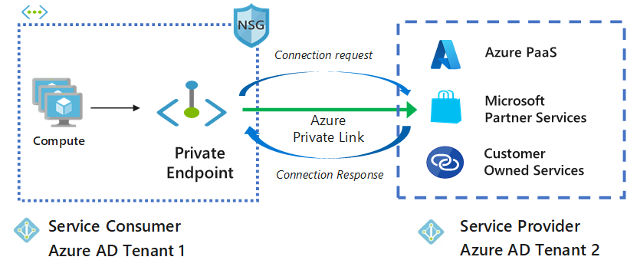

**Introduction**

The Internet is the globe's greatest enrolling network, with a capacity of 580 million purchasers. As indicated by the angle of a shopper, every center purpose or a resource on this association is afterward recognized through an outstanding name: the house name. Picture result for personal finish purpose a personal terminus is a corporation interface that utilizes a personal informatics address from your virtual organization. This organization interface associates you on the QT and safely to a facility that's controlled by Azure personal Link. By empowering a personal terminus, you are transferal the help into your virtual organization

The SMB convention was at first created by IBM as a client-server convention for about to shared documents, and printers over the network, and for empowering method correspondences. Created once in a while to fulfill dynamic organization conditions. The convention works at the appliance layer and might impart on port 445 over TCP/IP. Azure DNS may be a service of hosting for the domains of DNS that gives a resolution of name by victimization infrastructure of Microsoft Azure. Your domains being hosted in Azure, your DNS records will be managed by victimization constant credentials and others like API, tools, and asking as an alternative Azure service

**Related Work / Literature Review**

Storage security could be a space specialty of security that is involved in securing information of storage systems, ecosystem, and also information that is on them. The storage security will depict the convergence of the given network, storage and security disciplines, technologies, and method plan for the aim of protecting and securing digital resources. Security of storage is targeted on the physical, technical, and body control, similarly because detective, preventive, and corrective controls are related to systems of storage and infrastructure.

Ensuring the sufficient confidentiality, stability, and convenience of the information held on and access to the current and rising storage technology needs a joint effort on the ICT layer (Information and communications technology). Several protection efforts:

1. Safeguarding the capacity, the board (activities and interfaces), and the data restoration and recuperation assets.
2. Guaranteeing the sufficient declaration and trust of the board.
3. Information is moving, rest, and in accommodation security.
4. Calamity recuperation and Business congruity support.
5. Appropriate disinfection and removal.
6. Secure autonomous information movement and secure multi-tenancy.

**Storage Security Risk**

The risk of security is made by an associate organization's use of a specific storage system or infrastructure. Storage security risk is raised by the threats focusing on the data being managed by the storage system and the infrastructure, flaws (both technical and non-technical), and also the effect of roaring exploitation of the flaws by a warning.

Risk management is a significant concept in data security, and the strategy applies to the entire organization as a whole, as a separate section of the organization (e.g. Branch and tract, facility), one of the operations, concurrent or being arranged, or a specific feature of management (Business Continuity planning). The given method is formed on the context institution, assessment of warning, treatment of the risk, acceptance of the risk, communication of the risk, watching, and also a review of risk.

Given warnings will create a large risk. However, for the storage system infrastructure the risks related to information breach, information corruption, and destruction, are temporary and maybe a permanent and complete loss of access and availability, failure satisfaction statutory, managerial, legal necessities area unit the most important considerations.

**Data Breaches**

A data leak could be one of the consequences of a security breach, and it could take numerous forms. The unauthorized access and revelation of protected data area unit 2 are usually recognized kinds of information breaches, however, it's vital to know that lesser celebrated forms will embody the accidental or any unlawful destruction, loss, or alteration of the information. Resulting in quantity and kind of the knowledge concerned (in person distinctive data, health protected data, etc.) In addition to applicable laws and regulations, an information breach exposes the organization to significant risk as a result of the costs involved in work info breach, creating notifications to strained people, proceeding expenses, regulatory fines, and alternative legal penalties comparable to total harm accruing from the general public disclosure of info breach.

An entity that loses its or others protected data faces both economic and threat concerns. Non-trusted or unauthorized bodies seeking to disclose leaked data may come from a wide range of sources, be well-funded, and have several reasons. While cloud storage providers perform much of the work when it comes to keeping your data secure, you have a vital role to play as well. Here are four actions you may take to make positive utility storage as secure as possible.

**Activate two-step verification**

The maximum utility space suppliers supply a choice to defend the account with two-step verification. It needs us to simply avail each watchword and one-time confirmation code distributed to our device or any given email address, to get to log in to our utility space area. Due to this, attackers cannot simply force the lock of your account though they crack the watchword. Two-factor authentication is usually switched off by default once got wind of a replacement cloud storage account. Confirm switch this setting on to higher defend your knowledge.

**Protect the secret writing key**

The major catch to end-to-end secret writing is while not a secret writing key, that usually accounts for a watchword, no credit in looking back to the knowledge. If you miss placing the code, the utility supplier will not activate in facilitating. Invariably have a duplicate of your code accessible if you miss a place or can't remember it. Nevertheless, you do not need a duplicate of secret writing code for hackers to get their hands on. Contemplate writing the down key and assuring its security. Up to you if you wish to have a digital copy of the code, for that have a handheld device referred to as a hardware security module. This puts the key behind a firewall, so it can’t have access to your pc when hacked.

**Check apportions files**

Utility space allows it to be simple to apportion the files to/with anyone. Connections with files that offer anytime access, on the other hand, put knowledge at risk. Check the files and folders you've sent to someone from an account regularly and cancel the grant for anyone who does not want it. If your utility supplier grants links passwords and termination dues activate the following options rather than sending unhindered access to the files.

Utility space gives max knowledge security. Once you store knowledge within the cloud, the files area unit is encrypted and incessantly monitored to safeguard against cyber security threats. Knowledge is additionally held on redundantly to confirm that a duplicate can survive any catastrophe

**Proposed Project**

Secure Accessibility – Resources with personal Endpoints are accessible from the customers at intervals identical virtual network, regionally/globally peered virtual network, still as on-premises networks mistreatment VPN or categorical Route.

Unidirectional property – Network connections are one-way and are initiated by the customers for the personal end resource. Connections can't be initiated from the personal Link resource to the customers.

Consistent IP Address – once a personal end is made for a resource, a personal IP address from the virtual network is dynamically allotted, and that doesn't modify and remains consistent throughout the lifecycle of the resource. [1]

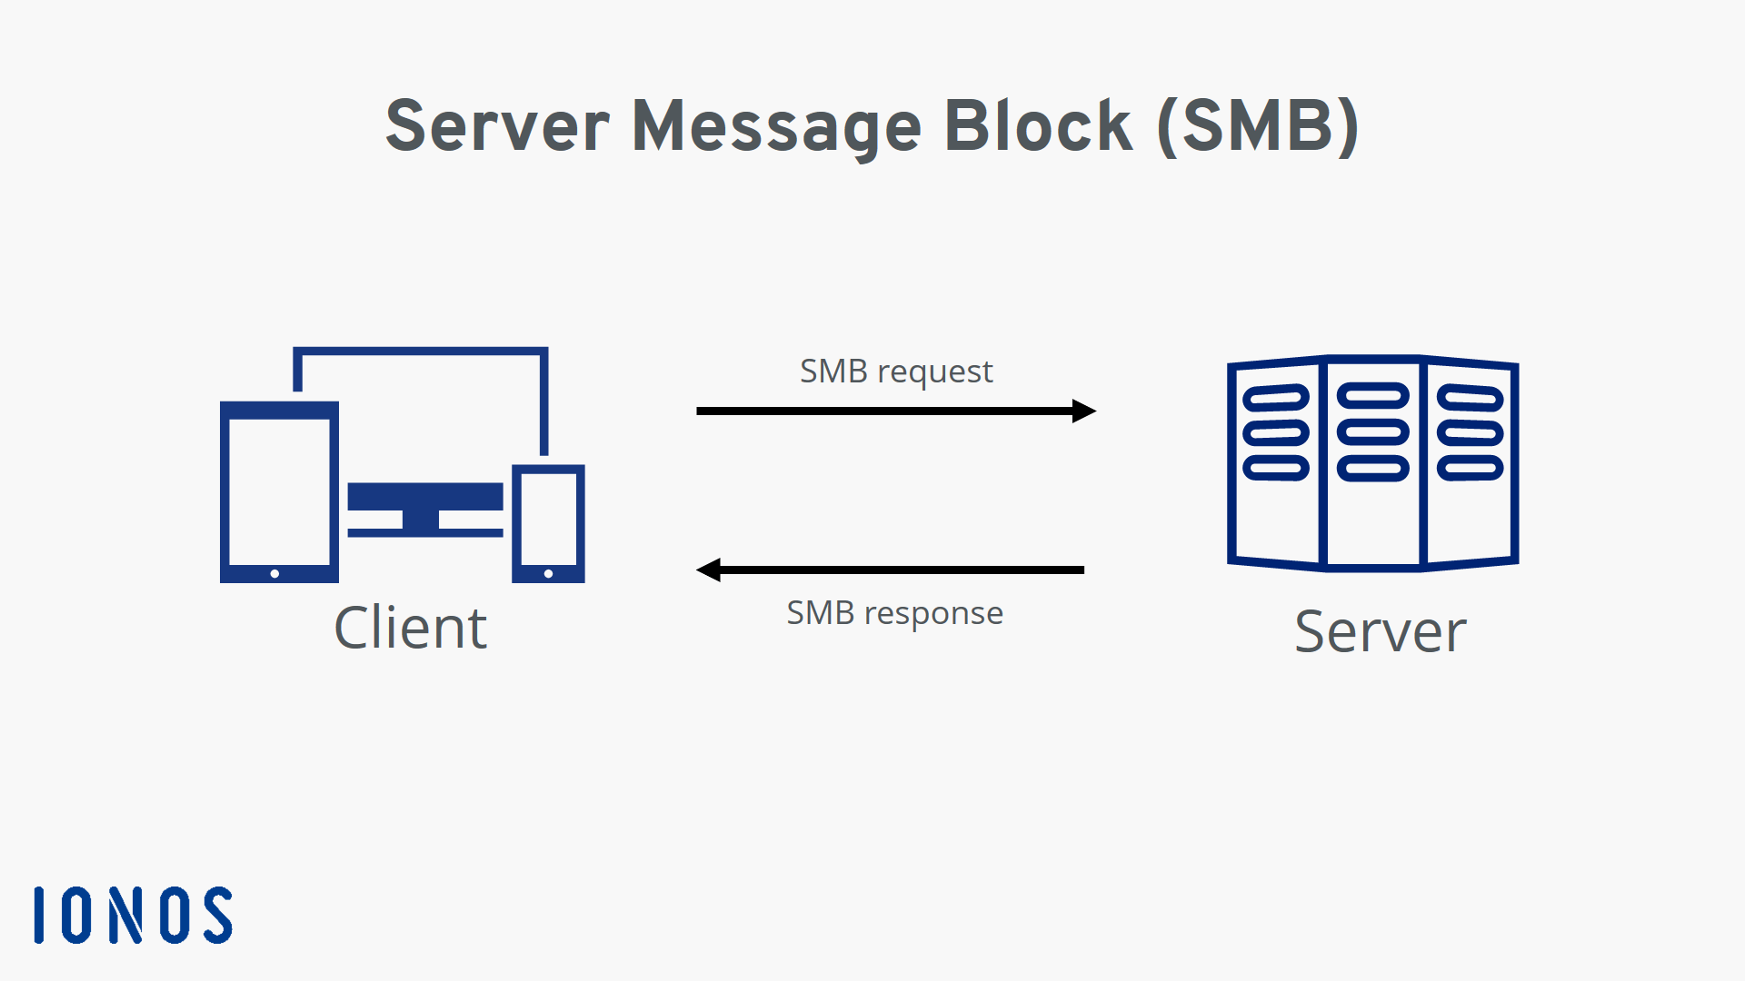Same Region Existence – The personal end should be redistributed within the identical area because of the internet, whereas personal link resources will be deployed in an exceedingly completely identical area.

Private end Limitations – Multiple personal Endpoints will be created at intervals with identical virtual networks. There will be a thousand personal Endpoints per virtual network and have a most of 64000 personal Endpoints per subscription.

Secure Accessibility – Resources with personal Endpoints are accessible from the customers at intervals identical virtual network, regionally/globally peered virtual network, still as on-premises networks mistreatment VPN or categorical Route.

Unidirectional property – Network connections are one-way and are initiated by the customers for the personal end resource. Connections can't be initiated from the personal Link resource to the customers.

Consistent IP Address – once a personal end is made for a resource, a personal IP address from the virtual network is dynamically allotted, and that doesn't modify and remains consistent throughout the lifecycle of the resource.

Same Region Existence – The personal end should be redistributed within the identical region because of the internet, whereas the personal link resource will be redistributed in an exceedingly completely unidentical area.

Private end Limitations – Multiple personal Endpoints will be created at intervals with identical virtual networks. There will be a thousand personal Endpoints per virtual network and have a most of 64000 personal Endpoints per subscription.

As you mentioned, just one personal DNS Zone (E.g., privatelink.blob.core.windows.net) will be tied to a VNET. This can be so that the VNET is aware of wherever to route traffic to.

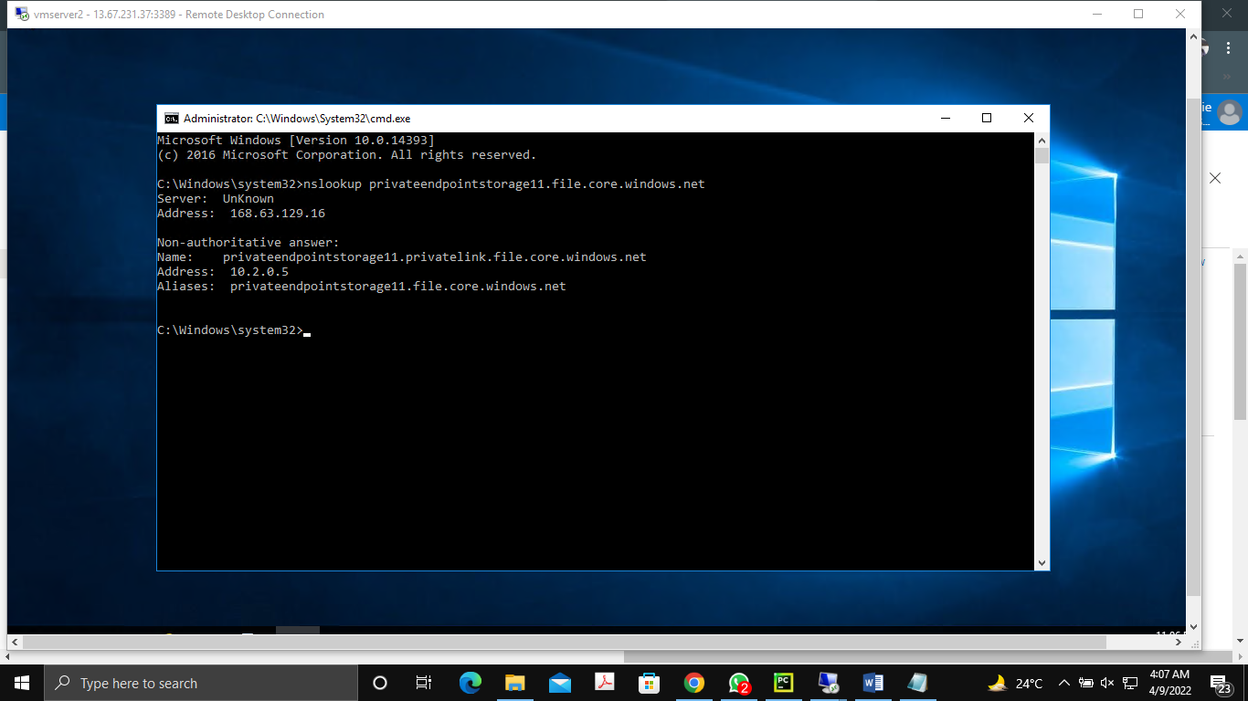

Resource teams' area units are typically simply logical containers used for access management. Resources you place in every Resource cluster typically depend on your organization's necessities or location necessities. Inline therewith, it might solely be that your personal DNS Zone is within the same Resource cluster as your VNET as it is tied to the VNET. [2]

In the future, you may have extra Storage Accounts, in numerous Resource teams, for alternative comes, which can use constant personal DNS Zone. Hence, it might not be to tie a 'shared' resource to a specific project/Resource cluster. On the opposite hand, personal Endpoint’s area unit joined to a particular resource. This implies their lifecycle will be tied thereto resources. Hence, it makes a lot of sense for them to be within the same Resource cluster because of the resource they talk over with.

The recommendation of design is simple: every project (scopes of however resource area units are managed by identical teams) should have its DNS zone.

**Project details / Proposed Solution**

A private terminal could be a network interface that uses your internet's web address. This network interface connects securely and privately to a service powered by an Azure non-public link. You receive the service into your virtual network by authorizing a personal terminal.

The service can be Associate in Nursing Azure service such as:

1. Azure Storage
2. Azure Cosmos sound unit
3. Azure SQL information
4. Your service, victimization non-public Link service.

## Authentication in Azure Authentication

For assets in Azure purposes the RBAC model (Role-based access control is a method of restricting network access based on the roles of individual users within an enterprise) for the board plane or entryway level access. Nonetheless, individual administrations facilitated in Azure, including smb, have their verification components. The favored strategy for verification of uses in Azure is through Azure Active Directory. It is a cloud-based way of life as a help presented from Azure that can be coordinated with a wide assortment of uses facilitated in the cloud as well as in your corporate network.

## **Azure AD Domain**

When you pursue an Azure cloud membership, a case of Azure AD is provisioned for you, which is called an Azure AD inhabitant. A devoted Active Directory that has an area name in the configuration <domain name>. Onmicrosoft.com is doled out to each occupant. All clients, gatherings, and applications connected to your association's Azure AD occupant will be essential for this Azure AD space. You can utilize custom space names with Azure AD, where clients can be made in Azure AD with your association's area name.

## Mount Azure File storage on Linux VMs using SMB | Teckadmin**Azure Files**

Files are the overseen documents shared in the cloud that can be gotten to over Server Message Protocol (SMB) from on-premises as well as cloud-based machines. The document offers can be straightforwardly provisioned from the Azure entryway, without going through the difficulty of provisioning a whole foundation to have the offers. It is a cross-stage administration, where the offers can be gotten from Windows, Linux, or MAC OS, given that they support SMB. Azure Files additionally [2]

## **Azure Files Share Access**

Azure Files utilizes SMB 3.0 and HTTPS for secure information access. You can likewise settle on REST API decisions from your applications to a facilitated Azure Files share. Validation of Azure documents is finished utilizing shared admittance signature (SAS) tokens while getting to the offers over REST API. For getting to over SMB, verification is finished utilizing stockpiling access keys. The disadvantage here is that anybody having capacity access keys can get to the record share, which is a degree of straightforwardness that a security review may be concerned with. Cloud Volumes ONTAP(software-defined storage offering that delivers advanced data management for file and block workloads) then again upholds AD-based(Active directory) confirmation for the document shares facilitated in the assistance, so clients can have fine-grain command over who approaches explicit offers and records provisioned utilizing the help

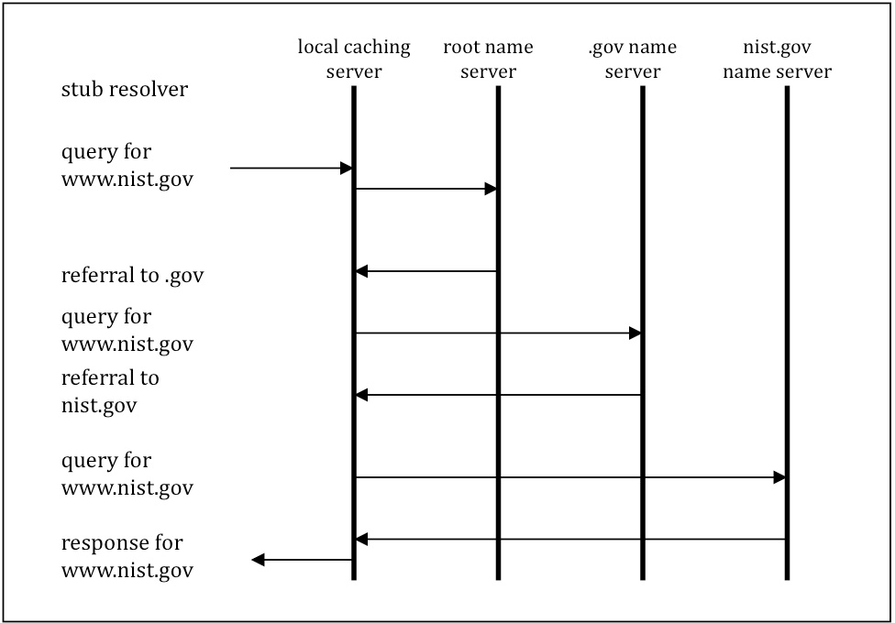

Figure 2 Name Resolution Process (without cache search)

## **SMB**

The Server Message Block (SMB) standard is an organization record sharing standard that allows PC applications to read and write to documents as well as request services from server programs in a PC network.

The SMB convention can be used in conjunction with the TCP/IP or other organization standards. The SMB convention permits clients to get to shared records on a far-off server through a bunch of solicitations sent between the client and the server through information parcels. These incorporate fundamentally meeting control bundles and document access parcels. [3]

## **Domain Name System**

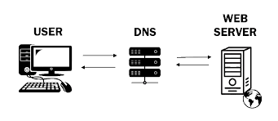The Domain Name System (DNS) is a multi-leveled, decentralized name system for distinguishing pcs, administrations, and other assets accessible over the Internet or other Internet Protocol organizations. The DNS partner space names contain asset entries with various sorts of data.

## 

## **Web technology**

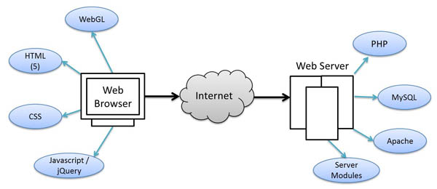Web technology refers to how computers communicate with one another using markup languages and mixed media files. It provides a site-like interface for interacting with assisted data. Hypertext markup language (HTML) and falling templates are examples of web innovation (CSS)

Figure 8 Protocol of WEB Technology

## **DNS BIND**

A tie is an open-source framework allowed to download and utilize, presented under the Mozilla Public License. A tie can be utilized to run a reserving DNS server or a legitimate name server and gives highlights like burden adjusting, inform, dynamic update, split DNS, DNSSEC, ipv6, and then some [4]

## **Microsoft Azure**

On the public platform DNS, Azure produces a canonical name DNS record (CNAME). The CNAME record redirects the resolution to a private domain name. The private IP address of your private endpoints can be used to override the resolution. The connection URL does not need to be changed in your apps. [5]

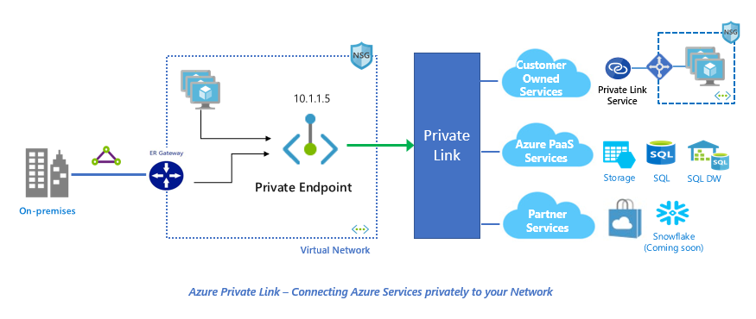

**Discussion and Future Work**

One of the simplest/most mentioned situations is the capacity to each an Azure SQL Database secretly from a Virtual Network, without presenting it to the Internet, or utilizing its Public IP address

The below picture is shown as a Practical device (SQL client) positioned on Avnet/Subnet (vneteastus/VM), an Azure SQL DB (azuresqlprivatedb01) deployed within an Azure SQL server (azuresqlpriavte).

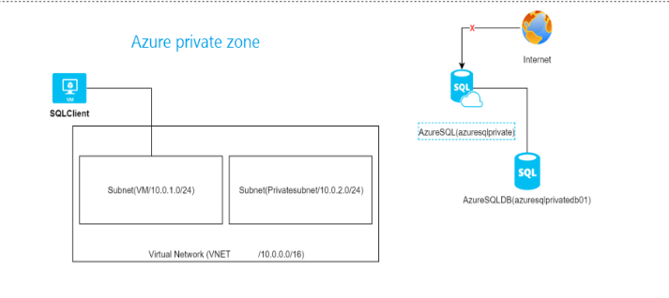

The main goal is for the VM (SQL client) to reach azure SQL private on a personal association, not through the web (won't permit any scientific discipline for consuming the Azure SQL server via the firewall)

**Solution via Private Endpoints**

The mixture is making a personal endpoint that can reveal the Azure SQL server through a personal information processing address on a netmask. The subsequent image will show a personal endpoint (PE) that is the victimization information processing address from the subnet Private subnet is connected to azure SQL private

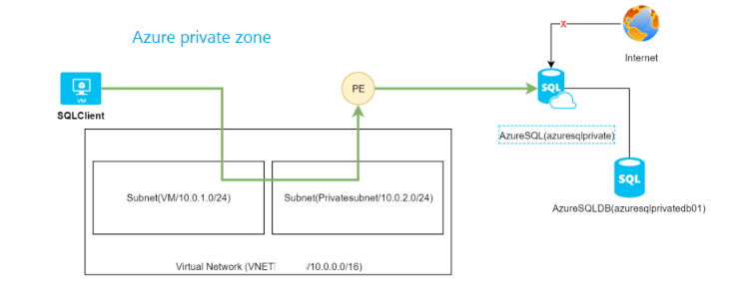

**Deploy the answer via the Azure Gateway**

1. Visit non-public link center –> non-public endpoint –> Add
2. The required information like the Subscription
3. For the source that will simply need to form a personal end for (in my case it is the azure SQL private Azure SQL server
4. Choose for vnet/netmask that may modify access to your resource. Beneath the hood, a network interface (NIC) is created, allotted an informatics address, and allotted to your resource Will be able to additionally integrate the resource with an azure non-public DNS zone so as that simply can decision the non-public end employing a DNS name. It is often not needed as you will produce your DNS record on your DNS service (a record)
5. At the end of development, you will notice:

The non-public end made an association type is accepted Approved meant the azure SQL party has approved the non-public end, this is often helpful once each party isn't from an equivalent team/tenant, anywhere the requester will elicit the non-public end association, let the head agree that. Additionally, you will cancel these associations at any time.

NIC (Network interface card) is made and redistributed on the subnet

DNS list is made (in case it has got enabled a non-public DNS option)

1. Secure the access to the non-public termination

Now that we've got a non-public approach to PAAS service, are there any ways to secure access to it? [6]

Use network security teams for a letter of alphabet inbound: you'll produce associate NSG(Network Security Group) apply it on the netmask NIC, non-public termination NIC, and clear incoming rules like every different NSG seems like this not nonetheless supported on a general common view

Applying an NSG to the NIC is not hold up

Applying an NSG to the Subnet is without any effect on Private Endpoints.

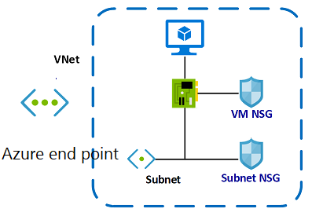

Use security teams’ network for leaving, you will sieve outward-bound traffic from the source to your non-public endpoints: that is often supported however it is not convenient, since it is higher on filter on destination and is not supply, once on securing the access from a destination position (image shows rule that the block access to the non-public scientific discipline of the non-public termination, applied to the SQLSQL client VM)

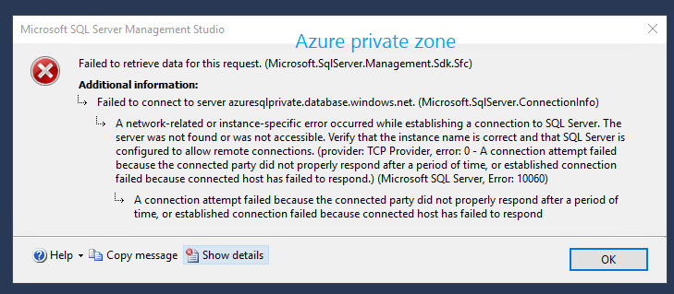

Since medical area address of private termination is on periods you’re VNET, you may clear out get right of entry to thereto in your perimeter firewalls like Azure firewall or your firewall [2]

**Conclusion**

The Internet's DNS framework works comparable to a smartphone listing via way of means of coping with the making plans amongst titles and numerals. DNS servers allow elucidation of adjuration for titles into web addresses, being in charge of which server a cease patron will appear at once into their net browser. These adjurations are known as questions.

Finally, we can share a file using azure DNS and a private endpoint. Since Azure file shares support industry-standard SMB and NFS (client/server) protocols, you can seamlessly replace your on-premises file shares with Azure file shares without fear of application compatibility issues. Private Link gives a safe method for relocating jobs to Azure. Insurance against information spillage: A private endpoint is planned for a case of a PAAS asset rather than the whole assistance. Buyers can associate with the particular asset. Admittance to some other asset in the assistance is obstructed.

Traffic can arrive at the help asset from on-premises without utilizing public endpoints. A Service Endpoint stays a freely routable IP address. A Private Endpoint is a private IP in the location space of the virtual organization where the private endpoint is arranged. Private Endpoints area unit associate degree evolution of Azure infrastructure. The direct configuration effort and in-progress service asking to be used mean you ought to fastidiously contemplate whether or not your organization wants them. As an example, if you wish to dam all network traffic to a service whereas creating services on the market to on-premises traffic, or if you wish to secure specific sub-resources in your virtual network, Azure currently offers that capability through non-public endpoints.

**The chosen cipher used in the *DOMAIN NAME SYSTEM (DNS)* is explained below**.

An Address

ACL Access Control List

AD Authenticated Data

ARP Address Resolution Protocol

CA Certificate Authority

ccTLD Country-code Top-level Domain

CD Checking Disabled

DHCP Dynamic Host Configuration Protocol

DNS Domain Name System

DNSSEC Domain Name System Security Extensions

DSA Digital Signature Algorithm

DSS Digital Signature Standard

HINFO Host Information

IN Internet

IP Internet Protocol

ISP Internet Service Provider

IT Information Technology

LAN Local Area Network

MAC Message Authentication Code

NS Name server

OS Operating System

RRSIG Resource Record Signature

SEP Secure Entry Point

SHA Secure Hash Algorithm

SHS Secure Hash Standard

TCP Transference Control Protocol

TLD Top-level Domain

TSIG Transaction Signature

TXT Text

UDP User Datagram Protocol

# References

|  |  |
| --- | --- |
| [1] | N. U. New Jersey, "Design the Azure Virtual Desktop Architecture," in *Design the Azure Virtual Desktop Architecture*, 2022. |
| [2] | S. Belgrade, "Virtual Networks in Azure," in *Virtual Networks in Azure*, 2021. |
| [3] | S. R. a. A. Nakassis, "Minimizing Information Leakage in the DNS," *IEEE Network Magazine vol. 22 no. 2,* p. 20, 2008. |
| [4] | S. Belgrade, "Azure Storage," in *Azure Storage*, 2021, p. 27. |
| [5] | T. G. Tejaswi Redkar, "Windows Azure Platform," in *Windows Azure Platform*, 2011, p. 581. |