# Private end point zone share a file on private network Restrict Public Access

**Abstract**

In this project we are fixing storage account problem for example we have a company which has file storage server and these servers are connected to many networks if we are connected to a network then we can switch from one network to another easily. For example my system is connected to a single network which is 192.168.3.0 (public network of the company) and the private network of that company is 10.70.0.1 now I can easily switch between these two networks both have their own firewalls but both are connected to a single router. In this way a person who is not a part of admin can easily access file storage servers and can retrieve the important information. So to fix this problem we switch from non-cloud to cloud. And use the private end point zone

In this project we are able to share a file one machine to different machine via personal finish purpose on azure exploitation personal network and creating a non-public DNS zone

This distribution tries to assist associations in obtaining the safe arrangement of name System (DNS) administrations during a venture. It provides all the way down to earth, certifiable direction on obtaining each facet of DNS within associate association visible of associate examination of the operating climate and connected dangers.

Right now, the DNS is not the objective of most assaults, but as hosts become bigger security conscious, and applications begin to rely on the DNS framework for network tasks, the DNS foundation can be converted into a very attractive objective. A definitive objective for DNSSEC is full causing across the complete space tree on the inspiration aspect, and execution in applications which will request the administrations given by DNSSEC. Nowadays there are not any useful hubs within the DNS space tree that offers DNSSEC capacities. So the initial move towards fully organization is to offer DNSSEC ability to space subtrees that have high security desires. Once DNSSEC skills become typically accessible within the framework, application engineers can truly wish to foster DNSSEC-mindful applications and afterward use DNSSEC as a way for network security.

**Introduction**

The Internet is that the world's greatest enrolling network, with quite 580 million purchasers. As indicated by the angle of a shopper, every center purpose or resource on this association is recognized by an outstanding name: the house name.

Picture result for personal finish purpose a personal terminus is a corporation interface that utilizes a personal informatics address from your virtual organization. This organization interface associates you on the QT and safely to a facilitate that's controlled by Azure personal Link. By empowering a personal terminus, you are transferal the help into your virtual organization

The SMB convention was at first created by IBM as a client-server convention for about to shared documents, printers over network, and for empowering between method correspondences. Completely different renditions of the convention, usually referred to as tongues, were created once a while to fulfill dynamic organization conditions. The convention works at the appliance layer and might impart on port 445 over TCP/IP

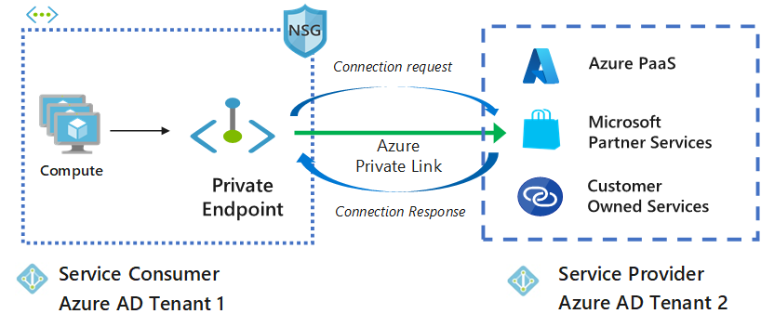Azure DNS may be a hosting service for DNS domains that gives name resolution by victimization Microsoft Azure infrastructure. By hosting your domains in Azure, you'll manage your DNS records by victimization constant credentials, APIs, tools, and asking as your alternative Azure services

**Related Work / Literature Review**

Storage security could be a specialty space of security that's involved with securing information storage systems and ecosystems and also the information that resides on these systems. Storage security represents the convergence of the storage, networking, and security disciplines, technologies, and methodologies for the aim of protective and securing digital assets.

Storage security is principally targeted on the physical, technical and body controls, similarly because the preventive, detective and corrective controls related to storage systems and infrastructure.

Ensuring adequate confidentiality, integrity, and convenience of information hold on and accessed on current and rising storage technologies needs a joint effort among this layer of ICT (Information and communications technology). Several security efforts can focus on:

* Protecting storage management (operations and interfaces), information backup and recovery resources
* Ensuring adequate certificate and trust management
* Data in motion, rest, and convenience protection
* Disaster recovery and Business continuity support
* Proper sanitization and disposal

Secure autonomous information movement and secure multi-tenancy

**Storage Security Risk**

Storage security risk is made by associate organization’s use of specific storage systems or infrastructures. Storage security risk arises from threats targeting the data handled by the storage systems and infrastructure, vulnerabilities (both technical and non-technical) and also the impact of roaring exploitation of vulnerabilities by threats.

Risk management could be a key construct in data security and its method may be applied to the organization as an entire, any separate a part of the organization (e.g. a department, a physical location, a service), any system, existing or planned or specific aspects of management (e.g. Business Continuity planning). This method consists of context institution, risk assessment, risk treatment, risk acceptance, risk communication, and risk watching and review.

Threats for storage systems and infrastructure embody things like:

* Unauthorized usage and access
* Liability because of regulative non-compliance
* Corruption, modification, and destruction of information
* Data run and/or breaches
* Theft or accidental loss of media
* Malware attack
* Improper treatment or sanitization when end-of-use

These threats will create to a large assortment of risks. However, for storage systems and infrastructure the risks related to information breaches, information corruption or destruction, temporary or permanent loss of access/availability, and failure to satisfy statutory, regulatory, or legal necessities area unit the most important considerations.

**Data Breaches**

A data breach may be one amongst the results of a security compromise and it will take several forms. Unauthorized access or revelation of protected data area unit 2 usually recognized kinds of information breaches, however it's vital to know that lesser celebrated forms will embody accidental or unlawful destruction, loss, or alteration of information.

Depending on the quantity and kind of knowledge concerned (e.g., in person distinctive data, protected health data, etc.) and also the applicable laws and laws, an information breach will expose the organization to vital risk arising from prices concerned in work the info breach, creating requisite notifications to affected people, proceeding expenses, regulative fines and alternative legal penalties similarly as whole harm accruing from the general public revelation of the info breach.

There are a unit economic and security risks to the entity that has lost their or others’ secured data. Untrusted or unauthorized entities seeking this leaked or spilled data may be of a broad vary of sources, be funded and have numerous motivations.

While cloud storage suppliers do most of the work once it involves keeping your knowledge secure, you have got a very important role to play additionally. Here are a unit four belongings you will do to create positive your cloud storage is as secure as attainable.

**Turn on two-factor authentication**

The majority of cloud storage suppliers supply a choice to defend your account with two-factor authentication. This needs that you simply have each your watchword and a one-time verification code that is distributed to your phone or email inbox, to log in to your cloud storage account. As a result, attackers can’t simply force the lock your account though they crack your watchword.

Two-factor authentication is usually turned off by default once you got wind of a replacement cloud storage account. Confirm you switch this setting on to higher defend your knowledge.

**Protect your secret writing key**

One major catch to end-to-end secret writing is that while not your secret writing key, that is usually your account watchword, there’s no thanks to access your knowledge. If you lose your key, your cloud supplier won’t be ready to facilitate. Invariably keep a backup copy of your key accessible just in case you lose or forget it.

However, you don’t need to stay a duplicate of your secret writing key somewhere that hackers may doubtless get their hands on that. Contemplate writing down your key and keeping it somewhere secure. If you wish to stay a digital copy of your key, you'll use a physical device referred to as a hardware security module. This puts your key behind a firewall, in order that it cannot be accessed through your pc is hacked.

**Check your shared files**

Cloud storage makes it simple to share files with friends, family, and colleagues. However making links to your files that provide unlimited access will leave your knowledge vulnerable.

Periodically audit that files and folders you’ve shared from your cloud account, and revoke access for anyone WHO now not wants it. If your cloud supplier offers links with passwords and expiration dates, place these options to use rather than sharing unrestricted access to your files.

Cloud storage is meant from the bottom up for max knowledge security. Once you store knowledge within the cloud, your files area unit encrypted and incessantly monitored to safeguard against cybersecurity threats. Your knowledge is additionally hold on redundantly to confirm that a duplicate can survive any catastrophe

**Proposed Project**

Secure Accessibility – Resources with personal Endpoints are accessible from the customers at intervals identical virtual network, regionally/globally peered virtual network, still as on-premises networks mistreatment VPN or categorical Route.

Unidirectional property – Network connections are one-way and are initiated by the customers for the personal end resource. Connections can't be initiated from the personal Link resource to the customers.

Consistent IP Address – once a personal end is made for a resource, a personal IP address from the virtual network is dynamically allotted, and that doesn't modification and remains consistent throughout the lifecycle of the resource.

Same Region Existence – The personal end should be deployed within the same region because the virtual network, whereas the personal link resource will be deployed in an exceedingly completely different region.

Private end Limitations – Multiple personal Endpoints will be created at intervals identical virtual network. There will be a thousand personal Endpoints per virtual network and have a most of 64000 personal Endpoints per subscription.

Secure Accessibility – Resources with personal Endpoints are accessible from the customers at intervals identical virtual network, regionally/globally peered virtual network, still as on-premises networks mistreatment VPN or categorical Route.

Unidirectional property – Network connections are one-way and are initiated by the customers for the personal end resource. Connections can't be initiated from the personal Link resource to the customers.

Consistent IP Address – once a personal end is made for a resource, a personal IP address from the virtual network is dynamically allotted, and that doesn't modification and remains consistent throughout the lifecycle of the resource.

Same Region Existence – The personal end should be deployed within the same region because the virtual network, whereas the personal link resource will be deployed in an exceedingly completely different region.

Private end Limitations – Multiple personal Endpoints will be created at intervals identical virtual network. There will be a thousand personal Endpoints per virtual network and have a most of 64000 personal Endpoints per subscription.

As you mentioned, just one personal DNS Zone sort (E.g. privatelink.blob.core.windows.net) will be tied to a VNET. This can be in order that the VNET is aware of wherever to route traffic to.

Resource teams area unit typically simply logical containers used for access management. Resources you place in every Resource cluster typically depends on your organization necessities or location necessities. In line therewith, it might solely be that your personal DNS Zone is within the same Resource cluster as your VNET as it’s tied to the VNET.

In the future, you may have extra Storage Accounts, in numerous Resource teams, for alternative comes, which can all use constant personal DNS Zone. Hence, it might not be to tie a 'shared' resource to a specific project/Resource cluster.

On the opposite hand, personal Endpoints area unit joined to a particular resource. This implies their lifecycle will be tied thereto resource. Hence, it makes a lot of sense for them to be within the same Resource cluster because the resource the talk over with.

Although it shouldn't very matter that Resource cluster you deploy them within the higher than is de facto a lot of a convention to form managing resources a lot of efficient

The design recommendation is simple: every Project (The scope of however resources area unit managed by identical team) should have its own DNS Zone.

**Project details / Proposed Solution**

A private terminus may be a network interface that uses a personal IP address from your virtual network. This network interface connects you in private and firmly to a service that is powered by Azure non-public Link. By sanctionative a personal terminus, you are delivery the service into your virtual network.

The service can be Associate in Nursing Azure service such as:

Azure Storage

Azure Cosmos sound unit

Azure SQL information

Your own service, victimization non-public Link service.

## Authentication in Azure Authentication

For assets in Azure purposes the RBAC model for the board plane or entryway level access. Nonetheless, individual administrations facilitated in Azure, including SMB, have their own verification components. The favored strategy for verification of uses in Azure is through Azure Active Directory. It is a cloud-based way of life as a help presenting from Azure that can be coordinated with a wide assortment of uses facilitated in cloud as well as in your corporate network.

## **Azure AD Domain**

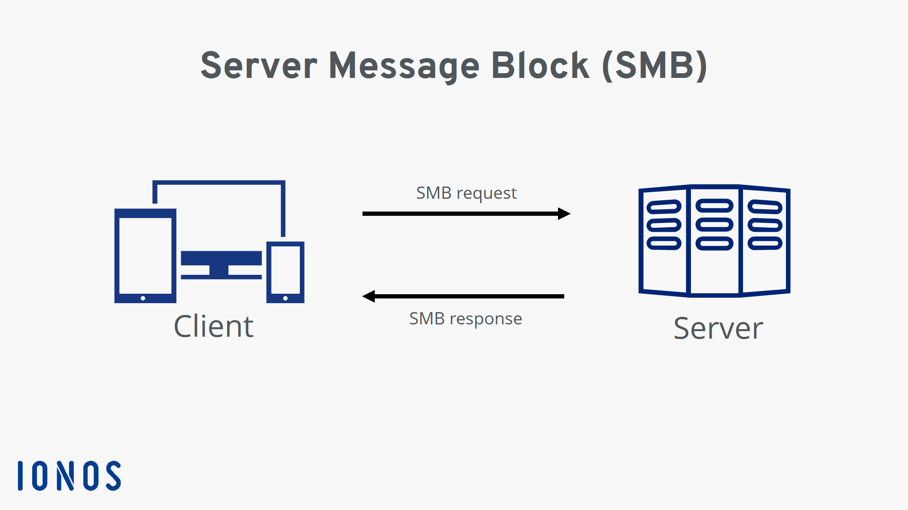When you pursue an Azure cloud membership, a case of Azure AD is provisioned for you, which is called an Azure AD inhabitant. A devoted Active Directory that has an area name in the configuration <domain name>.onmicrosoft.com is doled out to each occupant. All clients, gatherings, and applications connected to your association's Azure AD occupant will be essential for this Azure AD space. You can utilize custom space names with Azure AD, where clients can be made in Azure AD with your association's area name.

## **Azure Files Azure**

Files is the overseen document share in the cloud that can be gotten to over Server Message Protocol (SMB) from on-premises as well as cloud-based machines. The document offers can be straightforwardly provisioned from the Azure entryway, without going through the difficulty of provisioning a whole foundation to have the offers. It is a cross-stage administration, where the offers can be gotten to from Windows, Linux, or MAC OS, given that they support SMB.Azure Files additionally

## **Azure Files Share Access**

Azure Files utilizes SMB 3.0 and HTTPs for secure information access. You can likewise settle on REST API decisions from your applications to a facilitated Azure Files share. Validation to Azure documents is finished utilizing shared admittance signature (SAS) tokens while getting to the offers over REST API. For getting to over SMB, verification is finished utilizing stockpiling access keys. The disadvantage here is that anybody having capacity access keys can get to the record share, which is a degree of straightforwardness that a security review may be concerned with. Cloud Volumes ONTAP then again upholds AD-based confirmation for the document shares facilitated in the assistance, so clients can have fine-grain command over who approaches explicit offers and records provisioned utilizing the help

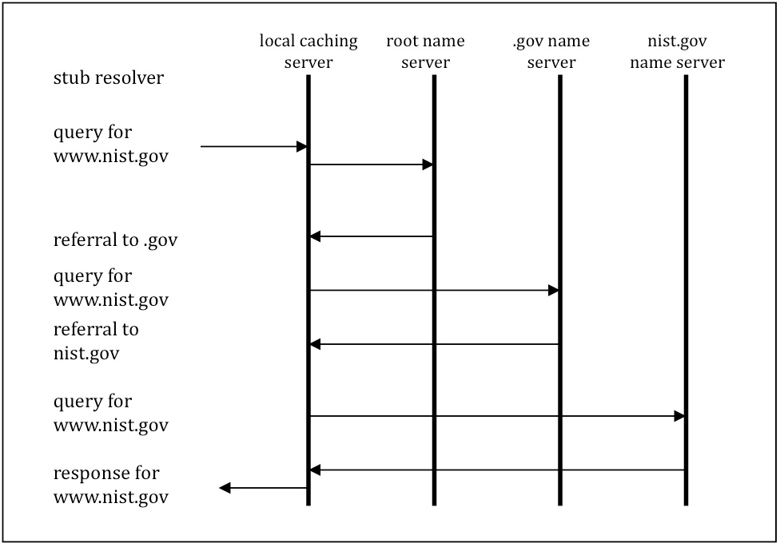

Figure 2Name Resolution Process (without cache search)

## **SMB**

The Server Message Block (SMB) convention is an organization record sharing convention that permits applications on a PC to peruse and write to documents and to demand administrations from server programs in a PC organization. The SMB convention can be utilized on top of its TCP/IP convention or other organization conventions

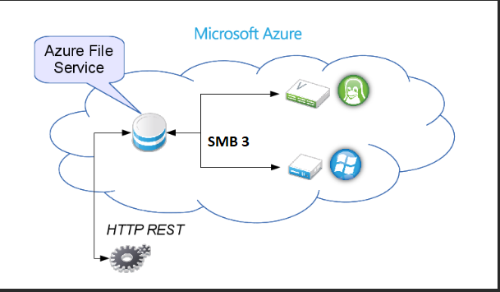The SMB convention permits clients to get to shared records on a far off server through a bunch of solicitations sent between the client and the server by means of information parcels. These incorporate fundamentally meeting control bundles and document access parcels

## **Domain Name System**

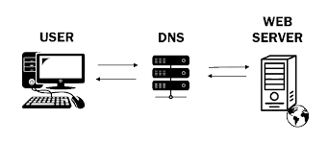The Domain Name System is the various leveled and decentralized naming framework used to distinguish PCs, administrations, and different assets reachable through the Internet or other Internet Protocol organizations. The asset records contained in the DNS partner space names with different types of data

Figure 6working of dns

## **Web technology**

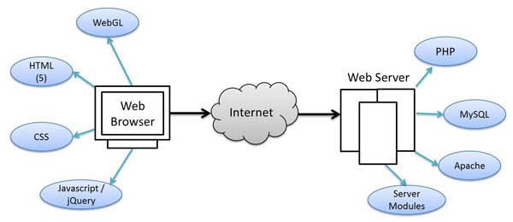Web technology alludes to the means by which PCs speak with one another utilizing markup dialects and mixed media bundles. It gives us a method for interfacing with facilitated data, similar to sites. Web innovation includes the utilization of hypertext markup language (HTML) and falling templates (CSS)

Figure 8protocol of WEB Technology

## **DNS BIND**

Tie is an open source framework allowed to download and utilize, presented under the Mozilla Public License. Tie can be utilized to run a reserving DNS server or a legitimate name server, and gives highlights like burden adjusting, inform, dynamic update, split DNS, DNSSEC, IPv6, and then some

## **Microsoft Azure**

Azure creates a canonical name DNS record (CNAME) on the public DNS. The CNAME record redirects the resolution to the private domain name. You can override the resolution with the private IP address of your private endpoints. Your applications don't need to change the connection URL

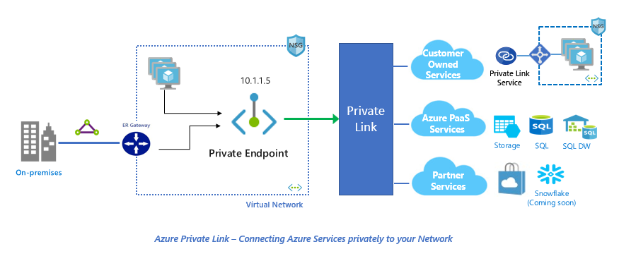

**Discussion and Future Work**

One of the easiest/most requested scenario is the ability to each an Azure SQL Database privately from a Virtual Network, without exposing it to Internet, or using its Public IP address.

The following picture shows a Virtual Machine (SQLClient) deployed to a VNET/Subnet (VNETEastUS/VM), and an Azure SQL DB (azuresqlprivatedb01) deployed within an Azure SQL server (azuresqlpriavte).

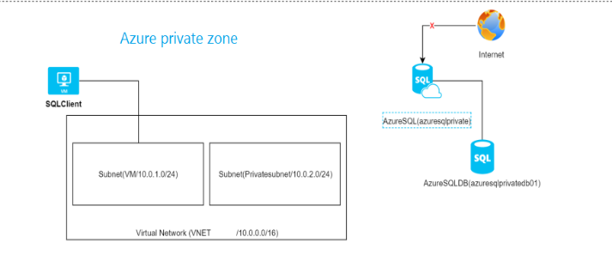

The goal is that the VM (SQLClient) reaches the azuresqlprivate over a personal association, and not via web (we won't permit any scientific discipline to consume the Azure SQL server through the firewall): The line in orange is that the goal

**Solution via Private Endpoints**

The solution is to make a personal end point that may expose the Azure SQL server via a personal information processing address on a Subnet. The subsequent image shows a personal end point (PE) that's victimization AN information processing address from the Subnet Private subnet and connected to azuresqlprivate

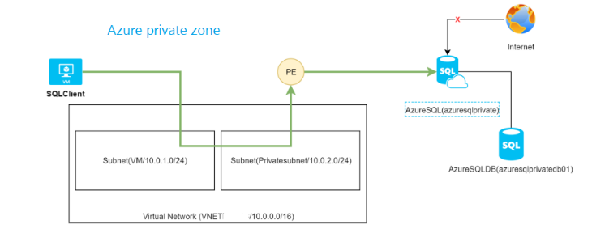

**Deploy the answer via the Azure Portal**

1- Visit the non-public Link Center –> non-public endpoints –> Add

2- Kind the desired data just like the Subscription, RG, Location…

3- Opt for the resource that you simply need to form a personal end for (In my case, it’s the azuresqlprivate Azure SQL server

4- Opt for a VNET/Subnet that may modify the access to your resource. Beneath the hood, a Network Interface (NIC) are created, allotted AN informatics address and allotted to your resource. will|you'll|you'll be able to} optionally integrate the resource with AN Azure non-public DNS Zone so as that you simply can decision the non-public end employing a DNS name. This is often not needed as you'll produce your own DNS record on your own DNS service (A record)

5- Once the readying, you may notice the following:

The non-public end is made AN the association State is Approved*

* Approved means the Azure SQL party has approved the non-public end, this is often helpful once each parties aren't from an equivalent Team/Tenant, wherever the requester will elicit the non-public end association, and waits for the owner to approve it. Additionally, you'll reject the association at any time

A NIC has been created and deployed to the Subnet

A DNS record has been created (in case you have got enabled non-public DNS option)

Secure the access to the non-public termination

Now that we've got non-public access to a PaaS Service, there any ways that to secure the access to it:

Use Network Security teams for the letter of the alphabet Inbound: you'll produce associate NSG and apply it to the Subnet NIC or the non-public termination NIC, and filter incoming rules like every different NSG –> seems like this not nonetheless supported on the general public Preview

Applying a NSG to the NIC isn't supported

Applying associate NSG to the Subnet is with none have an effect on on non-public Endpoints

Use Network Security teams for the Outbound: you'll filter outward-bound traffic from your sources to your non-public Endpoints: this is often supported however not convenient, since it’s higher to filter at the destination and not a the supply, once securing access from a Destination position (The image shows a rule that blocks access to the non-public scientific discipline of the non-public termination, and applied to the SQLClient VM)

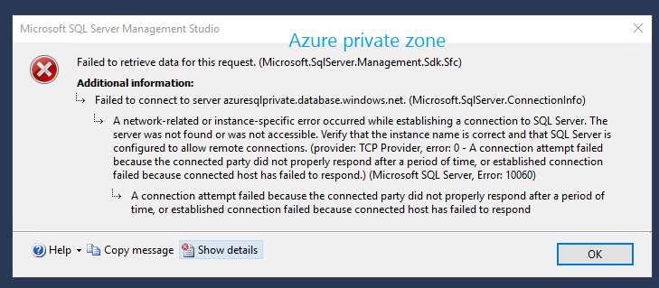

Since the scientific discipline address of the non-public termination is at intervals your VNET, you'll filter access thereto on your perimeter Firewalls, like Azure Firewall or your own Firewall

**Conclusion**

The Internet's DNS framework works similar as a telephone directory by dealing with the planning among names and numbers. DNS servers make an interpretation of solicitations for names into IP addresses, controlling which server an end client will arrive at when they type an area name into their internet browser. These solicitations are called questions

Now we can share file using azure dns and private end point. Shared access. Azure file shares support the industry standard SMB and NFS protocols, meaning you can seamlessly replace your on-premises file shares with Azure file shares without worrying about application compatibility

Private Link gives a safe method for relocating jobs to Azure. Insurance against information spillage: A private endpoint is planned to a case of a PaaS asset rather than the whole assistance. Buyers can associate with the particular asset. Admittance to some other asset in the assistance is obstructed

Traffic can arrive at the help asset from on premises without utilizing public endpoints. A Service Endpoint stays a freely routable IP address. A Private Endpoint is a private IP in the location space of the virtual organization where the private endpoint is arranged

Private Endpoints area unit associate degree evolution of Azure infrastructure. The direct configuration effort and in progress service asking to be used means you ought to fastidiously contemplate whether or not your organization wants them. As an example, if you wish to dam all net traffic to a service whereas creating services on the market to on-premises traffic, or if you wish to secure specific sub-resources in your virtual network, Azure currently offers that capability through non-public endpoints.

**Selected acronyms used in the *DOMAIN NAME SYSTEM (DNS) are* defined below**.

A Address

ACL Access Control List

AD Authenticated Data

ANSI American National Standards Institute

ARP Address Resolution Protocol

CA Certificate Authority

ccTLD Country-code Top-level Domain

CD Checking Disabled

DHCP Dynamic Host Configuration Protocol

DNS Domain Name System

DNSSEC Domain Name System Security Extensions

DS Delegation Signer

DSA Digital Signature Algorithm

DSS Digital Signature Standard

ECDSA Elliptic Curve Digital Signature Algorithm

FIPS Federal Information Processing Standards FISMA Federal Information Security Management Act FQDN Fully Qualified Domain Name

gTLD Generic Top-level Domain

HINFO Host Information

HMAC Hash-based Message Authentication Code

ICANN Internet Corporation for Assigned Names and Numbers

IETF Internet Engineering Task Force

IN Internet

IP Internet Protocol

ISP Internet Service Provider

IT Information Technology

ITL Information Technology Laboratory

KSK Key Signing Key

LAN Local Area Network

LOC Location

MAC Message Authentication Code

MD Message Digest

MX Mail Exchanger

NIST National Institute of Standards and Technology

NS Name Server

NSEC Next Secure

NSEC3 Hashed Next Secure

NTP Network Time Protocol

OMB Office of Management and Budget

OS Operating System

PKI Public Key Infrastructure

PIR Public Internet Registry

RFC Request for Comments

RP Responsible Person

RR Resource Record

RRSIG Resource Record Signature

SEP Secure Entry Point

SHA Secure Hash Algorithm

SHS Secure Hash Standard

SOA Start of Authority

TCP Transmission Control Protocol

TLD Top-level Domain

TSIG Transaction Signature

TTL Time to Live

TXT Text

UDP User Datagram Protocol

ZSK Zone Signing Key

**References**

[RFC3833] D. Atkins and R. Austein, “Threat Analysis of the Domain Name System (DNS)”, RFC 3833, August 2004.

[RFC2181] R. Elz and R. Bush, “Clarifications to the DNS Specification”, RFC 2181, July 1997. [RFC1912] D. Barr, “Common DNS Operational and Configuration Errors”, RFC 1912, Feb. 1996 [RFC1034] P. Mockapetris, “Domain Names - Concepts and Facilities”, STD 13, RFC 1034,

November 1987.

[RFC1035] P. Mockapetris, “Domain Names - Implementation and Specification”, STD 13, RFC 1035, November 1987.

[BCP140] J. Damas and F. Neves, “Preventing Use of Recursive Nameservers in Reflector Attacks”, BCP 140, RFC 5358. October 2008.

[RFC2671] P. Vixie, “Extension Mechanisms for DNS (EDNS0)” RFC 2671 August 1999 [RFC1996] P. Vixie, “A Mechanism for Prompt Notification of Zone Changes (DNS NOTIFY)”

RFC 1996. August 1996.

[IEEE] S. Rose and A. Nakassis. “Minimizing Information Leakage in the DNS” IEEE Network Magazine vol. 22 no. 2 April 2008.