**NAME: USAMA YOUSUF KHAN**

**ROLL NUMBER: P20-0646**

**CLASS: BCS 5-A**

**COMPUTER NETWORKS LAB**

**LAB TASK #1**

**SUBMITTED TO MISS HURMAT HIDAYAT**

**QUESTION 1:**

**PART A)**

**IP ADDRESS:**

192.168.18.1

**PART B)**

**SUBNET MASK:**

255.255.252.0

**PART C)**

**DEFAULT GATEWAY:**

192.168.18.1

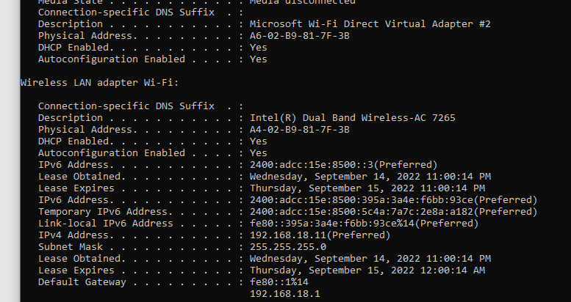

**QUESTION 2:**

**PART A)**

**IP ADDRESS:**

192.168.18.106

**PART B)**

**IP ADDRESS:**

192.168.18.6

**PART C)**

**IP ADDRESS:**

192.168.18.206

**QUESTION 3:**

**METHOD 1:**

Search for command prompt in windows search option and type ipconfig

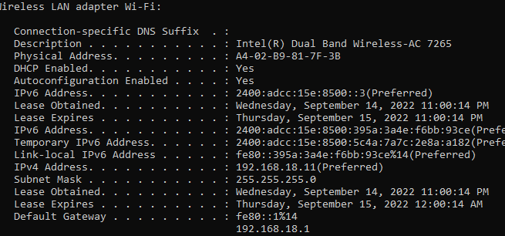

**METHOD 2:**

Go to settings, then network and internet, then click on wifi, click on the name of the wifi connection and scroll down to properties.

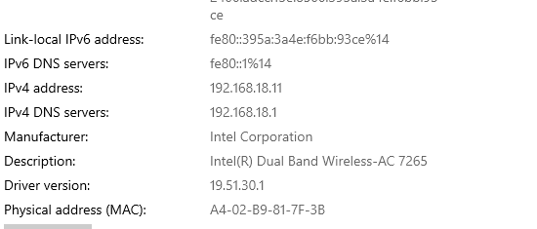

**METHOD 3:**

Go to control panel>Network and sharing center>change adapter settings>click on name of connection>prompt will show up so click on details>scroll down to find IP address.

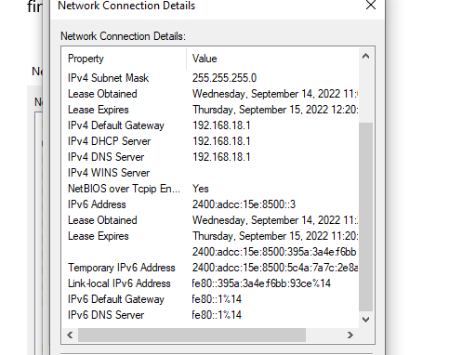

**METHOD 4:**

Search system information>click on components on left panel>click on network>click on adapter>scroll down to find ip address of current connection you are using

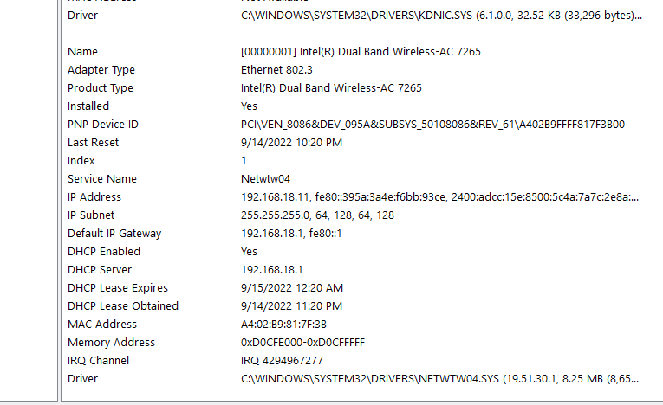

**METHOD 5:**

**POWERSHELL GIP COMMAND:**

Search powershell>type in command “gip”>find ip address

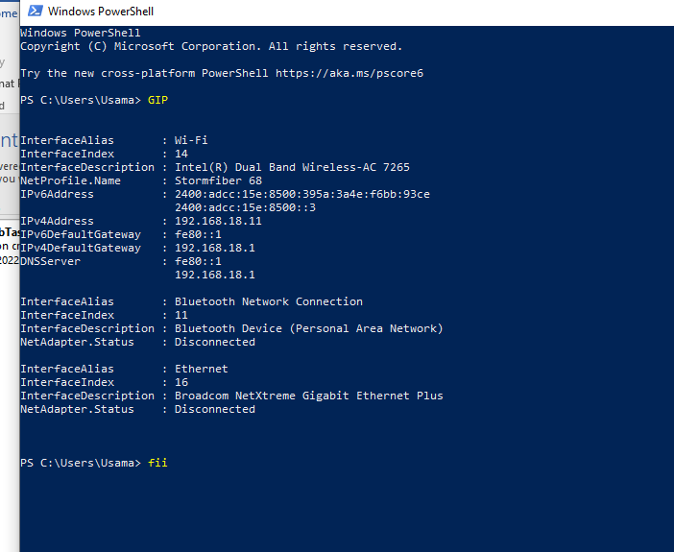

**METHOD 6:**

**POWERSHELL Get-NetIPConfiguration:**

Search powershell>type in command “Get-NetIPConfiguration”>find ip address

