Project Milestone #2

For this milestone we had to allow users to create accounts and to log in with them. Before we began doing that, we had to decide on which server-side programming language and database to utilize. We decided to use Python as our backend language using the Django framework as well as SQLite3 with plans to migrating over to mySQL or Postgres afterwards. We chose Django because of it’s popularity with major sites such as Instagram and Pinterest and it’s extensive libraries and support, especially with the built-in admin functionality. Our TA, Kevin, also had experience with it and recommend using it. We also enjoyed the idea of ‘pluggable apps’ where Django apps could easily be moved from one website to another.

One of the major advantages of using Django is that much of the initial work was already done for us. With Django commands such as “startproject, migrate, createsuperuser and startapp” we could easily have the initial code to have access to Django’s library of apps and listing them simply in the settings.py file under INSTALLED_APPS . The extensive online community also provides good tutorials that we were able to utilize when getting started, and will probably be useful in later milestones as well. When we start to build more functionality, we plan on using more libraries and apps in order to achieve the goals of the milestones. Django is also quite intuitive and practical.

A run-through of how Django works and what happens when the user creates an account and logs in is as follows. On a top-down approach, the user accesses the site, sends an HTTP request to the server which then through a urls.py file redirects that request to the correct View.py and Model.py files. It then sends an HTTP response back to the user.

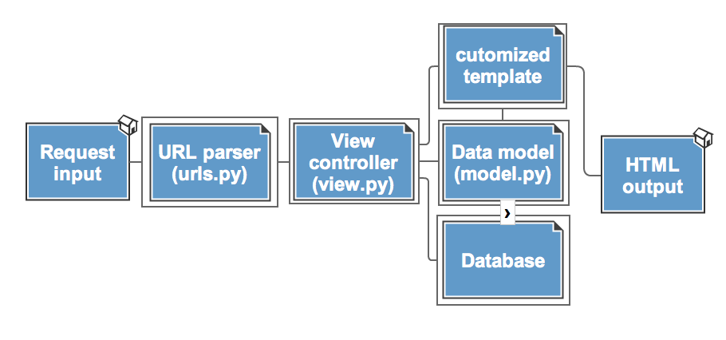

In a little more in-depth analysis, the url that the user sends is parsed which the urls file sends to a view. The view, in conjunction with a model, which is a database model, works with a template to spit out the correct response to the user. The templates which are HTML files with certain fields accessed through Python variables and functions from the model is what the user will see. For an account, the user enters data through a form with a POST method and Django takes that data and through its built-in user authentication and registration libraries, takes the password, adds a Salt to it (which is just a random character string added after the password) and hashes it. The admins can not even find out what the password is. To fully implement our milestone we used allauth, a library.

What we find admirable is that by Milestone 2, as a project group we learned how to use the GIT collaboration platform and tested ourselves in something we have no experience in (Django, Python & SQLite3). Also, we began to really understand how HTTP request/responses work. This was also a great experience in working with team members on a project.

A disadvantage of using Django was that it was a bit confusing to use and did require a bit of research since we had no prior experience. We had some setup issues and that left us a little lost for a while, especially since they updated the syntax of django and thus there is some inconsistency in tutorials and tools. This though can be handled when we understand what changes were made and use up to date libraries and tools only. We had several setbacks while programming and setting up our projects. It was frustrating when this happened but we were able to push through it. From this experience we learned a few things. We need to be better as understanding how to use and work with django, but that will come with practice and continued implementation.

Overall the progress of the project is coming along and and we’re making our plans and designs. By the next project milestone we hope to not only complete it but have a plan on how we’re going to use what we implement on a broader level, as in have a plan for milestone 4’s implementation.

CITE

<https://github.com/pennersr/django-allauth>

<https://www.djangoproject.com/>

<http://www.erikmitchell.info/wp-content/uploads/2010/09/screen-shot-2010-09-28-at-80456-am.png>