Hello Professor St Jacques,

I would like to show my work on the website that I can understand that I move forward on right way. Maybe You will have some question about my project.
My idea is there is the website for Nataliya's friends for exchanging books in different fields. I downloaded the template from internet and it is just modified for its functionality for to log and create accounts.
1. View of web site (template)
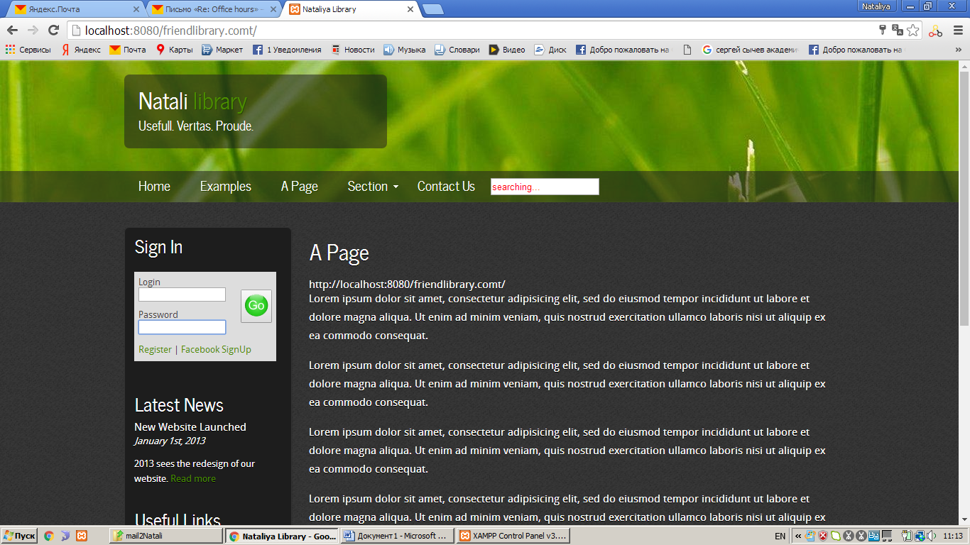

2. I use XAMPP (free and open source cross-platform web server solution stack package).
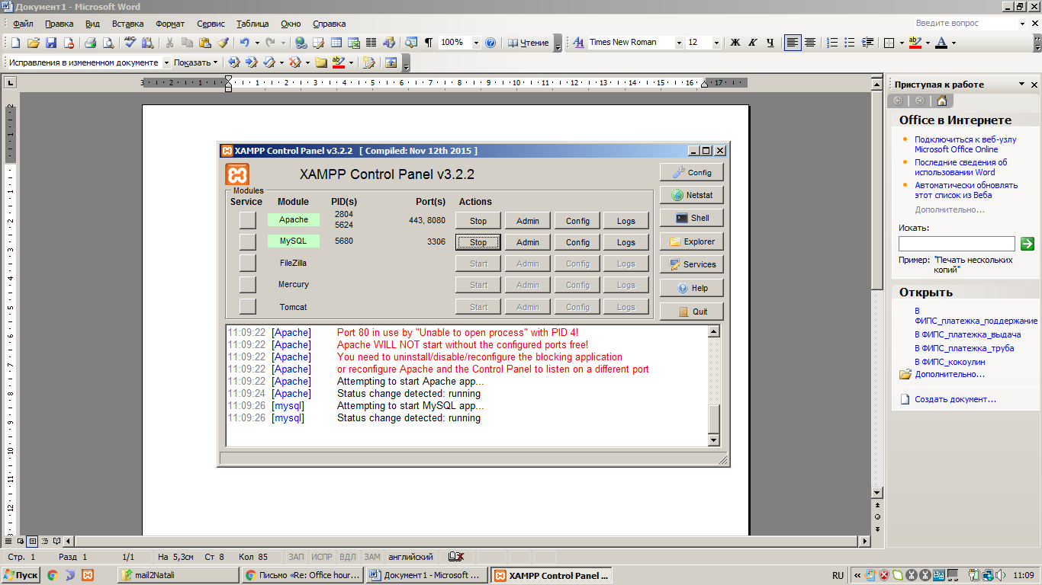

3. This site includes for main goal the sections for books online.
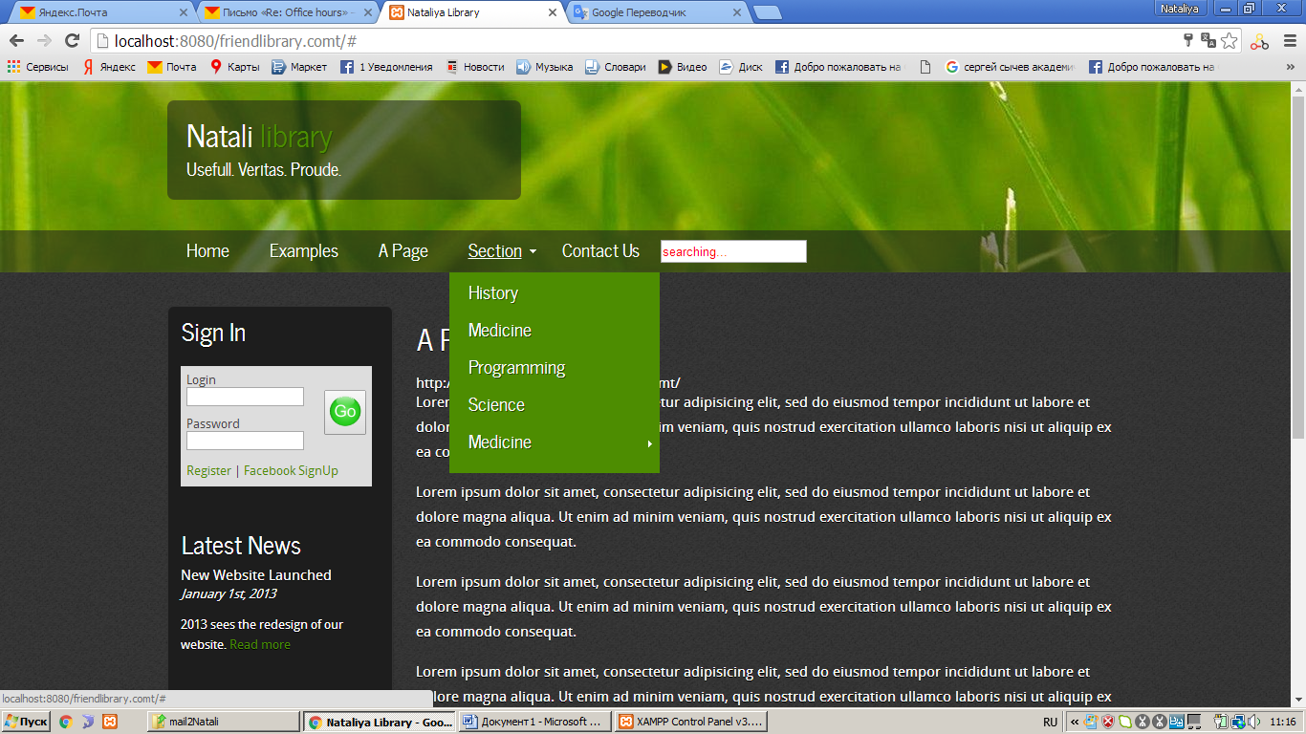

This site includes Front end (external view of website (pages) and Back end (admin)

4. Registration form (Front end)
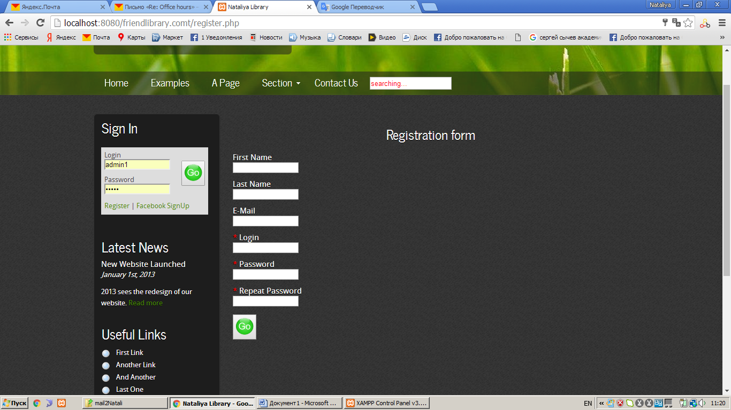

5. Back end, Admin Superadmin
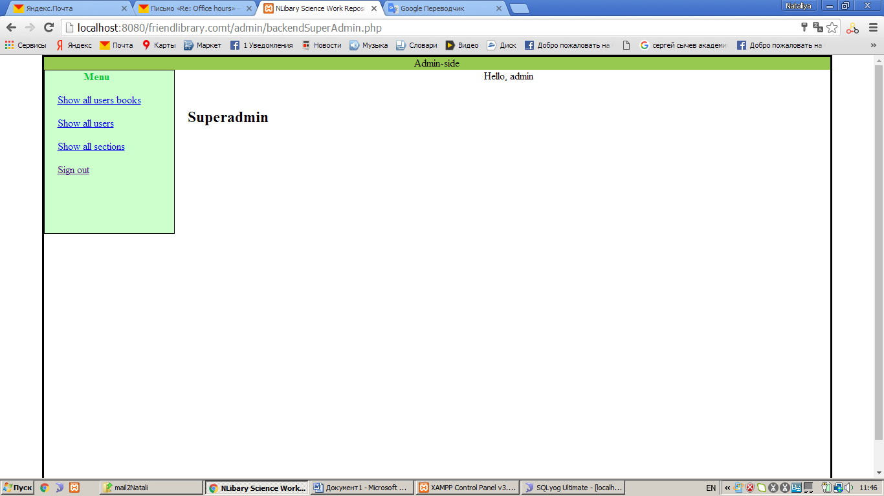

6. Back end, user
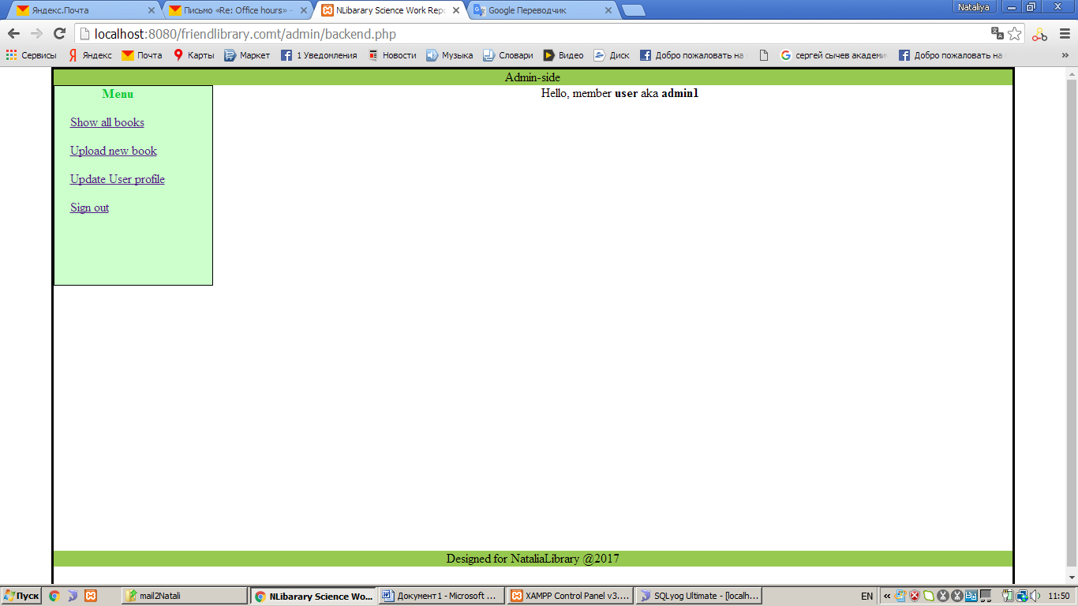

Now:
- allow users to create accounts

Next steps:
To create a CRUD (C​reate, R​ead, U​pdate, D​elete)
● allow users to create accounts and add new persistent data

● read data from the server and present it on a webpage

● allow users to update their existing data

● allow users to delete their own data and accounts

● do all of the above without reloading the webpage (Ajax)

