OptiMIPS
Pipeline-Aware MIPS Code Optimizer for MARS
Complete Project Report, Backend Explanation, Worked Example, and User Flow
In one sentence: OptiMIPS reads assembled MIPS instructions from MARS, finds pipeline hazards, safely reorders independent instructions, and shows the CPI improvement before the user applies or exports the optimized code.

1. Project Overview
OptiMIPS is a plugin for the MARS MIPS simulator. It helps students understand how instruction scheduling improves pipeline performance. The user writes MIPS code normally, assembles it in MARS, opens OptiMIPS from the Tools menu, and clicks Optimize. The tool then shows the original code, optimized code, hazard analysis, CPI before and after, and a plain-English explanation of the changes.
The goal is not to create a full industrial compiler. The goal is to build a clear educational optimizer that demonstrates one important compiler/backend idea: pipeline-aware instruction scheduling.
Feature | What it does
Hazard detection | Finds RAW, WAR, WAW, memory, and branch/control ordering constraints.
Instruction scheduling | Moves safe independent instructions earlier to fill cycles that would otherwise become stalls.
CPI comparison | Counts simplified pipeline stalls before and after optimization.
Apply to Editor | Writes the optimized instruction order back into the current MARS editor buffer.
Export Optimized | Saves optimized assembly to a new file without touching the original.
Save Report | Creates a thesis-friendly text report with CPI, hazards, moves, and explanation.

2. Main Concept in Easy Words
A pipelined processor works on several instructions at the same time. One instruction may be in fetch, another in decode, another in execute, and so on. This improves speed, but it creates a problem: sometimes a later instruction needs a value that an earlier instruction has not produced yet.
When this happens, the processor has to wait. That waiting time is called a stall. OptiMIPS tries to reduce stalls by moving independent instructions into those waiting spaces.
Simple idea: If instruction B is waiting for instruction A, but instruction C is independent, then OptiMIPS tries to place C between A and B. The program still means the same thing, but the pipeline wastes fewer cycles.

3. Backend Flow
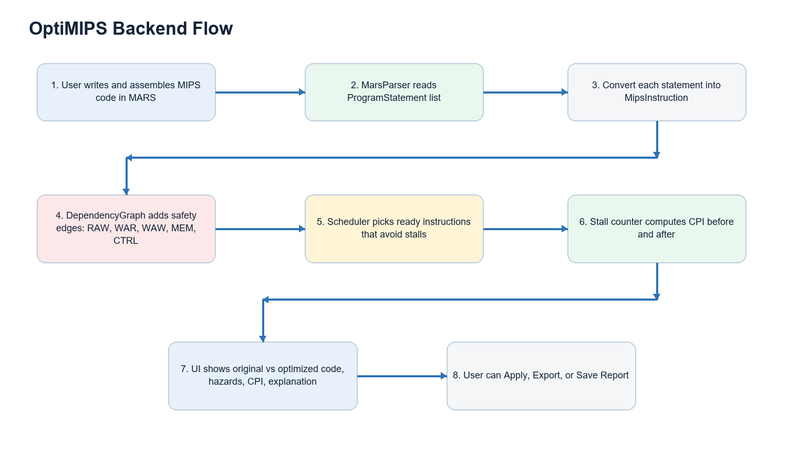
The flowchart shows the backend pipeline of the tool. MARS already parses and assembles the program, so OptiMIPS does not need to parse raw assembly from scratch. Instead, it reads MARS ProgramStatement objects and converts them into a smaller internal model called MipsInstruction.

4. Files and Classes Used
File | Purpose
MipsInstruction.java | Small wrapper class. Stores instruction index, mnemonic, destination register, source registers, memory flags, branch flag, original text, and source line.
MarsParser.java | Reads Globals.program.getMachineList() from MARS and converts ProgramStatement objects into MipsInstruction objects.
DependencyGraph.java | Builds directed edges between instructions that must stay in order.
Scheduler.java | Runs list scheduling, chooses ready instructions, counts stalls, and calculates CPI.
OptiMIPS.java | Main plugin class. Builds Swing UI and connects parser, graph, scheduler, apply/export/report features.

5. Instruction Model
Every assembled instruction is converted into a MipsInstruction object. This makes the rest of the code simpler because the scheduler does not need to know all details of MARS ProgramStatement internals.
public class MipsInstruction {
public int index; // original order in program
public String mnemonic; // add, lw, sw, beq, etc.
public int dest; // destination register, or -1 if none
public int[] sources; // registers read by the instruction
public boolean isMemLoad;
public boolean isMemStore;
public boolean isBranch;
public String originalText;
public int sourceLine; // original editor line for Apply to Editor
}

6. Dependency Graph
The dependency graph is the safety system of OptiMIPS. It prevents illegal movement. An edge from instruction A to instruction B means B must remain after A.
Dependency type | Meaning | Example
RAW | Read After Write. B reads a register written by A. | add $t0,... then lw $t3,0($t0)
WAR | Write After Read. B writes a register that A still needs to read. | A reads $t1, later B writes $t1
WAW | Write After Write. Both write the same register. | add $t0,... then sub $t0,...
MEM | Memory instructions are kept in order conservatively. | lw before sw
CTRL | Instructions are not moved across branches/jumps. | do not cross beq/j/jr

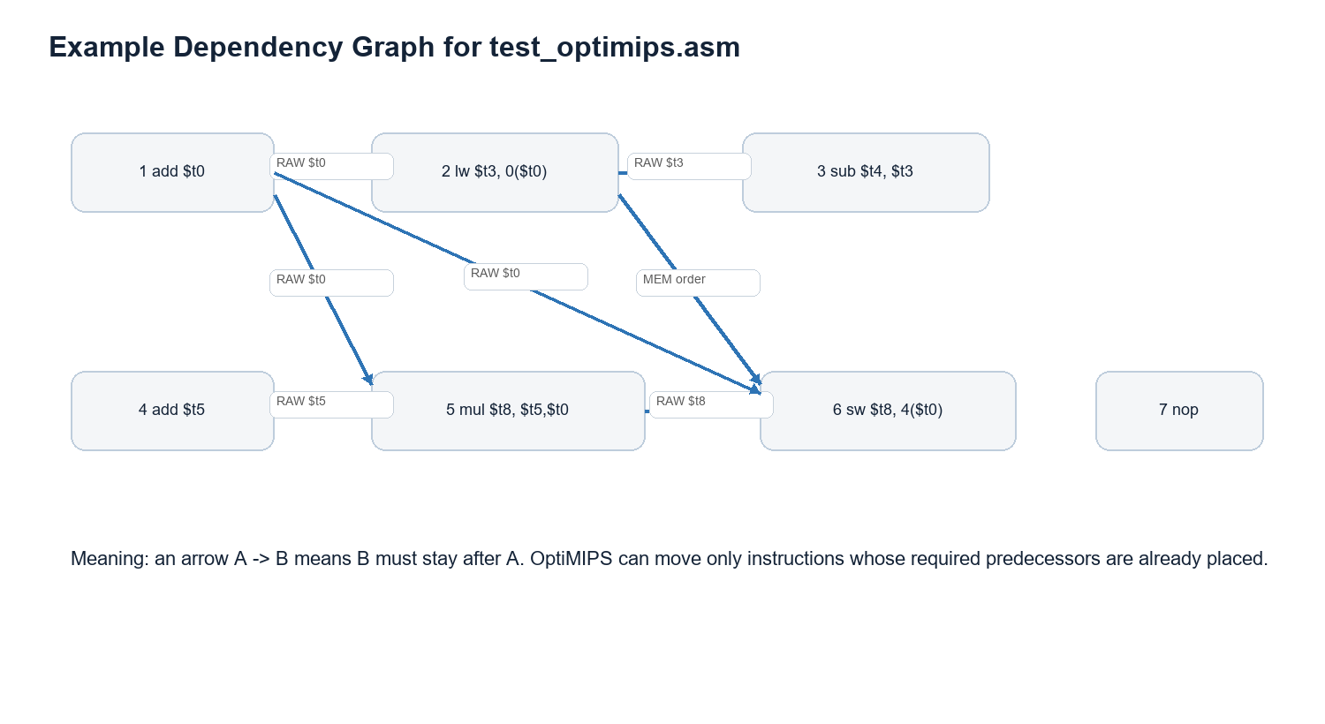

7. Scheduling Algorithm
OptiMIPS uses list scheduling. It repeatedly looks for instructions whose predecessors are already scheduled. These are called ready instructions. Among ready instructions, it prefers the instruction that adds the fewest immediate stalls. If there is a tie, it prefers the instruction with more successors because that instruction is more important for later progress.
- Start with an empty optimized list.
- Find all unscheduled instructions whose dependency predecessors are already placed.
- Estimate how many stalls each ready instruction would add if placed now.
- Pick the ready instruction with the lowest added stall count.
- Update register ready times and append the instruction to the optimized list.
- Repeat until all instructions are scheduled.
while optimized list is not complete:
ready = instructions whose predecessors are already scheduled
choose instruction with smallest immediate stall cost
if tie, choose instruction with more successors
append chosen instruction to optimized list
update register ready time

8. CPI and Stall Calculation
CPI means Cycles Per Instruction. Lower CPI is better. OptiMIPS uses a simplified educational pipeline model. It tracks when each register becomes ready. If an instruction reads a source register before it is ready, the difference becomes stall cycles.
The formula used by OptiMIPS is:
CPI = (instruction_count + stall_count) / instruction_count
For example, if a program has 7 instructions and 4 stalls:
CPI = (7 + 4) / 7 = 1.571
If optimization reduces stalls to 0:
CPI = (7 + 0) / 7 = 1.000
The improvement percentage is calculated as:
improvement = ((CPI_before - CPI_after) / CPI_before) * 100

9. Worked Example Using test_optimips.asm
This is the test program used for demonstration. It contains intentional RAW hazards and one independent instruction that can be moved to fill a stall.
# OptiMIPS Test Program
# This program has 3 intentional RAW hazards
# The optimizer should reorder to eliminate them

.text
.globl main
main:
add $t0, $t1, $t2 # writes $t0
lw $t3, 0($t0) # RAW: reads $t0 immediately
sub $t4, $t3, $t1 # RAW: reads $t3 before lw done
add $t5, $t6, $t7 # independent - safe to move up
mul $t8, $t5, $t0 # reads $t5, $t0 (both available after reorder)
sw $t8, 4($t0) # store result
add $zero, $zero, $zero # nop

9.1 Step-by-Step Hazard Meaning
Line | Instruction | Important dependency
1 | add $t0, $t1, $t2 | Writes $t0. Later lw, mul, and sw need $t0.
2 | lw $t3, 0($t0) | Reads $t0 from line 1 and writes $t3.
3 | sub $t4, $t3, $t1 | Reads $t3 from line 2, so this is a load-use RAW hazard.
4 | add $t5, $t6, $t7 | Independent from lines 1 to 3, so it can move earlier safely.
5 | mul $t8, $t5, $t0 | Reads $t5 and $t0, so it must wait for lines 4 and 1.
6 | sw $t8, 4($t0) | Reads $t8 and $t0, so it must wait for lines 5 and 1.
7 | add $zero, $zero, $zero | Acts like a nop in this example.

9.2 Example Optimized Order
A typical optimized order for this program is shown below. The independent add from original line 4 is moved upward to fill a waiting cycle after line 1. Then the load and multiply can also be positioned to reduce waiting.
Optimized position | Original line | Instruction | Why this is safe
1 | 1 | add $t0, $t1, $t2 | It produces $t0, so it must stay early.
2 | 4 | add $t5, $t6, $t7 | Independent instruction fills a stall slot.
3 | 2 | lw $t3, 0($t0) | Now $t0 has had more time to become ready.
4 | 5 | mul $t8, $t5, $t0 | Its inputs $t5 and $t0 are available.
5 | 3 | sub $t4, $t3, $t1 | Moved after useful work, avoiding the load-use stall.
6 | 6 | sw $t8, 4($t0) | Store remains after the values it needs.
7 | 7 | nop | No effect on program result.

10. GUI and User Features
UI part | Purpose
Original Code table | Shows the original assembled instruction order. Hazard rows are highlighted red.
Optimized Code table | Shows the reordered instruction order. Moved rows are highlighted green.
Before / After / Gain panels | Show CPI and stall count before and after optimization.
Hazard Log tab | Lists the hazards found and instruction moves.
Easy Explanation tab | Explains what changed in simple English.
Apply to Editor | Rewrites the current MARS editor with the optimized order while preserving surrounding source structure.
Export Optimized | Saves optimized assembly into a new file.
Save Report | Creates a text report with thesis table row, hazards, moves, and explanation.

11. Apply, Export, and Report Logic
Apply to Editor uses source line information from MARS. The parser stores stmt.getSourceLine() in each MipsInstruction. When Apply is clicked, OptiMIPS replaces the original instruction source lines with optimized instruction text. It preserves other lines such as .data, .text, .globl, labels, blank lines, and comments not attached to moved instructions.
Export Optimized is safer for programs with complex source structure. It writes a new file containing the optimized instruction order and CPI comments. Save Report is designed for thesis work. It records the numeric results and explains what happened.
Safety note: If one source line expands into multiple machine instructions, Apply is disabled for that case and the user should use Export Optimized instead. This prevents pseudo-instruction expansion from corrupting the source file.

12. Limitations
- The CPI model is simplified for teaching. It is not a full hardware-accurate simulator.
- Memory operations are kept in original order conservatively, so some safe memory optimizations are intentionally skipped.
- Instructions are not moved across branches or jumps because that could change control flow.
- Apply to Editor is careful, but Export Optimized is safer for complex programs with pseudo-instructions or unusual formatting.
- The tool focuses on instruction scheduling, not register allocation, global compiler optimization, or full basic-block analysis across labels.

13. Why This Project Is Useful
OptiMIPS is useful because it makes a hidden compiler/backend idea visible. Students can see the original code, the dependency graph logic, the reordered code, and the measured CPI improvement in one place. It connects assembly programming, pipelining, hazards, and compiler optimization into a single practical tool.
Final takeaway: OptiMIPS shows that even small changes in instruction order can reduce pipeline stalls when independent instructions are available. The program result stays the same, but the pipeline runs more efficiently.

14. Suggested Thesis Results Table
Benchmark | Before CPI | After CPI | Improvement | Observation
Arithmetic benchmark | Record from tool | Record from tool | Record from tool | Shows benefit from arithmetic RAW scheduling.
Loop benchmark | Record from tool | Record from tool | Record from tool | Shows mixed branch/load/arithmetic behavior.
Load-heavy benchmark | Record from tool | Record from tool | Record from tool | Shows strongest benefit when load-use hazards exist.

15. Future Improvements
- Add a visual pipeline timeline table showing IF, ID, EX, MEM, and WB stages.
- Preserve full .data section automatically in exported optimized files.
- Detect basic blocks using labels and branches more explicitly.
- Add CSV report export for easier thesis table import.
- Add more benchmark programs and average CPI improvement calculation.

