OptiMIPS
Pipeline-Aware MIPS Code Optimizer
A MARS Simulator Plugin

Project Team
Usbah Saleem (FA23-BCS-143)
Muhammad Huzaifa (FA23-BCS-113)
Arsalan Khan (FA23-BCS-019)
Muhammad Awais (FA23-BCS-017)

Computer Architecture Project Report
Submitted: May 2026

Abstract
OptiMIPS is a pipeline-aware MIPS code optimizer implemented as a plugin for the MARS simulator. The project focuses on a common problem in pipelined processors: stalls caused by data hazards. When one instruction needs a register value that is not ready yet, the processor may have to wait. OptiMIPS reduces this waiting time by finding safe independent instructions and moving them into positions where they can fill stall cycles.
The tool reads the assembled program from MARS, converts instructions into a simple internal model, builds a dependency graph, applies list scheduling, calculates CPI before and after optimization, and displays the result in a graphical interface. It also supports applying the optimized code to the editor, exporting optimized code, and saving an optimization report. This report explains the project concept, backend working, algorithms, example optimization, CPI calculation, implementation files, results format, limitations, and future improvements in easy English.

Table of Contents
- Introduction
- Problem Statement
- Objectives
- Background Concepts
- System Architecture
- Backend Working
- Dependency Graph
- Scheduling Algorithm
- CPI Calculation
- Worked Example
- GUI Features
- Testing and Results
- Limitations
- Conclusion
- References

1. Introduction
MARS is a popular simulator used for learning MIPS assembly language. It can assemble and run MIPS programs, but it does not automatically reorder instructions to reduce pipeline stalls. OptiMIPS adds this missing educational feature. It behaves like a small compiler backend inside MARS: it observes the assembled instruction list, checks dependencies, safely reorders instructions, and shows whether CPI improves.

2. Problem Statement
In a pipelined CPU, multiple instructions execute at different stages at the same time. This is faster than executing one instruction completely before starting the next. However, hazards can force the pipeline to wait. The problem solved by OptiMIPS is how to reorder MIPS instructions safely so that the program result remains the same, but pipeline stalls are reduced.
Project name: OptiMIPS means optimized MIPS. The project optimizes MIPS instruction order while respecting program correctness.

3. Project Objectives
- Create a MARS plugin that appears in the Tools menu.
- Read assembled MIPS instructions from MARS internal program data.
- Detect dependencies and hazards between instructions.
- Reorder only those instructions that are safe to move.
- Calculate CPI and stall count before and after optimization.
- Display original and optimized code side by side.
- Explain optimization decisions in easy English.
- Allow users to apply, export, and save a report of optimized code.

4. Background Concepts

4.1 Pipelining
Pipelining divides instruction execution into stages such as instruction fetch, decode, execute, memory access, and write back. A new instruction can enter the pipeline before the previous instruction fully finishes. This improves throughput, but it also means instructions can interfere with each other if one instruction needs the result of another too soon.

4.2 Pipeline Hazards
Hazard | Easy meaning | Example
RAW | Read After Write. A later instruction reads a register before an earlier instruction has written it. | add $t0,... then lw $t3,0($t0)
WAR | Write After Read. A later instruction writes a register that an earlier instruction still needs to read. | A reads $t1, B writes $t1
WAW | Write After Write. Two instructions write the same register, so their order matters. | add $t0,... then sub $t0,...
MEM | Memory instructions may access related memory, so OptiMIPS keeps them in order safely. | lw before sw
CTRL | Branches and jumps control the flow of execution, so instructions are not moved across them. | beq, j, jr

5. System Architecture
OptiMIPS is divided into small Java classes. Each class has a clear responsibility, which makes the backend easier to understand and debug.
Class/file | Responsibility
MipsInstruction.java | Stores instruction data such as index, mnemonic, destination, sources, memory flag, branch flag, original text, and source line.
MarsParser.java | Reads MARS ProgramStatement objects and converts them into MipsInstruction objects.
DependencyGraph.java | Builds safety edges between instructions that must stay in order.
Scheduler.java | Selects safe ready instructions and reorders them to reduce stalls.
OptiMIPS.java | Builds the GUI and connects parsing, scheduling, CPI display, apply, export, and report features.

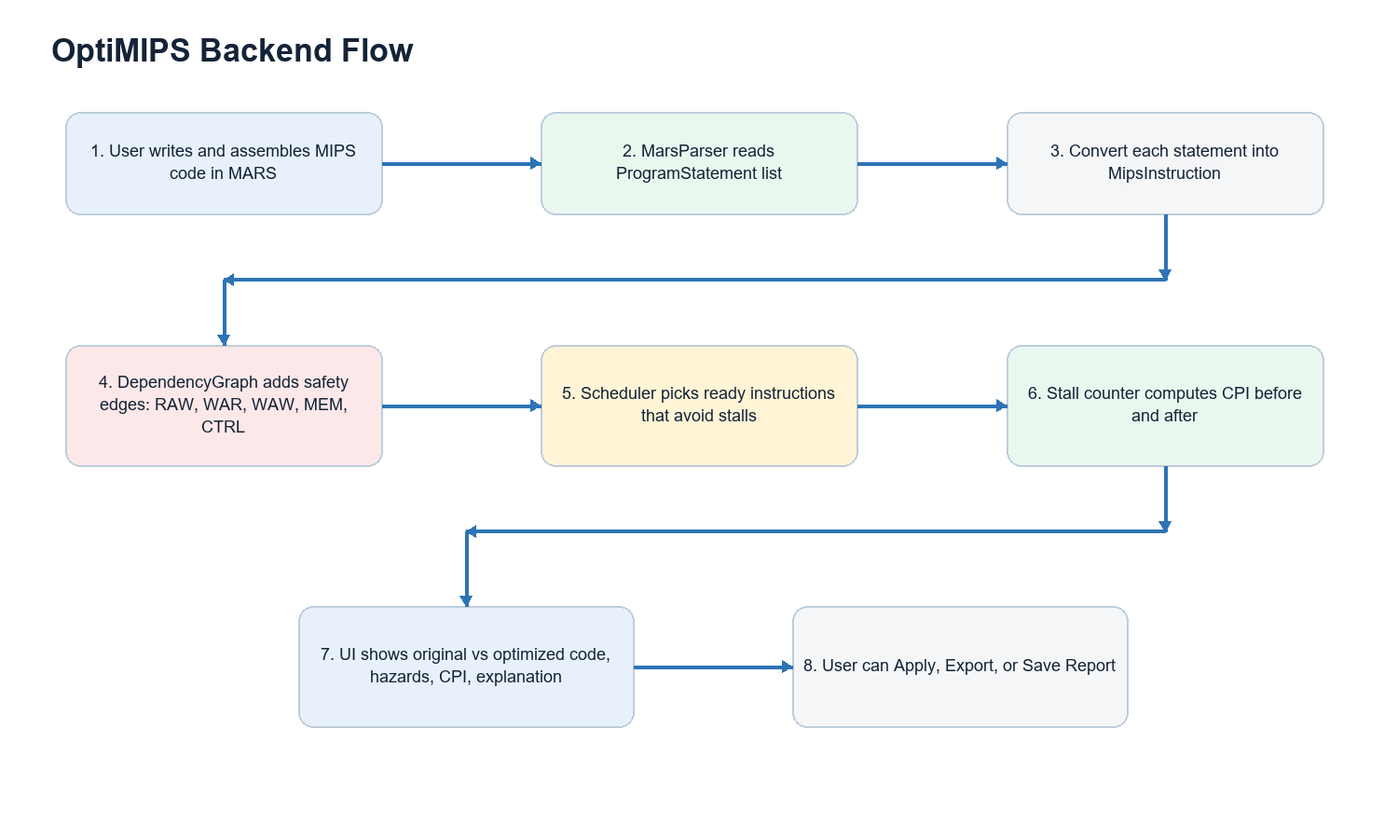

6. Backend Working
- The user writes and assembles a MIPS program in MARS.
- OptiMIPS reads the assembled instruction list using Globals.program.getMachineList().
- MarsParser converts each ProgramStatement into a MipsInstruction object.
- DependencyGraph checks every instruction pair and adds edges for hazards and ordering rules.
- Scheduler finds instructions that are ready and safe to place.
- The optimized order is produced without breaking dependencies.
- Stall count and CPI are calculated for both original and optimized order.
- The GUI displays original code, optimized code, hazards, CPI improvement, and explanation.

7. Dependency Graph
The dependency graph is the most important safety part of the optimizer. It prevents wrong movement. If there is an edge A -> B, then instruction B must stay after instruction A. OptiMIPS only moves an instruction when all instructions it depends on have already been placed.
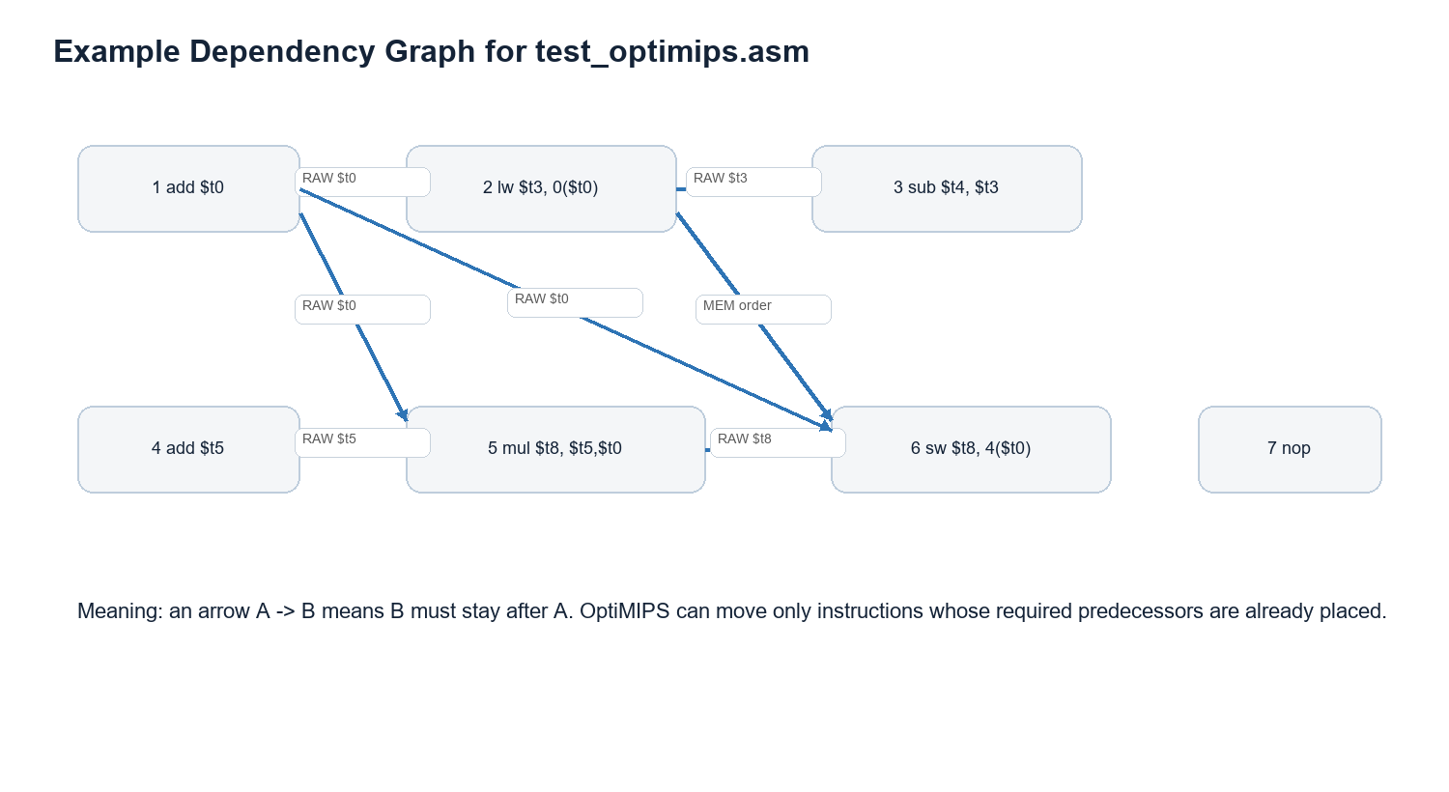
For example, if add writes $t0 and lw reads $t0, then lw depends on add. OptiMIPS can move another independent instruction between them, but it cannot move lw before add.

8. Scheduling Algorithm
OptiMIPS uses list scheduling. This means it builds the optimized list one instruction at a time. At each step, it checks which instructions are ready. A ready instruction is one whose required predecessor instructions have already been scheduled.
Among ready instructions, OptiMIPS chooses the instruction that creates the least immediate stall. If two choices are equally good, it prefers the one with more successors because that instruction may unblock more future work.
while optimized list is not complete:
find all unscheduled instructions whose dependencies are already placed
estimate the stall cost of each ready instruction
choose the ready instruction with lowest stall cost
if tied, choose the instruction with more successors
place it in the optimized list
update register ready times

9. CPI Calculation
CPI means Cycles Per Instruction. A lower CPI means better pipeline performance. OptiMIPS uses a simplified educational model. It tracks when each register becomes ready. If an instruction reads a register before it is ready, the tool counts stall cycles.
CPI = (instruction_count + stall_count) / instruction_count

Example: if a program has 7 instructions and 4 stalls, CPI = (7 + 4) / 7 = 1.571. If optimization reduces stalls to 0, CPI = (7 + 0) / 7 = 1.000.
Improvement = ((CPI_before - CPI_after) / CPI_before) * 100

10. Worked Example
The following example is the test file used in the project. It has intentional RAW hazards and independent instructions that can be moved safely.
# OptiMIPS Test Program
# This program has 3 intentional RAW hazards
# The optimizer should reorder to eliminate them

.text
.globl main
main:
add $t0, $t1, $t2 # writes $t0
lw $t3, 0($t0) # RAW: reads $t0 immediately
sub $t4, $t3, $t1 # RAW: reads $t3 before lw done
add $t5, $t6, $t7 # independent - safe to move up
mul $t8, $t5, $t0 # reads $t5, $t0 (both available after reorder)
sw $t8, 4($t0) # store result
add $zero, $zero, $zero # nop

10.1 Step-by-Step Optimization
Original line | Instruction | What OptiMIPS sees
1 | add $t0, $t1, $t2 | Writes $t0. Later instructions need $t0.
2 | lw $t3, 0($t0) | Reads $t0, so it depends on line 1.
3 | sub $t4, $t3, $t1 | Reads $t3, so it depends on the load in line 2.
4 | add $t5, $t6, $t7 | Independent at this point, so it can move upward safely.
5 | mul $t8, $t5, $t0 | Reads $t5 and $t0, so it depends on lines 4 and 1.
6 | sw $t8, 4($t0) | Reads $t8 and $t0, so it must remain after needed producers.

A useful optimized order can move the independent add $t5, $t6, $t7 into a stall position. This gives the pipeline useful work while it waits for another value to become ready.
Optimized position | Original line | Instruction | Reason
1 | 1 | add $t0, $t1, $t2 | Must stay early because it produces $t0.
2 | 4 | add $t5, $t6, $t7 | Moved up because it is independent and fills a stall slot.
3 | 2 | lw $t3, 0($t0) | Now $t0 has had more time to become ready.
4 | 5 | mul $t8, $t5, $t0 | Inputs $t5 and $t0 are available.
5 | 3 | sub $t4, $t3, $t1 | Moved after useful work to reduce load-use waiting.
6 | 6 | sw $t8, 4($t0) | Store remains after values it needs.

11. User Interface Features
Feature | Explanation
Original Code screen | Shows the original instruction order and highlights hazard rows in red.
Optimized Code screen | Shows the new instruction order and highlights moved rows in green.
CPI panels | Show before CPI, after CPI, and improvement percentage.
Hazard Log | Lists detected hazards and movement details.
Easy Explanation tab | Explains what changed in simple English.
Apply to Editor | Writes optimized order back into the currently open MARS editor buffer.
Export Optimized | Saves optimized assembly as a new file.
Save Report | Exports a thesis-friendly text report with results and explanation.

12. Testing and Results
Three benchmark files were created to test different instruction patterns. The exact CPI values should be recorded by running each file in MARS and saving the OptiMIPS report.
Benchmark | Purpose | Expected behavior
bench_arithmetic.asm | Straight-line arithmetic with RAW hazards. | Optimizer should move independent arithmetic instructions.
bench_loop.asm | Loop body with loads, arithmetic, and branch. | Optimizer should improve inside safe regions but avoid crossing branch boundaries.
bench_loadheavy.asm | Loads five values, sums them, and stores result. | Optimizer should reduce load-use stalls when independent work exists.

Benchmark | CPI Before | CPI After | Improvement | Notes
Arithmetic | Record from tool | Record from tool | Record from tool | Use Save Report output.
Loop | Record from tool | Record from tool | Record from tool | Use Save Report output.
Load-heavy | Record from tool | Record from tool | Record from tool | Use Save Report output.

13. Limitations
- The CPI model is simplified for educational use and is not a complete hardware simulator.
- Memory instructions are kept in original order conservatively to avoid unsafe changes.
- Instructions are not moved across branches or jumps.
- Apply to Editor is careful, but Export Optimized is safer for complex pseudo-instruction-heavy programs.
- The project focuses on local instruction scheduling, not full compiler optimization.

14. Conclusion
OptiMIPS successfully demonstrates pipeline-aware instruction scheduling inside the MARS simulator. It detects dependencies, builds a safe dependency graph, reorders instructions using list scheduling, calculates CPI improvement, and presents the results in a clear GUI. The project helps students understand how compiler-level scheduling can reduce pipeline stalls without changing program meaning.
Final result: OptiMIPS turns pipeline hazards from an abstract classroom topic into a visible and testable optimization process.

15. References
- MARS MIPS Simulator source code and tool plugin architecture.
- Computer Architecture concepts: pipelining, data hazards, control hazards, and CPI.
- MIPS instruction scheduling and compiler backend list scheduling concepts.

Appendix A: Project Team
# | Student name and registration
1 | Usbah Saleem (FA23-BCS-143)
2 | Muhammad Huzaifa (FA23-BCS-113)
3 | Arsalan Khan (FA23-BCS-019)
4 | Muhammad Awais (FA23-BCS-017)

