
February 2021
LOWERED COST CAUSES
LARGER MARKET SHARE
Zeit ist Geld = Time is Gold
PHILIPPINES: USBONG CONTINU​ES TO PROVIDE
COMPUTER SERVICE ASSISTANCE BY SHARING
KNOW-HOW ON MAPARAANG PAGBIBILANG

To eliminate excess steps and inefficient time usage, MARIKINA ORTHOPEDIC SPECIALTY CLINIC (MOSC) requested Usbong's services to automate routine, monotonous tasks and share with unit members know-how on computers.

Here are Key Action Items that we executed in this updates list.
1) Continued to update Knowledge Management System (KMS)
1.1) continued: to share know-how on computers and Information Technology (IT) tools
--> 1.1.1) shared: with Unit members XAMPP tool to quickly create Computer Web Server
--> Previously, computer services companies executed several steps to accomplish this action.
--> This is in addition to purchasing multiple computers with software licenses, e.g. Microsoft Windows.
--> The XAMPP tool eliminated excess steps, such that installation became faster.
--> We add that with multiple computers, instead of each computer using Microsoft Windows, only one (1) was sufficient.
--> This substantially reduced the cost;
--> At present each Microsoft Windows 10 license (HOME version) costs PHP9,999.
--> Reminder: from history, we learn that cost reduction caused an increase in the number of people who used the product/service; Lowered cost caused larger market share
--> Examples:
--> PlayStation Price History (USD1:PHP54); 1994-12 @PHP21,546, 1997-11 @PHP9,720; > 10Million Console Units sold
--> Prepaid Cellular Telephone Cards, e.g. SMART Network, 2021-02 @PHP100

NOTE (from SYSON, MICHAEL B.):
By PlayStation 2 in the year 2000, network cost was still high, such that few people used the service. I add that the RJ-45 Local Area Network (LAN) Card was an add-on hardware device for the PlayStation 2 (non-slim version).

However, Sony built partnerships with among others:
1) Nippon Telegraph and Telephone (NTT)
2) SoftBank
3) Microsoft

where: Sony and SoftBank for wireless radio networks; NTT for wired telephone network, i.e. Digital Subscriber Line (DSL); Microsoft for software-machine.

By PlayStation 3 and XBOX360 in 2005~2006, the LAN network Card was already included with the hardware-software unit.

At present, I use SMART prepaid cellular telephone cards @PHP100 (valid for a year), instead of paying for the monthly online network access, e.g. SMART postpaid @PHP999 (minimum).

In addition, even in 2021, I still find use for pre-used, i.e. previously used, machines, e.g. PlayStation 3. I note that the Philippines is not yet included as country address in the PlayStation Network (PSN) service, albeit Malaysia and Singapore are.

From observation, people in Japan do not all buy the newest machines. In 2004, Japanese people still played the Super Family Computer (Famicom) with used games. To increase income, Square Enix partnered with NTT to provide as downloadable application to their NTT mobile telephones, select Famicom games, e.g. Final Fantasy series, with Super Famicom Graphics.

I add that the mobile telephones had faster processors and more memory storage than those available in the Philippines at the time. The turn-based games caused less noticeable processing delays and memory problems.

References:
1) Asakura Reiji's "Revolutionaries at Sony"
2) David Shippy and Mickie Phipps' "The Race for a New Game Machine"
3) https://smart.com.ph/Postpaid/signature;
last accessed: 2021-02-22
4) https://www.nttdocomo.co.jp/english/info/media_center/
pr/2004/001146.html; last accessed: 2021-02-22

--> 1.1.2) shared: with Unit members PhantomJS tool to quickly capture photograph images
--> We tend to use Javascript with computer web development, e.g. to speed-up system by eliminating excess computer database access.
--> Computer databases are usually stored at the Computer Server Back-end, while the web page display is executed at the Computer Client Front-end.
--> Reminder: Errors in Javascript instructions can be difficult to identify.
--> This is due to the computer does not automatically display as output any error message.
--> In fact, the computer immediately executes what it understands.
--> Engineers who write computer instructions as Batch or Bash Shell files at the Server Back-end shall also find that adding Javascript instructions using the PhantomJS tool is quick and can speed-up Report generation.
--> Example: We can automatically capture as a photograph image web pages that are scrollable, instead of saving a screenshot for each portion of the web page as we scroll it.

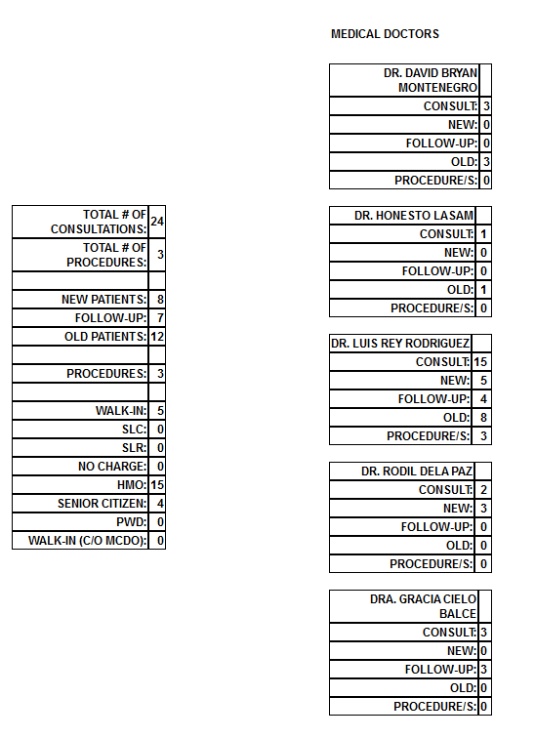
Sample Auto-generated Report (678 x 894px; Width x Height)

NOTE (from SYSON, MICHAEL B.):
From observation, companies in the Philippines tend to use the Java Computer Language and the accompanying frameworks and tools, e.g. Spring, Hibernate, to execute web development.
Example: https://www.orangeandbronze.com/; last accessed: 20210203

However, from experience, it is faster to show quick and correct outputs using XAMPP with PHP Hypertext Preprocessor (PHP) Computer Language and the CodeIgniter Framework. I add that we still use the Java Computer Language in web development, albeit to execute PHP commands with multiple computers on a network.

Example: Auto-generate Payslip and Official Receipt Slip

We connect Microsoft EXCEL workbooks that our partner already use to the computer network. This is to send payslip reports for the computer server to auto-add in the Database (DB).

From the DB, another computer connected to the network can auto-access the report to auto-correct its own report at the Unit.
In addition, we can use XAMPP with Linux machines, in combination with Windows machines.

1.1.3) shared: Byzanz tool to quickly record a continuous sequence of photograph images
Example Command (Terminal Window on LUBUNTU 20.04 (LTS)): byzanz-record --duration=6 --x=0 --y=0 --width=600 --height=600 outHalimbawa.gif

1.1.3.1) Additional Notes:
--> We set the start x and y-axes positions for the recording window to be at the top-left position of the computer window.
--> We add to the start x and y-axes positions 600pixels to set the width and height of the recording window
--> The output recorded animating file is in ".gif" format.
--> With a recording duration of 6secs, the output file is already at 1.6MB (MegaBytes)
--> where: 1MB = 1000Bytes; 1Byte = 8Bits; 1Bit = 1 set of yes OR no, true OR false, 1 OR 0, on OR off
--> 1Bit is sufficient if there is only 1 variation, e.g. on OR off of an electric light switch
--> The total output combinations of 1Byte is 256, i.e. 2*2*2*2*2*2*2*2 (total: eight (8) 2's)
--> From 1Byte, we can identify a letter of the alphabet, e.g. by setting the capital letter 'A' to be 65.
--> From 1Bit, we can build a system to output among others the following: Physical material action, e.g. emission of light using a Light Emitting Diode (LED) lamp
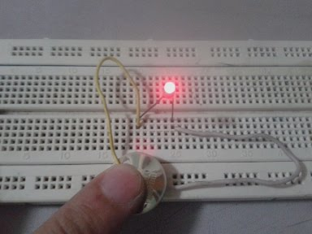

My index finger executes as the on OR off switch by connecting OR disconnecting the electric circuit.
We use a 3 Voltage (V) battery to cause with its electricity the LED lamp to emit light.
A 3V battery does not cause physical injury to my index finger.

Reminder: A 9V battery shall destroy the LED lamp due to receiving excess electricity.

In the following photograph, I connected to the circuit another set of circuit with a LED and a sound emitting device. I add that this set is from a "Happy Birthday" Greeting Card.

--> verified: Ramon uses 福建話 (fujianhua, hokkienoue, liannanoue ("our people's language")) to classify Filipinos as "juana" to signify "inutil";
--> requested: assistance from law enforcement via filing of written reports
--> 4.3) References: 4.3.1) https://www.keishicho.metro.tokyo.jp/kurashi/
drug/drug/taima_interview.html; last accessed: 20210117
--> 4.3.2) https://www.interpol.int/en/News-and-Events/News/2021/
INTERPOL-report-charts-top-cyberthreats-in-Southeast-Asia; last accessed: 20210228

NOW HIRING: COMPUTER SERVICES SALESPERSON
✓Receive half of the revenue from your DIRECT SALE of the service

✓Receive training:
Filipino Language, Sales, Information Technology
Requirements:
1) Curriculum Vitae
2) Portfolio
3) Sulat ng Hangarin
3.1) Ano ang maitutulong mo?
3.2) Bakit mo nais ito?
3.3) Bakit ka karapat-dapat?



EMAIL: APPLY@USBONG.PH

Tanong at Sagot

1) Magkano ang aking kikitain bilang Computer Services Salesperson at Manunulat ng paliwanag sa kompyuter, e.g. Add-on Software?
--> Kung babayaran tayo ng klinik ng 10K pesos bawat buwan, 5K ang sa iyo bilang Computer Services Salesperson.
--> Bilang Manunulat, 4K pesos ang maibibigay sa iyo ng Usbong.
--> Sa kabuuan, 9K pesos ang matatanggap mo bawat buwan.
--> Ang matitirang 10% ng 10K, i.e. 1K pesos, gagamitin ng Usbong sa pag-iipon ng kapital.
--> Gagamitin ito ng Usbong sa paggawa ng mga investment at "float", na ang kahulugan, liquid asset.

2) Paano ako makibabahagi sa tagumpay ng kompanya?
--> Kung wala tayong kikitain mula, halimbawa, sa Computer Automation Service, mauubusan tayo ng kapital na pambayad sa ating lahat. Hindi magtatagal, wala na tayong kompanya.
--> Dahil dito, kailangang maayos ang ating paggawa at pagtuturo sa mga trainee upang tuluy-tuloy ang daloy ng ating kita, habang nagbibigay ng ginhawa sa lipunan.

MAPARAANG PAGBIBILANG
ALGEBRA SKILL LEVEL 1:
INPUTS:
X = 250 //ITEM PRICE
V = 12% //VALUE ADDED TAX (VAT)
Q = ? //ITEM PRICE WITH VAT

TANONG: WHAT IS ITEM PRICE WITH VAT?
SAGOT:

ALGEBRA SKILL LEVEL 2:
INPUTS:
X = ? //ITEM PRICE
V = 12% //VALUE ADDED TAX (VAT)
Q = 364 //ITEM PRICE WITH VAT

TANONG: WHAT IS ITEM PRICE WITHOUT VAT?
SAGOT:

USBONG SOCIAL SYSTEMS, INC.
COMPUTER SERVICES

SYSON, MICHAEL B.
FOUNDER

MOBILE: +63929.952.7263
EMAIL: MASARAPMABUHAY@GMAIL.COM

WEBSITE: WWW.USBONG.PH
ADDRESS: #2 E. MANALO (FORMERLY, E. RODRIGUEZ) AVE., STO. NIÑO, MARIKINA CITY, 1820, PHILIPPINES
The budol-budol/manloloko/carnapper/cybercriminal/communist terrorist group uses this know-how to cause vehicle incidents, e.g. noise pollution as classified in the Marikina City Ordinance Enacting the Noise Control Regulations (ORDINANCE No. 100 Series of 2010), vehicle battery drain. The result of these actions is additional delays, e.g. verifying vehicle's electrical condition, executing vehicle battery replacement. Because Zeit is Geld (Time is Gold), such delays cause loss of Time, thereby loss of Money, which is made using Time.
--> 3.2) observed: increase in mosquitoes inside the clinic
--> Recommended actions:
--> 3.2.1) clean toilet with Zonrox chemical liquid
--> 3.2.2) wipe wet floor using mop
--> 3.2.3) use racket with electricity and light to destroy flying mosquitoes
--> after verification, it is faster to destroy mosquitoes with hands, albeit we'll need to wash hands after the action.
NOTE (from SYSON, MICHAEL B.):
I myself execute actions 1 and 2 with my room toilet every week. In addition, with the toilet bowl, if left uncleaned for more than 1 week, you'll also need Muriatic Acid to clean the stains. I previously verified using ground pepper and container cup, which I painted black, and filled with water. I put a strip of cloth that touched the water. The mosquitoes were supposed to lay their eggs there. However, these actions were not effective. At present, the quickest and effective action is to regularly clean the toilet once every week. I add that I identified the toilet to be the source of water, where mosquitoes lay their eggs. Mosquitoes from eggs fly after 5~7 days. From literature and interacting with researchers, I learned that in the United Kingdom (UK), the British are developing techniques and chemicals, so that mosquitoes no longer lay any eggs. In addition, in Indonesia, researchers are working on stronger chemicals to destroy mosquitoes. I was notified that when the mosquitoes grow stronger to become immune to the chemicals, the researchers shall use new and stronger chemicals. After computation, the British shall also need to develop stronger techniques and chemicals, so that the mosquitoes who become immune will not lay eggs.
4) Continued to update Training Centre: Security Defense Force
--> 4.1) added: Part 6: Michelangelo Buonarroti's "Giudizio Universale"
--> Recommended Action: verify: http://www.arte.it/opera/giudizio-universale-4709; last accessed: 20210223
--> Additional Note: Matatandaan na sa unang pagdating ni Kristo, nagbigay siya ng mensahe ng pagbabago at pagbabalik kay Bathala. Sa kanyang ikalawang pagbabalik, pupuksain na niya ang mga Teroristang Komunista.
--> 4.2) added: Part 7: 大麻とは・・・
「大麻草（学名：カンナビス・サティバ・エル）とその製品をいいます。大麻に含まれる成分のひとつTHC（テトラヒドロカンナビノール）が主に中枢神経に作用し、興奮、陶酔、幻覚などを引き起こします。使い方には「乾燥大麻を燃やしてけむりを吸う」などがあります。なお、大麻の所持や栽培などは「大麻取締法」で厳しく規制されています。」
--> Translated from nihongo to English by SYSON, MICHAEL B.
--> taima, i.e. "big hemp weed" (studied name: kanabis・satiba・el) as manufactured product. Included in taima is a made part THC (tetrahidro kanabis so-l) mainly made to use with central nerve, i.e. 神経 (God Passage), to cause excitement, dizziness, illusion, etc. Usage: There exist "burn dried taima, breathe smoke", etc. In addition, possession, cultivation, etc of taima are strictly regulated via "Rule on Controlling taima"
--> Additional Notes: 4.2.1) The budol-budol/manloloko/carnapper/
cybercriminal/communist terrorist group uses wireless broadcasting technology to cause the effects of taima.
--> 4.2.2) The International Criminal Police Organization International Police (INTERPOL) notes that due to COVID-19, it is expected that there is an increase in criminal activies by budol-budol/manloloko/carnapper/
cybercriminal/communist terrorist group to quickly get money.
--> 4.2.3) マリファナ (marijuana) is classified to be with taima
--> identified: Dr. Pedro Syson's younger brother, "tai-ah", i.e. Ramon Syson, to be with this Manloloko group.
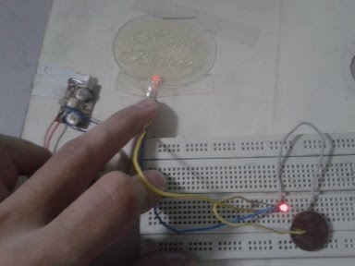
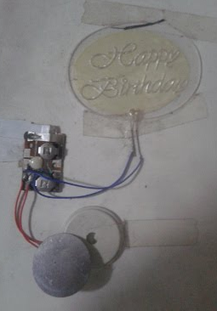
We reuse metal paperclips to build the circuit. The round object located in the bottom-right of photograph #1 is the 3V battery.

Photograph #2: The round object (BOTTOM) emits sound. Diameter Size: 1nch; Pet Bottle Cap

In addition, from literature on space exploration, we learn that when astronauts return to planet earth after traveling to outer space, the remaining vehicle from the spaceship assists Unit members at Headquarters (HQ) by emitting a radio, i.e. electric wave, signal to notify them of the location.

Reminder: There exist waves, e.g. sound, electric, light. All waves need and use energy. More energy is needed to travel farther distances. Energy from waves can cause physical injury, e.g. during impact when we are hit.

We add that due to the size of the pacific ocean, it still took days to find the astronauts. Therefore, it shall not be efficient to attempt to find the location of the budol-budol/manloloko/
carnapper/cybercriminal/communist terrorist group using the electric wave signal that they emit by misusing devices and vehicles, in addition to network towers, e.g. from cellular telecommunications companies, which include among others: SMART and GLOBE

This is due to their objective is not to be found at all.

After verification, the quickest technique is to identify their place of residence. This is due to from history and observation, it is not sustainable for a household to be continuously moving its place of residence, especially as members become classified to be Senior Citizens.

The information on place of residence is available with among others: National Bureau of Investigation (NBI)
--> 1.1.4) shared: with Unit members we increase productivity by using computers and IT tools
--> Example: work valued at 10 units can be multiplied to be 20 units. This is while not increasing the number of human persons.
--> Reminder: increase in human persons in the human network causes increase in communication problems
--> This is due to productivity is increased by laborers who are mechanical and devoid of emotions.
--> However, from history, e.g. Industrial Revolution, human persons do not maintain such states longer than machines.
--> Recommendation: Receive assistance from computers/software/
machines to execute routine, monotonous tasks.
--> Additional Note: 1) Incorrect input from human Unit member causes incorrect output. KMS provides computation assistance, not human Unit member replacement.
NOTE (from SYSON, MICHAEL B.):
From literature, we learn that Germany and Japan focused on using computers/machines to assist humans. This is instead of focusing on developing Artificial Intelligence (AI) as in the case of the United States of America (USA), so that the computers/machines learn to be independent from humans who continuously give them instructions.

In the Philippines, we at USBONG focus on using computers/machines as assistive tools.

From experience, I find problems to not be with computers/
machines who intentionally cause us physical injury. Instead, physical injury is caused by humans classified to be with the budol-budol/manloloko/carnapper/cybercriminal/communist terrorist group who intentionally misuse computers/machines to quickly get money.

Reference: 1) Kraiss, K. (2006). "Advanced man-machine interaction: fundamentals and implementation". Berlin Heidelberg: Springer-Verlag
--> continued: to share that the computers and IT tools need not all be the newest and fastest
--> Examples in Actual Use:
--> 1.1.4.1) Hewlett Packard (HP) Printer Ink Cartrdige (704)
--> When printer notes low remaining ink, we verify available colors, e.g. yellow, blue, pink.
--> With this action, we maximize ink cartridge usage.
--> This is due to remaining ink of select colors may not yet be low. At present, each ink cartridge costs PHP475~500.
--> 1.1.4.2) Lenovo IdeaPad K1 Tablet Personal Computer (released: 2011; technology from 10+ years ago)
--> 1.1.4.3) HTC Wildfire Smart Telephone (released: 2010; technology from 10+ years ago)
--> We can still use these due to eliminating excess instructions that cause delays in web page loading and viewing.
--> In addition, we do not use additional tools, e.g. Adobe (formerly, Macromedia) Dreamweaver, to write the Hypertext Markup Language (HTML) and Cascading Style Sheets (CSS) commands. In their stead, we use Notepad++ and Firefox Browser.
--> These tools can be legitimately downloaded without additional license fees.
NOTE (from SYSON, MICHAEL B.):
From experience, Dreamweaver adds additional HTML text that makes the output pages difficult to edit without Dreamweaver.

However, I found Flash, another tool that accompanies Dreamweaver, to be faster to use to write instructions to animate and interact with auto-drawn objects than C/C++ Computer Language and Java Computer Language.

This is due to the need to have know-how of C/C++ Computer Language's syntax and memory allocation techniques. As with the Java Computer Language, without existing sets of instructions, e.g. object animation, collision detection, development becomes longer.

In addition, Flash's existing tools, e.g. Timeline, ActionScript 2.0 and 3.0 (to an extent) Computer Languages, provided a faster alternative, especially those who understand video/animation/film editing. I add that sets of instructions, e.g. collision detection, are already available for use with Flash.

Additional Note: ActionScript 3.0 is a big variation to 2.0, albeit is also classified to be with ActionScript. I preferred version 2.0.

From observation, due to Flash using more processing computations to auto-draw objects, mobile computers from more than 10 years ago began to consume more energy from their batteries. With low remaining energy, devices do not execute instructions correctly.
--> 2.1) Automotive: Usbong OpenGL (Graphics Library) and Usbong Engine
--> updated: set of instructions for computer to read as input .csv (comma-separated values) files
--> The computer uses this input file to auto-draw the level on the computer monitor.
--> used: C++ Commands, e.g. std::string, to quickly read values classified to be String of characters from the .csv input file.
NOTE (from SYSON, MICHAEL B.):
With values classified as single characters, I find writing the instructions in the C Computer Language to be difficult when using a container classified to be a "double Array", i.e. a container with two (2) containers inside. I add that we can use numbers, instead of single characters or String of characters as values in our "double Array". This is in addition to writing a map of the significance of the number.

Example: 1 = grass
Additional Note: C++ Computer Language includes tools as set of instructions to make it faster to write the instructions than with only the C Computer Language.
--> verified: setting horizontal scrolling view from isometric view
--> With correct instructions to auto-draw the 3-Dimensional (3D) objects, we can set another view, without need to make additional changes to the objects' instructions.
--> From history, we learn that in the 90's, sports games, e.g. Electronic Arts (EA)'s National Basketball Association (NBA) Live games series, used 3D objects to increase camera angle views.
--> In addition, developers began using motion capture technology to auto-write instructions for movements whose instructions take longer to write by hand.
--> Example: Namco's Tekken 3 vs Capcom's Street Fighter EX
--> learned: we can reduce the file size of the output Windows executable by reducing usage of glPush and glPop commands
--> The file size is now 1,525KB from 11,556KB (Windows).
--> The file size is now 197KB from 181KB (Linux).
--> updated: Computer Interactive: Lessons-Learned
--> ロックマン（Rockman） X:
--> sigma stage: toro boss battle; excess use of rockets, i.e. homing missile, in stage; less available rockets during boss battle
--> sigma stage: spider boss battle; "no money", but have time; make money using time
--> Example: カプセル (capusel, i.e. Capsule)
コンピュータ(Computer); CAPCOM
--> 2.2) Energy: Food
--> verified: arrival of insects that eat the leaves of the plants.
--> observed: caterpillar ate kalamansi leaves
--> action: removed caterpillar; solved
--> observed: black ants ate papaya and tomato leaves
--> action: removed ants from leaves; not yet solved
--> action: sprayed with water and vinegar the ants and leaves;
not yet solved
--> action: added dry pepper seeds to cause the ants to not come due to smell; not yet solved
--> action: added cinnamon powder to cause the ants to not come due to smell; not yet solved
3) Continued to share Information on Energy and Health
--> verified: vehicle battery, e.g. MOTOLITE
--> https://motolite.com/faq/#battery-faq; last accessed: 20210228
Can electrical gadgets that operate when the key is turned off affect the performance of a battery?
Key-off electrical loads are common. The vehicle's electrical system is adjusted to accommodate this extra drain. Nevertheless, if a car is equipped with devices that require power even after the key has been turned off, care must be taken during extended periods of vehicle inactivity or frequent short trips, since these do not allow the battery to recharge after the drain resulting from starting the engine. If a vehicle is used for short trips only and its electrical system is in good working condition, periodic recharging is required.
NOTE (from SYSON, MICHAEL B.):
At present, vehicles can receive wireless electric waves, i.e. radio, even during key-off. Example Usage: wirelessly unlock vehicle
Example: https://github.com/usbong/KMS/blob/master/usbong_kms/kasangkapan/autoScreenCaptureReportMedicineIPCA.bat

Sample Output:
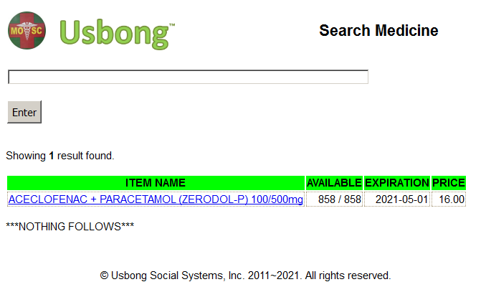
Previously, we recommended to identify the income contribution of each Unit member.

Example: As a computer services company, our income contribution to our partners is based on saved time to execute tasks. Without our service, how much time does it take you to finish tasks? Reminder: Zeit ist Geld. Time is Gold.

I add that we received the computer services request from MOSC due to tasks are not finished quickly and correctly. After working on the tasks ourselves, we learn that this is due to the budol-budol/manloloko/carnapper/cybercriminal/communist terrorist group who use as weapon wireless broadcasting technology to attack Unit members. Again, their objective is to quickly get money, which can be in the form of received products and services as gifts not reported to the Bureau of Internal Revenue (BIR).
1.3) received: Bureau of Internal Revenue (BIR) Form 1900:
--> Application for Authority to Use Computerized Accounting System or Components thereof/Loose-leaf Books of Accounts
--> List of requirements
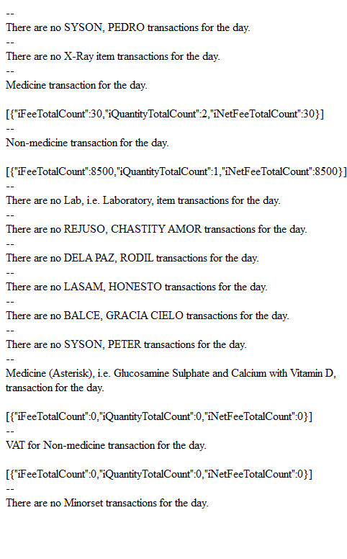
Sample auto-generated Computer Summary Report
to verify with Cash Register's Printed Summary Report
--> 1.3.1) Command 1: The computer writes as an output .txt file in the JavaScript Object Notation (JSON) format each section of the Report, e.g. medicine, non-medicine items.
--> 1.3.2) We use LibreOffice Calc and the workbook with our Macros, i.e. sets of instructions, to auto-import and export files.
--> Command 2: We auto-import the output files and write the values to be similar, if not equal, with those used in the Cash Register Summary Report and the handwritten report executed at the Accounting/Cashier Unit.
--> 1.3.3) Command 3: If there is no more additional editing, we export the Summary Report as .csv file.
--> This .csv file is used as input by another set of instructions to be viewable on a computer web browser.
--> 1.3.4) Command 4: This action empowers us to use the PhantomJS tool to automatically take a photograph of this report.
--> We have eliminated excess steps, such that the Unit member shall only need to use four (4) commands for the computer to auto-execute the actions.
2) Continued with Research & Development (R&D)

Since 2021-01-12, Adobe stopped support for Flash Player.
SAMSUNG HARMAN is now continuing the support.

Recommended Action:
1) reverify: FlashDevelop ActionScript 2.0 Editor
--> 1.1.5) shared: with among others Unit members Introduction to Maparaang Pagbibilang Questions
--> added: Coordinate System questions
--> used: keyword "mapa" to signify "Coordinate System"
--> used: keyword "daungan ng barko" to signify "point" to locate

NOTE (from SYSON, MICHAEL B.):
Hanap-buhay = unti-unting pagkita ng pera mula sa paggawa.

The budol-budol/manloloko/carnapper/cybercriminal/communist terrorist group executes actions, e.g. panloloko, pandurugas, to quickly get money, i.e. NOT hanap-buhay.

Example: carnapping, i.e. vehicular theft; where vehicle costs at least PHP500K. Reminder: With this action, there is no Tax being paid to the barangay, city, country at all.

Recommended Action: verify people's lifestyle

Additional Notes:
1) From history (since the 1860's), we learn that in Germany and Japan, police boxes were added, so as to identify community problems, e.g. criminal activities.
--> When a newcomer arrives, neighbors verify activities, e.g. receiving delivery items.
--> If the work of the neighbor does not add positively with the cost of the total delivered items, any community member can file a report to the police box.
--> This is to investigate the source of such items.
--> In the Philippines, we have the barangay to assist community members.
2) I admit that I am not the person from whom to request for money, e.g. valued at least 1/2 month's work, in exchange for nothing.
--> From history, we learn that in Italy, closure of banks could be executed by people who withdraw money simultaneously, such that the bank does not anymore have remaining capital.
--> However, I am willing to provide financial assistance for another to receive gradually increasing income in exchange for increasing skill level of work.
--> This is due to it is not sustainable to give money that we saved from work without receiving any product/service that we value to be equal.
--> From observation, volunteer work is not sustainable if the worker does not receive income from any source at all.
--> Reminder: Actions of people who quickly need money become dirty;
--> classification: Mandurugas.
--> At present, the highest Algebra Skill Level that Unit members has finished is 3.
ALGEBRA SKILL LEVEL 3:
INPUTS:
S = 600K //EXCESS STOCK IN WAREHOUSE (JAPAN)
D = 180 //IN USD OF EACH STOCK
L = ? //LOSS
NOTES:
1) USD = UNITED STATES DOLLAR
2) PHP = PHILIPPINE PESO
3) USD1 : PHP54

TANONG: WHAT IS THE LOSS IN PHP?
SAGOT:
NOTE (from SYSON, MICHAEL B.):
The loss in USD is 108Million and in PHP 5.832Billion. If we set the USD and PHP currency exchange ratio, i.e. number relationship, to be USD1 : PHP2, the loss decreases in PHP to be 216Million, instead of 5.832Billion. With physical material object weight, there exists the following: 1pound : 0.453592kg

At present, this ratio is similar to the following currency exchange. yen1 : PHP0.46

If we set the ratio to be USD1 : PHP0.46, the total loss in PHP from USD 108Million decreases to be 49.68Million. I add that it is useful to quickly know the output result, e.g. increases or decreases, by verifying the currency exchange ratio and its equation.

Example: (1)p = (1/2)u
where: u = USD 108Million
Tanong: p = ?
Sagot: p = PHP 54Million; (total loss) decreases
--> As for Coordinate System Skill Level, it is 1.


NOTE (from SYSON, MICHAEL B.):
I add that I worked with a Japanese company which assisted financially learners, e.g. Filipinos, Koreans, with their school tuition.
Examples:
1) College Tuition
--> Set location is private university in Metro Manila, Philippines.
2) Master in Business Administration (MBA)
--> With the MBA, the set school location is Hawaii.

From world history, we learn that the Japanese achieved sufficient know-how to identify the location of Hawaii and the port where naval ships were located. After computation, manufacturing of Zero Jet Fighters at the time did not include variations that required the use of computers, e.g. Personal Computers (PC) from even 20 years ago. To save oil, the Zero Jet Fighters had to quickly find Hawaii in the Pacific Ocean. Therefore, a 2 Dimensional (2D) map with assistance from those already in Hawaii to identify the location is necessary before flight.

After interacting with Hawaiians, whom I met as fellow students in Japan back in 2004, I note that they appear as Filipinos whose way of speaking English is similar, if not equal, with mine. This is at least before the budol-budol/manloloko/carnapper/
cybercriminal/communist terrorist group misuse wireless broadcasting technology to cause Ear, Nose, and Throat (ENT) problems, e.g. variations in sound of voice, neck pains, vein pain of the throat, breathing difficulty.

In addition, I played ping-pong with a fellow student from Hawaii, albeit not competitively, e.g. in university tournaments. I add that with competitive tournaments, this Communist Terrorist group misuse wireless broadcasting technology. This is especially certain when money can be quickly received.
Recommended Reading: Barack Obama's "The Audacity of Hope"
--> requested: Unit member at partner Sta. Lucia Health Care Center (SLHCC) Unit to create a web page version of the printed Laboratory Request Form
--> This action is to verify if task can be finished with present skill-level. In addition, this action is to assist us to speed-up system due to we use additional time for re-verification.
--> noted: that with present workload, Unit member shall need 2~3 weeks to finish task.
--> Reminder: if Unit member as Chief accepts task to be finished in 3 weeks, but takes 6 weeks, then we expect payment to be only for 3 weeks. Unit of Unit Chief do not receive from client payment for the excess weeks of work. However, if estimated time is excessively long for client, the project task may be given to another development Unit. Therefore, correct time and cost estimates are vital, so that income is higher than expenses.
NOTE (from SYSON, MICHAEL B.):
I am already writing the computer instructions for both back-end and front-end of the Laboratory Request Form at partner, MOSC.

This action is to assist the Laboratory Unit with the computations and reports, which at present are executed without automatic computer output generation.

We use as input a .csv (comma separated values) file to add the Laboratory items in their set row and column. This is read by the computer, which automatically writes the Hypertext Markup Language (HTML) commands.
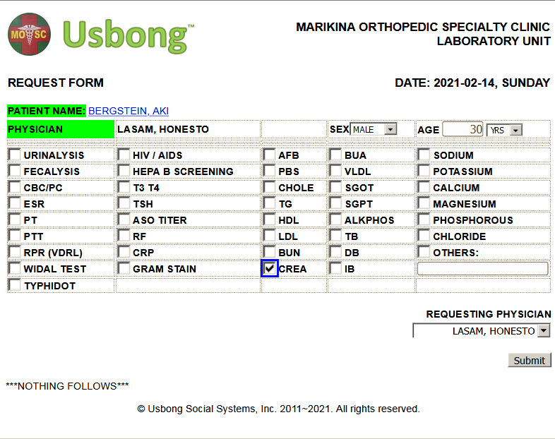
I add that I am also writing the instructions for the index card page of each patient at MOSC. The next step is to add photograph images of the printed index cards with handwritten notes by the Medical Doctors.
--> 1.1.6) continued: to share printed Usbong Newsletters to Salespersons, e.g. Newspapers, Computer Shops, Medical Representatives, and partners, e.g. Sta. Lucia Health Care Center (SLHCC), in the following Barangays:
--> Marikina City: Barangays Sto. Niño, Sta. Elena, San Roque, Kalumpang, and Marikina Heights
--> Cainta, Rizal: Barangay San Isidro
--> Reminder: digital version available at www.usbong.ph
--> This is in addition to the Maparaang Pagbibilang Questions.
1.2) reverified: set of instructions for KMS to display correct list of expiring medicine items as output
--> The computer writes in the list the items from the nearest to farthest expiration date using now as the reference date.
--> In the view item page, the computer displays the item with nearest expiration date.
--> However, getting the physical material object with the correct expiration date increases delay due to difficulty in finding the item and reading its expiration date.
--> At present, available space in the item physical storage rooms, which contain both medicine and non-medicine items, have become lower due to increasing items and variations.
NOTE (from SYSON, MICHAEL B.):
We are adding more Medical Representatives who visit MOSC to our KMS reports. We identified a variation in their preferred unit of measurement, which now includes box and piece. At present, we prepare and send them the reports via email and Rakuten Viber. In addition, we again use the PhantomJS tool to automatically take photographs of KMS's auto-generated reports, which we include as file attachments.

