
January 2022
SAVED TIME : Geld, i.e. GOLD, MONEY
スーパーファミリーコンピュータ
Su-pa- Famiri- Kompyu-ta

PHILIPPINES: USBONG CONTINU​ES TO PROVIDE
COMPUTER SERVICE ASSISTANCE BY SHARING
KNOW-HOW ON MAPARAANG PAGBIBILANG

To eliminate excess steps and inefficient time usage, MARIKINA ORTHOPEDIC SPECIALTY CLINIC (MOSC) requested Usbong's services to automate routine, monotonous tasks and share with unit members know-how on computers.

Here are Key Action Items that we executed in this updates list.
1) Continued to update Knowledge Management System (KMS)
1.1) continued: to share know-how on computers and Information Technology (IT) tools
1.1.1) shared: with Public, select IT know-how to learn
--> VALUE noticeable when transactions count > 1000 per year
--> Output of Action:
1) Increased Work Income
2) Increased Work Contribution to Community, Family, Company

Example Work Output: Usbong Computer Software Automation
Your browser does not support the video tag.

--> Recommended Actions:
--> Skill-Level#1) learn: correct use of rows and columns to quickly execute computations
--> verify: first using pen-and-paper Workbook
--> verify: next using Computer Software Workbook, e.g. from Microsoft Excel, LibreOffice Calc

--> Skill-Level#2) learn: correct use of MACRO, i.e. set of instructions, to auto-execute computations
--> learn: Visual Basic for Applications (VBA) with Microsoft Excel
--> observed: Offices of Private Companies usually have at least one (1) Computer with Microsoft Excel
--> Example#1: Weekly Health Maintenance Organization (HMO) Report

--> learn: BASIC with LibreOffice Calc
--> observed: VALUE of output reports that are quickly and corrected finished > VALUE of technique used --> Example#1: X-ray Unit Charge Slip
--> Example#2: Weekly Cash Payment Collection Report

--> Reminder#1: Microsoft Office License
Office Home & Student 2021
One-time purchase for PC and Mac
₱6,999.00

--> Reminder#2: LibreOffice Calc
Downloadable version (Legitimate, GRATIS)

--> Skill-Level#3) learn: correct use of JAVA Computer Language to auto-execute computations with Multiple Computers
--> Output JAVA application receives as input another computer's Workbook.
--> note#1: Workbook can be from Microsoft Excel and/or LibreOffice Calc.
--> note#2: File transfer can first be via Universal Serial Bus (USB) Memory Storage.
--> Example#1: Patient Referral 5% Incentive Summary Report

NOTE (from SYSON, MICHAEL B.):
After verification, the next Skill-Level shall require an increased know-how in multiple Computer Languages.

Skill-Level#4) learn: correct use of Computer Network
--> learn: Computer Web Technologies
4.1) Apache Web Server
4.2) Hypertext Markup Language (HTML)
4.3) PHP Hypertext Preprocessor (PHP) Computer Language
4.4) MySQL (Structured Query Language) Database
note: file transfer via computer network

Additional Notes:
1) We use the Apache Web Server so that multiple computers connected to the network can access files in another computer classified to be the Server.
2) We use HTML to write the instructions of the page files stored in the Server to be viewed by multiple computers.

3) We use PHP to write the instructions that connect the page files to the Database in the Server.
Example: Auto-write in the page file all the patient names in the Database with the keyword "Miguel"

4) We use MySQL to create a structure of all the data, e.g. patient names, to quickly execute actions, e.g. search.
Reminder: No structure : CHAOS/GULO

This structure uses the technique that we use with the pen-and-paper TABLE with rows and columns;

With TABLE count > 1, we connect each TABLE in the set using a unique identification (ID) that exists in the two (2) connected TABLEs.

Example: Patient ID as used by both Patient TABLE and Transaction TABLE

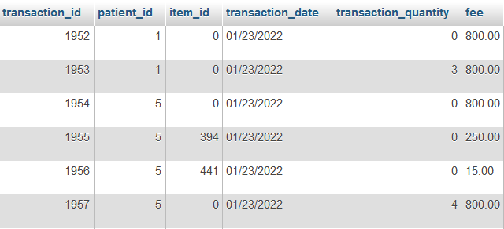
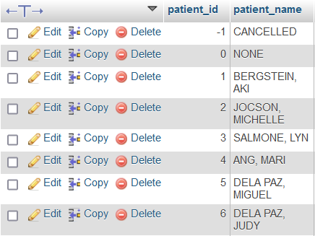
From observation, I share that Database know-how is a fundamental concept in Computer Science, as applied using Information Technology.
where: Science : identification and classification of objects

In addition to PHP, there also exist Computer Languages, e.g. Python, Perl, that can be used for Web Development. However, after verification, I still use PHP due to being faster to write the computer instructions and also maintain with assistance from the CodeIgniter Framework (version 2).
where: CodeIgniter Framework: guide to create structure for the files;

Example:
1) View Folder for the page files that is viewed by Humans of the Unit;
2) Model Folder for instructions to access the Database
3) Controller Folder for instructions to connect the View Folder and the Model Folder by identifying which items to use in the Database query, i.e. question, based on the input from the page files in the View folder

1.1.2) reminded: Public, VALUE of IT know-how in relation to TIME

Example#1: Incorrect INFORMATION by Human Unit Member that she has already written the Transactions for the Day in the MS Excel Workbook;

COST to Tech Support: 17mins, attempting to identify in the computer instructions the CAUSE of Incorrect Output

Note: VALUE becomes unclear if SAVED TIME NOT measured;
where: SAVED TIME : Geld, i.e. GOLD, MONEY

SAVED TIME can be used to execute these actions among others:
1) Another work task to speed-up system
2) Rest with own Family Unit

CASIO WRIST WATCH Purchased History
Purchased Date: 2013-05-12  Cost: PHP4950  ELAPSED TIME: OVER 4 YEARS; @PHP3.39/day | 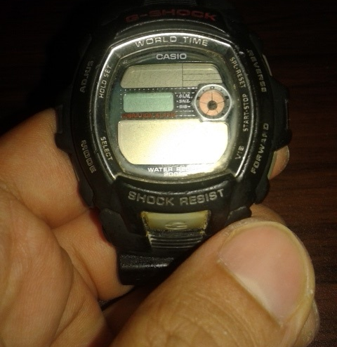
Purchased Date: 2017-09-07  Cost: PHP4950  ELAPSED TIME: OVER 4 YEARS; @PHP3.39/day | 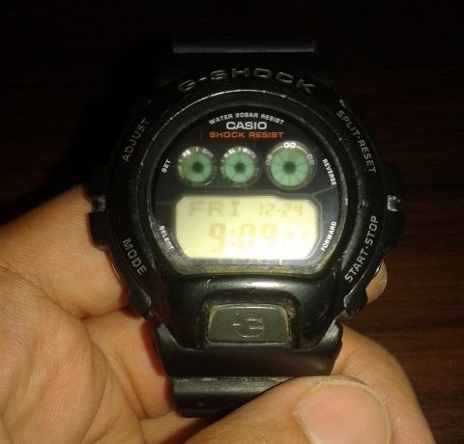
Purchased Date: 2021-12-14  Cost: PHP5000  ELAPSED TIME: ???;  @?/day | 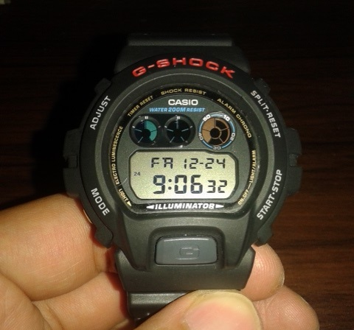

NOTE (from SYSON, MICHAEL B.):
I recommend using items that I continue to use.

Example: CASIO WRIST WATCH

In addition, its functions that I mainly use include:
1) DAY of the WEEK & Date: to quickly get such information
2) Back LIGHT: to view TIME even when there is insufficient ambient light
3) STOP WATCH: to measure ELAPSED TIME when executing physical activities, e.g. RUNNING, SWIMMING

In the same manner, I recommend eating FOOD that I continue to eat.
Example: No need to eat PORK, insects that eat dirt, et cetera

Additional Note:
1) Question & Answer of whether Husband or Wife is also THIN or BIG;
observed: those who eat together the same FOOD shall be of the same size;
--> those that are even a little separated due to work, et cetera
--> AND do NOT eat the same FOOD shall NOT be of the same size;

Recommended Action:
1) Work to build OWN Family Unit together @HOME as Husband and Wife
2) verify: own weight each morning after waking up and before drinking or eating anything
--> If weight increased, this action assists in identifying which FOOD from the previous day caused it.
--> Examples of observed FOOD to cause increase in weight:
--> chicken gravies, campbell soup, cake cream

Recommended Reading:
--> Suzuki, D.T.'s "Training of a Zen Buddhist Monk"

Recommended Computer Game Character:
--> テリー（ドラゴンクエストVI； スーパーファミリーコンピュータ版）
--> teri- (doragonkuesuto VI; su-pa- famiri- kompyu-ta ban)
--> classified to be already strong by himself;
--> however, opts to join Unit to be stronger

2) Continued with Research & Development (R&D)
2.1) joined: GitHub Game Off 2021: TUGON



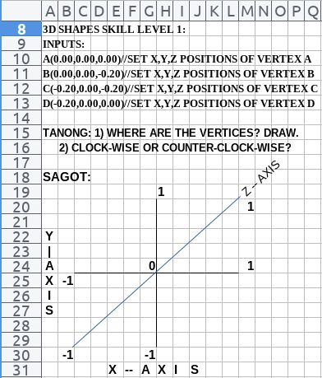

USBONG I.T. SOLUTIONS
COMPUTER SERVICES

SYSON, MICHAEL B.
FOUNDER

MOBILE: +63929.952.7263
EMAIL: MASARAPMABUHAY@GMAIL.COM

WEBSITE: WWW.USBONG.PH
ADDRESS: #2 E. MANALO (FORMERLY, E. RODRIGUEZ) AVE., STO. NIÑO, MARIKINA CITY, 1820, PHILIPPINES

MAPARAANG PAGBIBILANG
ALGEBRA SKILL LEVEL 1:
INPUTS:
X = 250 //ITEM PRICE
V = 12% //VALUE ADDED TAX (VAT)
Q = ? //ITEM PRICE WITH VAT

TANONG: WHAT IS ITEM PRICE WITH VAT?
SAGOT:

ALGEBRA SKILL LEVEL 2:
INPUTS:
X = ? //ITEM PRICE
V = 12% //VALUE ADDED TAX (VAT)
Q = 364 //ITEM PRICE WITH VAT
TANONG: WHAT IS ITEM PRICE WITHOUT VAT?
SAGOT:

ALGEBRA SKILL LEVEL 3:
INPUTS:
S = 600K //EXCESS STOCK IN WAREHOUSE (JAPAN)
D = 180 //IN USD OF EACH STOCK
L = ? //LOSS

NOTES:
1) USD = UNITED STATES DOLLAR
2) PHP = PHILIPPINE PESO
3) USD1 : PHP54

TANONG#1: WHAT IS THE LOSS IN PHP?
SAGOT:

TANONG#2: WHAT IS THE LOSS IN PHP IF WE SET
USD1 : PHP0.50?
SAGOT:



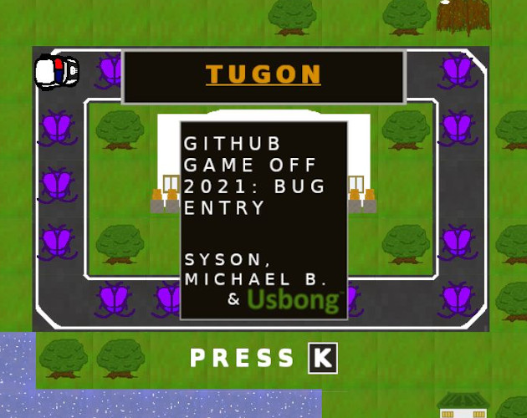

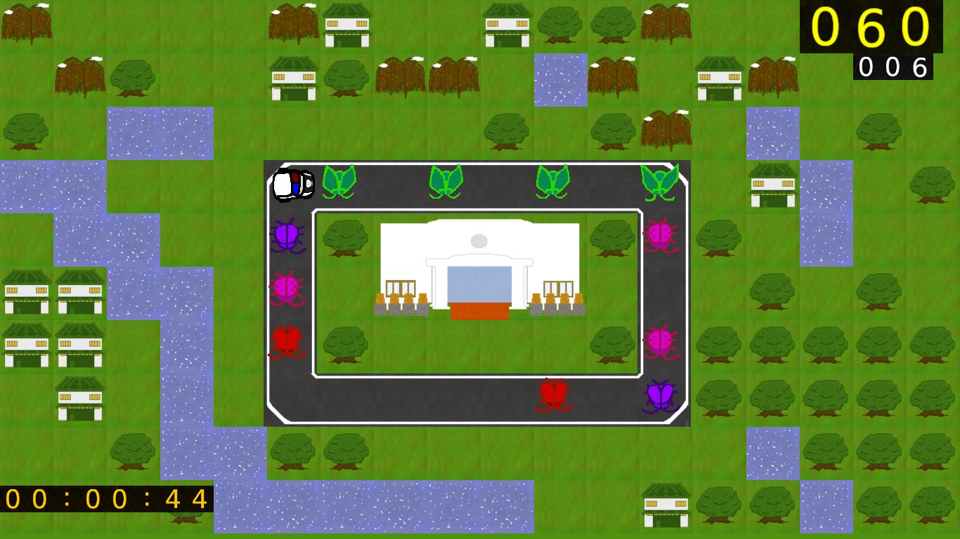

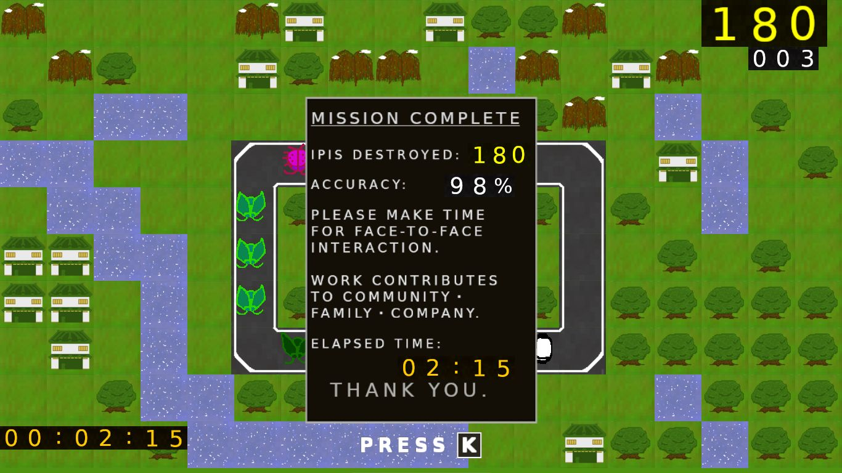

2.2) Usbong Tugon: Auto-resize Output Image Tile based on Computer/Television Monitor
--> 2.2.1) verified: using OpenGL (Graphics Library) Technology's scale COMMAND, tile image size CAN be quickly and correctly resized to be SMALLER or LARGER than its original size
--> This is due to among others:
--> floating-point numbers are accepted as inputs, instead of ONLY whole numbers
--> where: floating-point numbers : numbers with decimal point
--> Examples: 2.5, 3.0
--> where: whole numbers : integers, numbers with NO decimal point
--> Examples: 2, 3
--> Reminder#1: 10/3=3.333...
--> Reminder#2: Shall need to download and install OpenGL, in addition to SDL (SimpleDirect Library)

--> 2.2.2) verified: using ONLY SDL Technology's set width and height, tile image size CAN be quickly and correctly resized to be SMALLER than its original size if using the same ratio;
--> where: same ratio : from 64x64 to 32x32; NOT from 64x64 to 32x35
--> Incorrect Output: excess or missing pixel markings, near the tile image's borders

--> Additional Note: If size increased to make tile image LARGER, also incorrect output
--> Present actions:
--> 1) use the original Tile Image's pixel width and height, e.g. 64x64;
--> 2) resize to be LARGER only Tile Image with transparent borders
--> Example: Font texture

NOTE (from SYSON, MICHAEL B.):
Using available TIME received from system efficiency, we are able to execute Research & Development (R&D) work tasks, e.g. Usbong TUGON. From History, we learn that select computer simulation game companies also executed such action.
Example: From Software (Founded in 1986)
Section 2 CS Development Team:
Shinichiro Nishida, Associate General Manager
Section 1 CS Development Team:
Yasuyoshi Karasawa, Associate General Manager
Production Division: Toshifumi Nabeshima, Unit Chief
From Software Example Works: King's Field Saga, Armored Core Series, Shadow Tower, Echo Knight
Select Interview Questions:
1) Why did you decide to start making games?
"When we were making home applications there would sometimes be periods of free time between our customers' orders where we had no work to do. Of course we couldn't sit around doing nothing, so we sometimes wrote PC games. Anyway, at the time when the 3DO, Sega Saturn and PlayStation came out we decided to have a go at producing a game for real. In the end we chose to develop on the PlayStation because it had the highest spec."
2) Armored Core was a big departure from your hit RPG series. Were you worried that your fans wouldn't like it?
"Sony actually said to us that a robot fighting game would have a much smaller base market for our target user, and that concerned us. However, while creating Armored Core, we genuinely enjoyed playing with it and we were fairly confident that it would do well, and when we showed it at the PlayStation Expo, we received a lot of positive feedback from the gamers."
Unit Team Notes:
"At first there was just one team for King's Field. Then we split this team into two and increased their numbers. Then later on we split these two teams again and enlarged them with new staff. Thus, there are both new people and people who have worked on the King's Field series in this team."
--> From 3 people making games, to 7 by King's Field; in 1998, 30 people working only on games.
Unit 3D Graphic Engine Note:
Push Engine to the entertaining edge of game creation
Reference:
Halverson, D., et al. (1998). "Gamers' Republic (Issue 7, December 1998)". CA, USA: Millenium Publications, Inc.

2.3) Lessons-learned Report
2.3.1) What is your reasoning behind the corrective actions that your team chose?*
We started by verifying instructions from our existing applications that executed on Windows machines. However, due to there were more unused Linux machines available, we quickly created a Linux version. We also used the macOS and the GarageBand Tool to convert to .mp3 file format the Audio file that we recorded using an Android telephone.

2.3.2) Describe one example of what went right.*
We did NOT experience stress caused by attempting to add more with decreasing available TIME during development.

2.3.3) Describe one example of what went wrong.*
I set the COMMENTS to off in our GitHub Game Off 2021 Project page after observing that it appeared that those who did NOT even Submit an Entry could POST a comment; After re-verification, there was an update, such that comments began to include the Developer's Submitted Entry.

2.3.4) Give your personal words of wisdom based on your team's experiences.*
Execute tasks yourself instead of immediately delegating them to people; We learn how select applications became a certain way after noticing during development that select developers were also working on a similar path, and reached their END Output based on the paths that they chose.

2.4) Lessons-learned Report (Japanese version)

学んだ事に関するレポート

2.4.1) 直すための選んだ行動に関する理由は?*
先ず、WINDOWSマシンで実行するアプリケーションのソースコードを調べ始めた。しかし、使ってないLinuxマシンがより多くて、LINUX版を速く作ることにした。また、macOSとGarageBandツールで、アンドロイドケータイ電話で記録した音声を、.mp3ファイル式に変更した。

2.4.2) うまく行ったことを一つ下さい。*
残り時間が少なくなり、より多くのモノを入れようとしないため、ストレスを感じなかった。

2.4.3) うまく行かなかったことを一つ下さい。*
何のエントリーも提出してないのに、コメントができることに観えて、GitHub Game Off 2021 Projectのページで、コメントをＯＦＦにした。 しかし、また調べたら、更新があり、コメントに開発者の提出したエントリーが付けるようになった。

2.4.4) チームの経験から、個人的な知恵を一言を下さい。*
人に直ぐ任せるより、ジョブタスクを先ず自分で実行してみること。そうすると、如何にあるアプリケーションの一定的な結果となったか、ということがわかるようになる。そして、こういうことにも気づく。開発中の時に、開発者が似てるパス（道）で働き、選んだパスで、最終出力に着いたこと。

NOW HIRING: COMPUTER SERVICES SALESPERSON
✓Receive half of the revenue from your DIRECT SALE of the service

✓Receive training:
Filipino Language, Sales, Information Technology
Requirements:
1) Curriculum Vitae
2) Portfolio
3) Sulat ng Hangarin
3.1) Ano ang maitutulong mo?
3.2) Bakit mo nais ito?
3.3) Bakit ka karapat-dapat?



EMAIL: APPLY@USBONG.PH

Tanong at Sagot

1) Magkano ang aking kikitain bilang Computer Services Salesperson at Manunulat ng paliwanag sa kompyuter, e.g. Add-on Software?
--> Kung babayaran tayo ng klinik ng 10K pesos bawat buwan, 5K ang sa iyo bilang Computer Services Salesperson.
--> Bilang Manunulat, 4K pesos ang maibibigay sa iyo ng Usbong.
--> Sa kabuuan, 9K pesos ang matatanggap mo bawat buwan.
--> Ang matitirang 10% ng 10K, i.e. 1K pesos, gagamitin ng Usbong sa pag-iipon ng kapital.
--> Gagamitin ito ng Usbong sa paggawa ng mga investment at "float", na ang kahulugan, liquid asset.

2) Paano ako makibabahagi sa tagumpay ng kompanya?
--> Kung wala tayong kikitain mula, halimbawa, sa Computer Automation Service, mauubusan tayo ng kapital na pambayad sa ating lahat. Hindi magtatagal, wala na tayong kompanya.
--> Dahil dito, kailangang maayos ang ating paggawa at pagtuturo sa mga trainee upang tuluy-tuloy ang daloy ng ating kita, habang nagbibigay ng ginhawa sa lipunan.

